YFN LUCCI RELEASES NEW SINGLE "BOSS LIFE" FEATURING OFFSET

Full-Length Debut Coming 2018

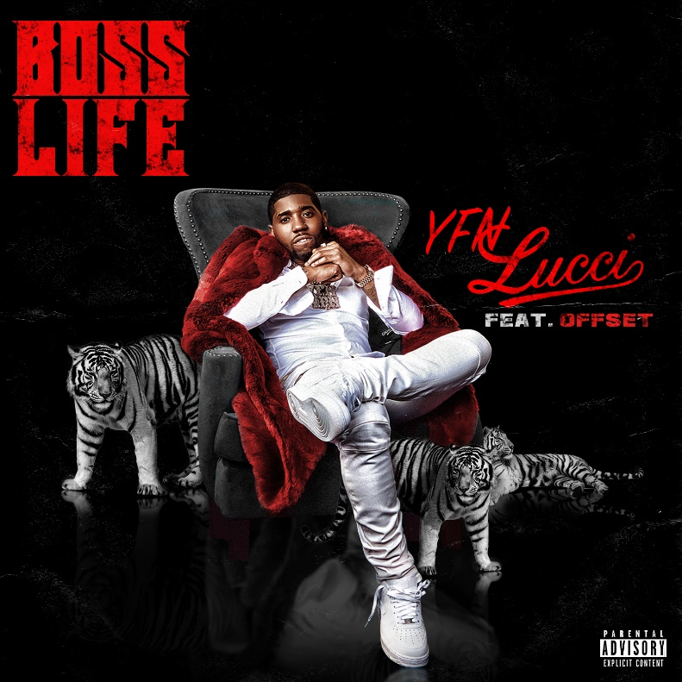

LOS ANGELES (December 15, 2017) - Continuing a massive breakout in 2017, YFN Lucci reveals his new single "Boss Life" [feat. Offset] at all digital retailers today-available via Think It's A Game Records.

Get it HERE.

The platinum-certified and critically acclaimed Atlanta rapper and singer serves up yet another bossed-up, banger. Over strutting keys and hypnotic bass, his distinctive and dynamic flow immediately captivates as fellow Atlanta luminary Offset delivers a head-turning and hard-hitting cameo of his own. "Boss Life" lives up to its title, uniting two of the South's most influential and impactful young leaders on one essential and authoritative anthem that's impossible to shake.

Listen HERE.

Showing no signs of stopping, "Boss Life" heats up Lucci's unbreakable hot streak to a boiling point. It arrives on the heels of 2017's smash "Everyday We Lit" [feat. PnB Rock]. Recently certified Gold by the RIAA, it soared to #1 on Urban Radio and notched more than 300 million streams and counting.

In addition, the latest single paves the way for his anxiously awaited full-length album debut, arriving in 2018.

Ring in the new year by living the "Boss Life" with YFN Lucci now!

Singing and rapping with the same fiery force, YFN Lucci represents the next evolution of the Atlanta sound. Inking a deal with Think It's A Game Records in 2014, he quietly developed into one of his city's most powerful voices. Following the success of Wish Me Well, he unleashed Wish Me Well 2 in 2016. It yielded the platinum-certified smash "Key to the Streets" [feat. Migos & Trouble], which amassed more than 43.2 million Spotify streams, turned up a high-profile remix with Lil Wayne, 2 Chainz, and Quavo, and landed on XXL's "50 Best Hip-Hop Songs of 2016" and Vibe's "The 60 Best Songs of 2016" list. Forbesproclaimed YFN Lucci among "5 Breakout Hip Hop Artists to Watch This Summer" and Billboard dubbed him one of the "Top 10 Hip-Hop & R&B Artists to Watch in 2017"-he's living up to those claims with his EP Long Live Nut [Think It's A Game Records].
Digital Assets:
Download/stream "Boss Life" HERE.

Follow YFN Lucci:
Website: https://yfnlucci.com/
Facebook: https://www.facebook.com/YFNLucci/
Twitter: @yfnluci
Instagram: @yfnlucci

Press materials:
http://press.wbr.com/yfnlucci

