COUNTRY STAR ZACH BRYAN RELEASES HEARTRENDING “SOMETHING IN THE ORANGE”
LISTEN HERE / WATCH HERE

STAGECOACH FESTIVAL PERFORMANCE SET FOR SATURDAY, APRIL 30TH

WARNER RECORDS ALBUM DEBUT AMERICAN HEARTBREAK
SET FOR RELEASE ON MAY 20TH
PRE-ORDER HERE

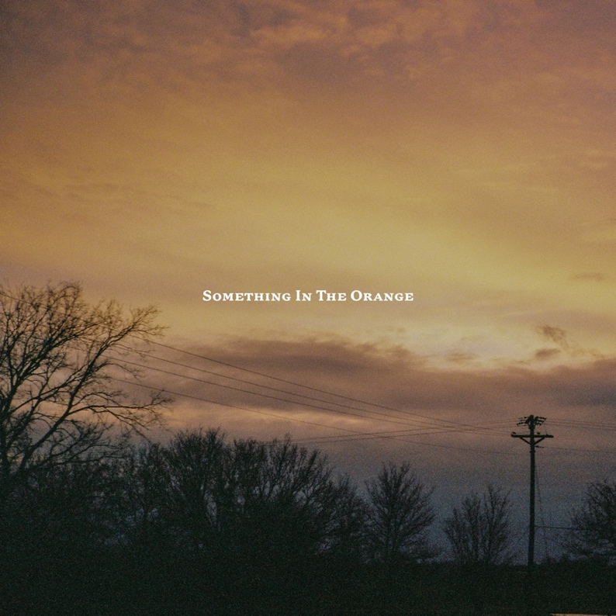
(Download “Something in the Orange” artwork HERE)

April 22, 2022 (Los Angeles, CA) – Oklahoma born and bred songwriting force of nature Zach Bryan continues his profound explorations of human emotion with his heartrending new single “Something in the Orange,” out today via Warner Records. Like “Highway Boys” and the chart-topping “From Austin” before it, “Something in the Orange” finds Bryan laying himself bare, willing himself to believe there’s a chance of survival for an all-but-doomed relationship. “To you I’m just a man, to me you’re all I am, where the hell am I supposed to go?” Bryan howls, nearly broken. “I poisoned myself again; something in the orange tells me you’re never coming home.” It’s the sort of sharp intensity that’s quickly made him one of country music’s most compelling voices. Listen to “Something in the Orange” HERE and watch HERE.

There are two versions of “Something in the Orange” – the “Z&E” version was produced and mixed by Eddie Spear recorded at Electric Lady Studio in New York City, while the other was produced and mixed by Ryan Hadlock at Bear Creek Studio in Washington State.

The former is vast and lonesome, with sparse, booming percussion and swells of overdriven guitar in the distance; the latter blossoms, with sweeping, low-down strings, and a wash of piano, like the soft, heavy light of the orange Bryan sees in the sunrise. Both versions are linked by a ghostly longing and grave loneliness that haunts every bar. The video features crowd sourced footage shot by fans and captures the raw and unfiltered emotion of the Bryan’s live experience. The song will be featured on his long-awaited third album—and his first for Warner Records—American Heartbreak, due for release on May 20. Pre-save American Heartbreak HERE.

Bryan’s most recent releases—the heartsick “From Austin” and the rambling “Highway Boys”—immediately resonated with fans, with the former topping both Spotify and Apple Music’s Country charts. Listen to “From Austin” HERE and watch the video HERE; listen to “Highway Boys” HERE and watch the video HERE. Each new track from American Heartbreak continues to hit home with a dedicated audience that’s been steadily growing by the millions via Spotify, TikTok, YouTube, and his magnetic live shows. Upon release, “From Austin” claimed the #1 Country Song on Apple Music, debuted at #4 on Spotify’s Global Country chart, and made spectacular first-day impressions by hitting #38 Overall Song on Spotify US Top 200 and #63 Overall Song on Apple US. On the strength of the song’s deeply personal story, it amassed 487K global and 445K US first-day streams on Spotify, a staggering result for an upstart songwriter. Like the singles that precede it, “Something in the Orange” finds Bryan plumbing the depths of himself to bring listeners something honest, something real.

2022 Tour Dates:
Apr 22 Miramar, FL Moon Crush Music Festival
Apr 23 Opelika, AL Field Party Presented by Auburn Rodeo
Apr 28 Stillwater, OK Calf Fry
Apr 30 Indio, CA Stagecoach Festival
May 21 Denver, CO Empower Field at Mile high
May 25 Fort Worth, TX Billy Bob’s
May 28 New Braunfels, TX Whitewater Amphitheatre
May 29 New Braunfels, TX Whitewater Amphitheatre
June 04 Seattle, WA Lumen Field
June 19 Manchester, TN Bonnaroo Music & Arts Festival
July 15 Canby, OR Wild Hare Music Festival
July 15-17 Whitefish, MT Under The Big Sky Music & Arts Festival (Sold Out)
July 23 Columbus, OH Buckeye Country Superfest
July 29 Fort Smith, AR Peacemaker Music & Arts Festival
July 30 Atlanta, GA Mercedes-Benz Stadium
Aug 04 Chicago, IL Windy City Smoke Out
Aug 12 Gilford, NH Bank of NH Pavilion
Aug 13 Bethel, NY Bethel Woods Center
Aug 14 Darien Center, NY Darien Lake Amphitheater
Sep 17 Columbia, MD Merriweather Post Pavilion
Sep 23 Camden, NJ Waterfront Music Pavilion
Sep 24-25 Bridgeport, CT Sound On Sound Festival

About Zach Bryan:
Zach Bryan is a singer/songwriter from Oologah, Oklahoma, proud of his small-town roots and whose music is fueled by a desire to stay true to himself. The 24-year-old is a recent active-duty member of the US Navy, previously stationed in Washington state—a family tradition that has instilled a sense of honor and humility that is clear in his music. His success is found in his raspy voice, a mix of classic folk melody and outlaw country with a raw edge that cuts to the bone. His breakthrough moment makes all that clear as day. In the video for “Heading South,” shot by phone outside of his Navy barracks in humid 95-degree heat, Bryan’s passion echoes off the strings of his trusted Guild. Drenched in sweat and belting words that he had written minutes earlier, the moment is authentic, brutal, and real. Millions of fans have now seen that video without any sort of industry assist, and millions more have connected to the tender, sincere songs found on both Bryan’s 2019 debut album DeAnn—dedicated to his late mother—and his 2020 follow-up, Elisabeth, an ode to those he loves. His recent show at Nashville’s famed Ryman Auditorium sold out in record time and now finds Bryan amidst a headline tour of sheds and festivals through summer 2022. His recent hit single “From Austin” topped both the Spotify and Apple Music’s Country charts. A man of simple words, Bryan’s ability to create depth in his work is rivaled by few artists. He believes that who you are only extends to the person you are today, an ideology reflected in everything he creates.

# # #
For more information, please contact:
Rick Gershon | Warner Records
Rick.Gershon@warnerrecords.com

FOLLOW ZACH BRYAN:
Website | Instagram | TikTok | Twitter | YouTube

