**LOS ANGELES ALT-POP DISRUPTERS more* RELEASE SECOND EP**

**‘2/2’ AVAILABLE VIA WARNER RECORDS NOW**

**FEATURING THE TRACKS** [**“KEEPING IT IN THE FAMILY”**](https://more.lnk.to/KIITFvideo) **AND** [**“GREEN”**](https://www.youtube.com/watch?v=wbkyWl3YZG4)

**SET TO JOIN HAIM AT SANTA BARBARA BOWL ON SEPT. 17TH**

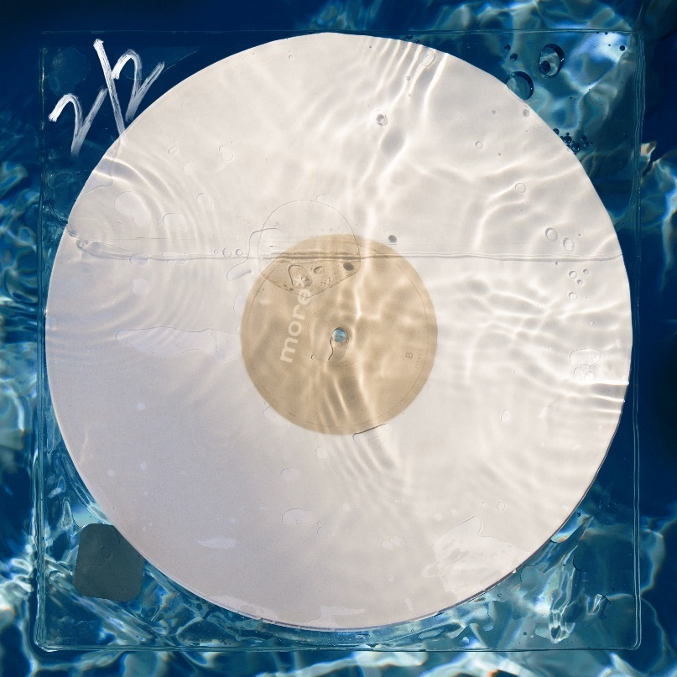**(Click** [**here**](https://press.warnerrecords.com/wp-content/uploads/2021/09/more-22-ep-artwork-scaled.jpg) **for hi-res image)**

**September 10, 2021 (Los Angeles, CA) –** Emerging Los Angeles alt-pop duo **more\*** release their new EP **‘2/2’** today via Warner Records – listen [HERE](https://more.lnk.to/2of2). **Kane Richotte** (vocals/guitar/bass/keys/drums) and **Malcolm McRae** (vocals/ bass/guitar/keys) return with their second project in a series of 5-song EPs written and recorded w/ the venerable producer/musician **Tony Berg** (Phoebe Bridgers, Lorde, Paul McCartney, etc.) at his famed Sound City Studios in Los Angeles.

The songs effortlessly ebb and flow together with multiple layers of guitars, keyboards, and almost unrecognizable sounds woven together to create something that is at once familiar and new. Earworm hooks, angelic vocals, lyrical eloquence filtered through and imaginative production have become their trademarks as evident on the new single and video **“Keeping It In The Family.”**

**Richotte** comments on the track, *“Malcolm had done something morally ambiguous, and this is a half-sincere apology letter. We wanted it to sound fun.”* **Keene McRae** directed the accompanying music video, upholding the familial creative bond surrounding the band. Click [HERE](https://more.lnk.to/KIITFvideo) to view and share the video for **“Keeping It In The Family.”**

Just confirmed, **more\*** will perform live with **Haim** on September 17th at the Santa Barbara Bowl. Click [**here**](https://sbbowl.com/home) for ticket and show information. Additional dates to be announced soon.

**‘2/2’ Tracklisting:**

1. Ride Along
2. Keeping It In The Family
3. Green
4. Isn’t That Just Like Me
5. Lazy James

***‘2/2’*** picks up where the band left off on last year’s [***'1/2'***](https://more.lnk.to/1of2) debut EP. The latter has already gathered over half-a-million cumulative streams and counting. In addition to plugs from the likes of [***American Songwriter***](https://americansongwriter.com/los-angeles-duo-more-release-their-debut-ep-1-2/)and more. [***Meaaww***](https://meaww.com/more-la-indie-band-era-defying-melodic-pop-rock-kane-ritchotte-malcolm-mc-rae-tony-berg-riley-keough) claimed, *“****more****’s '****1/2****' EP is a superbly produced and finely-crafted offering. It features classic song structures, strong melodies and psychedelic dabbling filtered through expressive guitars, dexterous drums and great vocal harmonies*.*”* Click [**here**](https://more.lnk.to/1of2) to stream the first 5-song EP **‘1/2.’**

Expect much more from **more\*** to be revealed soon. Until then go[**here**](https://www.moretheband.com/).

**# # #**

For further information, contact **Rick Gershon** at Warner Records Publicity:

[**rick.gershon@warnerrecords.com**](mailto:rick.gershon@warnerrecords.com)

**Follow more*:**

[**Official**](https://nam04.safelinks.protection.outlook.com/?url=https%3A%2F%2Fwww.moretheband.com%2F&data=02%7C01%7CRick.Gershon%40warnerrecords.com%7Ce29e7142537b406ea79508d8283887d2%7C8367939002ec4ba1ad3d69da3fdd637e%7C0%7C0%7C637303570552819318&sdata=gKaN%2B%2FTXA6H%2FE0sAmOTLYOg%2FpejEd0N9oydIB3%2Fli6o%3D&reserved=0) **|** [**Instagram**](https://www.instagram.com/moretheband/) **|** [**Facebook**](https://nam04.safelinks.protection.outlook.com/?url=https%3A%2F%2Ffacebook.com%2Fmoremp3&data=02%7C01%7CRick.Gershon%40warnerrecords.com%7Ce29e7142537b406ea79508d8283887d2%7C8367939002ec4ba1ad3d69da3fdd637e%7C0%7C0%7C637303570552839308&sdata=7hb8Infa%2FVVKTa6jdD1yUrAp3Fi25Dx3c1%2FxP6JmTNc%3D&reserved=0) **|** [**Twitter**](https://nam04.safelinks.protection.outlook.com/?url=https%3A%2F%2Ftwitter.com%2Fmoremp3&data=02%7C01%7CRick.Gershon%40warnerrecords.com%7Ce29e7142537b406ea79508d8283887d2%7C8367939002ec4ba1ad3d69da3fdd637e%7C0%7C0%7C637303570552839308&sdata=Nm9cIHSbyQSYf3gQEqIqRHYvREFMnq0P4OCT8KZaWEo%3D&reserved=0) **|** [**YouTube**](https://www.youtube.com/channel/UC1PeiNDN1_oSAYgGRn09-mQ) **|** [**Press Materials**](https://nam04.safelinks.protection.outlook.com/?url=https%3A%2F%2Fpress.warnerrecords.com%2Fmore%2F&data=02%7C01%7CRick.Gershon%40warnerrecords.com%7Ce29e7142537b406ea79508d8283887d2%7C8367939002ec4ba1ad3d69da3fdd637e%7C0%7C0%7C637303570552849305&sdata=6aNGfbmvpi70Cj8IO7sqevqozdYi790cHnWmfT52wZg%3D&reserved=0)

