LOS ANGELES ALT-POP DISRUPTERS more* RELEASE MUSIC VIDEO FOR LATEST SINGLE “LAZY JAMES”

WATCH HERE
more*’s RICHOTTE & MCRAE CAST IN JEFF BUCKLEY FILM EVERYBODY HERE WANTS YOU & AMAZON SERIES DAISY JONES & THE SIX

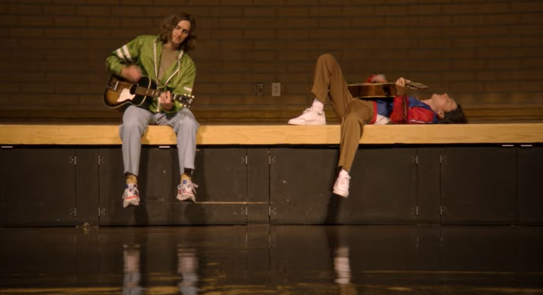

December 15, 2021 (Los Angeles, CA) – Closing out 2021 with one last drop, emerging Los Angeles alt-pop duo more* unveil the music video for their single “Lazy James” today via Warner Records. It’s the latest standout from the group’s EP “2/2.” Click HERE to watch and share.

Once again, more*—Kane Richotte (vocals/guitar/bass/keys/drums) and Malcom McRae (vocals/bass/guitar/keys)—present a cinematic visual for the track. Its breezy melodies coast over a jangly sixties pop-style beat. The clip unfolds as yet another clever filmic Los Angeles-based vignette directed by Malcom’s brother Keene McRae. It marks the latest chapter in an ongoing and ever-evolving pastiche of unique videos from the group.

The guys recently wrapped up a string of seminal shows, sharing the stage with the likes of Haim at Santa Barbara Bowl in Santa Barbara, CA and Grouplove at The Palladium in Hollywood, CA. Next up, they support Bad Suns at The Hollywood Palladium on February 3, and March 2, at the Observatory in Orange Country.

more* have made waves throughout not just music, but popular culture as well. Kane and Malcom will play Matt Johnson and Michael Tighe, respectively, in the upcoming film Everybody Here Wants You based on the life and music of the legendary Jeff Buckley and directed by Orian Williams. They not only accompany Buckley (Reeve Carney) on screen as his bandmates, but they will also perform the re-records of selections from his classic catalog. Production starts in January 2022. Additionally, they bring fictional band The Winters to life in the upcoming series Daisy Jones & The Six, releasing on Amazon in 2022.

The band recently got into the spirit of the season, on their own terms of course, with the holiday single “When Christmas Comes to LA.” Right now, more* is in the studio recording new music with producer Tony Berg (Phoebe Bridgers, Lorde) with a view to release new material in 2022.

“2/2” picked up where the band left off on last year’s “1/2'” debut EP. The latter has already gathered over half-a-million cumulative streams and counting. In addition to plugs from the likes of American Songwriter and more, Meaaww claimed, “more’s '1/2' EP is a superbly produced and finely-crafted offering. It features classic song structures, strong melodies and psychedelic dabbling filtered through expressive guitars, dexterous drums and great vocal harmonies.” Click here to stream the first 5-song EP “1/2,” and here for “2/2.”

‘2/2’ EP Tracklisting:
- Ride Along
- Keeping It In The Family
- Green
- Isn’t That Just Like Me
- Lazy James

‘1/2’ EP Tracklisting:
- Settled In
- God’s in the Details
- Elaborate Attractions
- All-American Guts
- The Way

Expect much more from more* to be revealed soon. Until then go here.

# # #

For further information, contact Rick Gershon at Warner Records Publicity:
rick.gershon@warnerrecords.com

Follow more*:
Official | Instagram | Facebook | Twitter | YouTube | Press Materials

