LOS ANGELES ALT-POP DISRUPTERS more* REVEAL NEW SINGLE
“REALLY WANT TO SEE YOU AGAIN” – LISTEN HERE

HITTING THE ROAD WITH HAIM THIS SUMMER!

WATCH VIDEO FOR “REALLY WANT TO SEE YOU AGAIN” HERE

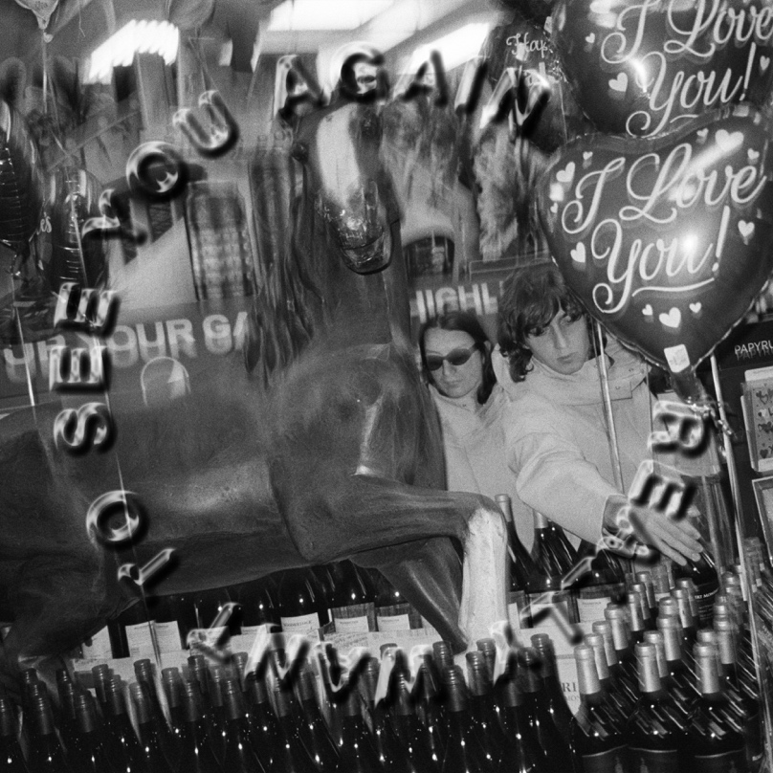
(Click here for hi-res artwork)

March 11, 2022 (Los Angeles, CA) – Gearing up for a busy Spring, emerging Los Angeles alt-pop duo more* share a new single entitled “Really Want To See You Again” available today on all streaming platforms via Warner Records. It will be followed by another new single “Whose Side You’re On” in two weeks on March 25th. Listen to “Really Want To See You Again” HERE and watch the Keene McRae directed video HERE. Pre-save “Whose Side You’re On” HERE.

“Really Want To See You Again” hinges on the seamless interplay of Malcom McRae and Kane Ritchotte. Embodying California spirit and soul, Blake Mills’ sunny guitar riff breezes alongside a simmering steady beat as McRae’s vocals echo on the instantly unshakable hook.

About the song, McRae shared, “As a duo and a rule, Kane and I share everything. ‘Really Want To See You Again’ was written two days after meeting the girl I’m very much in love with. The three of us are very happy together.”

On its heels, “Whose Side You’re On” rides a smoky slow burn groove into a glassy harmony highlighted by tambourine and wah-drenched guitar. It will also be accompanied by a music video. Both tracks were recorded at Sound City and co-produced by more* and Tony Berg (Paul McCartney, Taylor Swift, Phoebe Bridgers). “Whose Side You’re On” is set for release later this month on March 25 alongside another Keene McRae directed video. Pre-save “Whose Side You’re On” HERE.

Next up, more* hit the road supporting HAIM in amphitheaters and sheds coast-to-coast this summer. Ritchotte will also notably hold down drum duties for HAIM. The three-week run kicks off on May 22 at Live Oak Bank Pavilion at Riverfront Park, visits major cities across North American, and concludes on June 14 in Bend, OR at Les Schwab Amphitheater.

more* closed out 2021 with the music video for the single “Lazy James.” Receiving critical acclaim, coup de main spoke to the band in-depth and raved, “With guitar and drums leading the way, their old-school vocal and sonic sound is immediately attention-catching.”

more* have made waves not just in music but throughout popular culture as well. Ritchotte and McRae will play Matt Johnson and Michael Tighe, respectively, in the upcoming film Everybody Here Wants You based on the life and music of the legendary Jeff Buckley and directed by Orian Williams. They not only accompany Buckley (Reeve Carney) on screen as his bandmates, but they will also perform the re-records of selections from his classic catalog. Production began at the top of 2022. Additionally, they will bring fictional band The Winters to life in the upcoming series Daisy Jones & The Six, releasing on Amazon this year.

Also available from more*, their first two EP’s. The latter has already gathered over half-a-million cumulative streams and counting. Click here to stream the first 5-song EP ‘1/2,’ and here for ‘2/2.’

‘1/2’ EP Tracklisting:
- Settled In
- God’s in the Details
- Elaborate Attractions
- All-American Guts
- The Way

‘2/2’ EP Tracklisting:
- Ride Along
- Keeping It In The Family
- Green
- Isn’t That Just Like Me
- Lazy James

Expect much more from more* to be revealed soon. Until then, go here.

2022 Tour Dates w/ HAIM:
May 22 Wilmington, NC Live Oak Bank Pavilion at Riverfront Park
May 24 Toronto, ON RBC Echo Beach
May 25 Detroit, MI Meadow Brook Amphitheater
May 28 Philadelphia, PA TD Pavilion at the Mann
May 31 Milwaukee, WI BMO Harris Pavilion
June 01 Indianapolis, IN TCU Amphitheater at White River State Park
June 03 Chicago, IL Huntington Bank Pavilion at Northerly Island
June 04 Kansas City, MO Starlight Theater
June 08 Minneapolis, MN The Armory
June 10 Vancouver, BC Doug Mitchell Thunderbird Sports Centre
June 11 Portland, OR Theater of the Clouds at Moda Center
June 13 Seattle, WA WAMU Theater
June 14 Bend, OR Les Schwab Amphitheater

# # #

For further information, contact Warner Records Publicity:

Rick Gershon | Warner Records
rick.gershon@warnerrecords.com

REGIONAL: Jenny Huynh | Warner Records
jenny.huynh@warnerrecords.com

Follow more*:
Official | Instagram | Facebook | Twitter | YouTube | Press Materials
