LOS ANGELES ALT-POP SAVANTS more* RELEASE NEW SINGLE
“WHOSE SIDE YOU’RE ON” – LISTEN HERE / WATCH HERE

HITTING THE ROAD WITH HAIM THIS SUMMER!

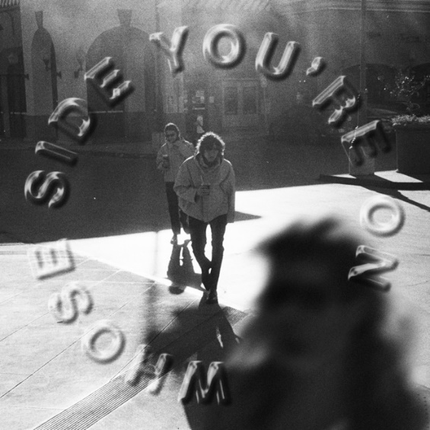
(Click here for hi-res artwork)

March 25, 2022 (Los Angeles, CA) – Buzzing Los Angeles alt-pop duo more* unveil their second single of the month “Whose Side You’re On” available today on all streaming platforms via Warner Records. To celebrate the release, more* also launched their new Community number today – connect with them at (818) 651-9669. Listen to “Whose Side You’re On” HERE and watch the Keene McRae directed video HERE.

About the track, Ritchotte said, “I began this song writing about relationships I’d been in. Only upon completing it, did I realize I was writing about my parents.”

“Whose Side You’re On” rides a smoky slow burn groove into a glassy harmony highlighted by tambourine and wah-drenched guitar as the duo somberly croon, “Let’s call it even, walk away.” “Whose Side You’re On” follows their previous release, “Really Want To See You Again” – watch the video HERE. Both tracks were recorded at Sound City and co-produced by more* and Tony Berg (Paul McCartney, Taylor Swift, Phoebe Bridgers).

The first of the pair of new tracks, “Really Want To See You Again,” hinges on the seamless interplay of Malcom McRae and Kane Ritchotte. Embodying California spirit and soul, Blake Mills’ sunny guitar riff breezes alongside a simmering steady beat as McRae’s vocals echo on the instantly unshakable hook. McRae shared, “As a duo and a rule, Kane and I share everything. ‘Really Want To See You Again’ was written two days after meeting the girl I’m very much in love with. The three of us are very happy together.”

As previously announced, more* hit the road supporting HAIM in amphitheaters and sheds coast-to-coast this summer. Ritchotte will also notably hold down drum duties for HAIM. The three-week run kicks off on May 22 at Live Oak Bank Pavilion at Riverfront Park, visits major cities across North American, and concludes on June 14 in Bend, OR at Les Schwab Amphitheater.

more* closed out 2021 with the music video for the single “Lazy James.” Receiving critical acclaim, coup de main spoke to the band in-depth and raved, “With guitar and drums leading the way, their old-school vocal and sonic sound is immediately attention-catching.”

more* have made waves not just in music but throughout popular culture as well. Ritchotte and McRae will play Matt Johnson and Michael Tighe, respectively, in the upcoming film Everybody Here Wants You based on the life and music of the legendary Jeff Buckley and directed by Orian Williams. They not only accompany Buckley (Reeve Carney) on screen as his bandmates, but they will also perform the re-records of selections from his classic catalog. Production began at the top of 2022. Additionally, they will bring fictional band The Winters to life in the upcoming series Daisy Jones & The Six, releasing on Amazon this year.

Also available from more*, their first two EPs. The latter has already gathered over half-a-million cumulative streams and counting. Click here to stream the first 5-song EP ‘1/2,’ and here for ‘2/2.’

‘1/2’ EP Tracklisting:
- Settled In
- God’s in the Details
- Elaborate Attractions
- All-American Guts
- The Way

‘2/2’ EP Tracklisting:
- Ride Along
- Keeping It In The Family
- Green
- Isn’t That Just Like Me
- Lazy James

much more from more* soon. Until then, go here.

2022 Tour Dates w/ HAIM:
May 22 Wilmington, NC Live Oak Bank Pavilion at Riverfront Park
May 24 Toronto, ON RBC Echo Beach
May 25 Detroit, MI Meadow Brook Amphitheater
May 28 Philadelphia, PA TD Pavilion at the Mann
May 31 Milwaukee, WI BMO Harris Pavilion
June 01 Indianapolis, IN TCU Amphitheater at White River State Park
June 03 Chicago, IL Huntington Bank Pavilion at Northerly Island
June 04 Kansas City, MO Starlight Theater
June 08 Minneapolis, MN The Armory
June 10 Vancouver, BC Doug Mitchell Thunderbird Sports Centre
June 11 Portland, OR Theater of the Clouds at Moda Center
June 13 Seattle, WA WAMU Theater
June 14 Bend, OR Les Schwab Amphitheater

# # #
Contact Warner Records Publicity:
National: Rick Gershon | Warner Records
rick.gershon@warnerrecords.com

Regional: Jenny Huynh | Warner Records
jenny.huynh@warnerrecords.com

Follow more*:
Official | Instagram | Facebook | Twitter | TikTok | YouTube | Press Materials
