LOS ANGELES ALT-POP DUO more* RELEASE NEW SINGLE “WOMAN ON THE MOVE”

LISTEN HERE

HITTING THE ROAD WITH HAIM THIS MONTH!

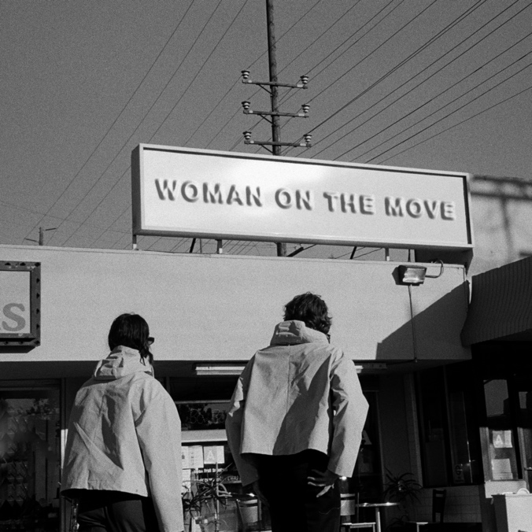
(Click here for hi-res artwork)

May 6, 2022 (Los Angeles, CA) – Today, buzzing Los Angeles alt-pop doublet more* return with a new single “Woman On The Move” – out now via Warner Records. Listen to “Woman On The Move” HERE. The single arrives a couple weeks ahead of their three-week trek opening for HAIM on tour.

On the song’s inspiration, McRae shared, “The events written into this song are all exaggerated truths. I did, in fact, crash my car (with lapsed insurance) on Franklin Avenue in LA. The debt collectors were after me for almost two years. I also did, in fact, work at a law firm located on the seventh floor of a Pasadena office building, where I accidentally drank a drug laced smoothie for breakfast before heading to work.”

He further reflected, “It was a genuine accident and a pretty overwhelming day. However, the sardonic quality tied to the line ‘looking back, it doesn’t seem so bad’ is untrue. Looking back, none of it really doesn’t seem so bad.” Stay tuned for a visual to accompany this grand adventure!

more* is set to hit the road later this month supporting HAIM in amphitheaters and sheds coast-to-coast this summer. Ritchotte has already started notably holding down drum duties for HAIM. The three-week run kicks off on May 22 at Live Oak Bank Pavilion at Riverfront Park, visits major cities across North American, and concludes on June 14 in Bend, OR at Les Schwab Amphitheater.

“Woman On The Move” follows the band’s previous releases "Whose Side You're On" and "Really Want To See You Again". Both tracks were recorded at Sound City and co-produced by more* and Tony Berg (Paul McCartney, Taylor Swift, Phoebe Bridgers). Last month, more* also launched their new Community number, inviting fans to connect with them at (818) 651-9669.

more* closed out 2021 with the music video for their single “Lazy James.” Receiving critical acclaim, coup de main spoke to the band in-depth and raved, “With guitar and drums leading the way, their old-school vocal and sonic sound is immediately attention-catching.”

more* have made waves not just in music, but throughout popular culture as well. Ritchotte and McRae will play Matt Johnson and Michael Tighe, respectively, in the upcoming film Everybody Here Wants You based on the life and music of the legendary Jeff Buckley and directed by Orian Williams. They not only accompany Buckley (Reeve Carney) on screen as his bandmates, but they will also perform the re-records of selections from his classic catalog. Production began at the top of 2022. Additionally, they will bring fictional band The Winters to life in the upcoming series Daisy Jones & The Six, releasing on Amazon this year.

Also available from more*, their first two EPs – '1/2' and '2/2'. Along with their newest releases, more* have garnered over 1.6M global streams to date.

Expect much more from more* soon. Until then, go here.

2022 Tour Dates w/ HAIM:
May 22 Wilmington, NC Live Oak Bank Pavilion at Riverfront Park
May 24 Toronto, ON RBC Echo Beach
May 25 Detroit, MI Meadow Brook Amphitheater
May 28 Philadelphia, PA TD Pavilion at the Mann
May 31 Milwaukee, WI BMO Harris Pavilion
June 01 Indianapolis, IN TCU Amphitheater at White River State Park
June 03 Chicago, IL Huntington Bank Pavilion at Northerly Island
June 04 Kansas City, MO Starlight Theater
June 08 Minneapolis, MN The Armory
June 10 Vancouver, BC Doug Mitchell Thunderbird Sports Centre
June 11 Portland, OR Theater of the Clouds at Moda Center
June 13 Seattle, WA WAMU Theater
June 14 Bend, OR Les Schwab Amphitheater

# # #
Contact Warner Records Publicity:
National: Rick Gershon | Warner Records
rick.gershon@warnerrecords.com

Regional: Jenny Huynh | Warner Records
jenny.huynh@warnerrecords.com

Follow more*:
Official | Instagram | Facebook | Twitter | TikTok | YouTube | Press Materials

