RELEASE NEW ALBUM ‘SCREAM ABOVE THE SOUNDS’
ON NOVEMBER 3RD ON PARLOPHONE

Lead single ‘All In One Night’ is out now: https://wbr.ec/allinonenight

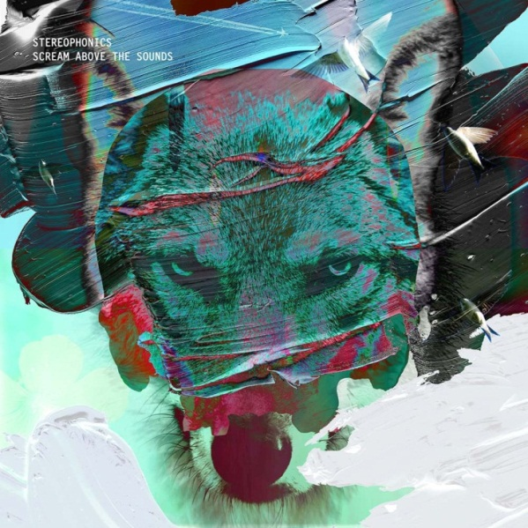
(Stereophonics photo by Andrew Whitton)

Twenty years after their debut ‘Word Gets Around’ and six #1 albums later, Stereophonics are set to release their new album ‘Scream Above The Sounds’ on November 3rd on Parlophone Records.

Their tenth studio album, ‘Scream Above The Sounds’ follows ‘Keep The Village Alive’ which went straight to #1 when it was released in 2015 – their sixth chart-topper after ‘Performance and Cocktails’ (1999), ‘Just Enough Education To Perform’ (2001) ‘You Gotta Go There To Come Back’ (2003), ‘Language. Sex. Violence. Other?’ (2005) and ‘Pull The Pin’ (2007).

Stereophonics consists of founding members Kelly Jones (vocals/guitar) and Richard Jones (bass) along with Adam Zindani (guitar) and Jamie Morrison (drums). Long-term keyboardist Tony Kirkham joins the band for live shows.

Kelly said of the songwriting process that he began to write “big, anthemic songs that are rallying against those anxious feelings that have flooded through cities. Every song offers a sense of release,” he says. “Even when there’s nostalgia, fear or anxiety, they’re still all offering hope and room to manoeuvre.”

The first single ‘All In One Night’ represents the band’s affection for the melancholy. Set to a consistent mid-paced rhythm which evokes a nocturnal motorway drive, it finds the narrator’s life taking a dramatic turn as night brightens to day. Influenced by the Sebastian Schipper film ‘Victoria’, it’s a song that had an unusual genesis – Kelly started it when the band had an unscheduled day’s stay in China before he finished it back home in London. Even the atmospheric call of the chorus was fortuitous, being an adaptation of a vocal exercise he was using.

‘Scream Above The Sounds’ was primarily recorded in the band’s HQ in west London with a further session at RAK Studios. Created with the help of regular collaborator Jim Lowe, it’s an album in which creative sonic touches add to the band’s emphasis on songwriting and melody.

‘Scream Above The Sounds’ will be released on digital (standard and deluxe), CD (standard and deluxe) and vinyl formats. It’s available to pre-order from http://www.stereophonics.com with ‘All In One Night’ provided as an instant download.

Stereophonics will headline Kendal Calling on July 28th, Y Not Festival on July 29th, and Victorious Festival on August 26th ahead of their set at BBC 2 Live In Hyde Park on September 10th.

The ‘Scream Above The Sounds’ tracklisting is:

- ‘Caught By The Wind’
- ‘Taking A Tumble’
- ‘What’s All The Fuss About?’
- ‘Geronimo’
- ‘All In One Night’
- ‘Chances Are’
- ‘Before Anyone Knew Our Name’
- ‘Would You Believe?’
- ‘Cryin’ In Your Beer’
- ‘Boy On A Bike’
- ‘Elevators’

Bonus tracks on the deluxe edition:

12. ‘Never Going Down’ (live at RAK Studios)
13. ‘Drive A Thousand Miles’ (‘Graffiti…’ sessions)
14. ‘Breaking Dawn’ (written for ‘Twilight’)
15. ‘All In One Night’ (unplugged)
16. ‘Caught By The Wind’ (unplugged)

Official website
Spotify
Facebook
Twitter
Instagram
YouTube

For more information please contact:
Kristen.Foster@pmkbnc.com / Lauren.Morris@pmkbnc.com

