SWERVE CITY IPA – THE SECOND IN A SERIES OF SEASONAL SPECIALTY BREWS FROM GRAMMY®-WINNING BAND DEFTONES AND
BELCHING BEAVER BREWERY – DEBUTS THIS SUMMER

Phantom Bride IPA, Introduced in 2016, To Become Available In Cans This Summer At Markets And At Select Venues On Band’s Summer Tour

North American Co-Headline Run With Rise Against Kicks Off On June 9 At Chicago’s Huntington Bank Pavilion at Northerly Island
Deftones Will Join Guns N’ Roses On Select Stadium Dates Of Summer Tour

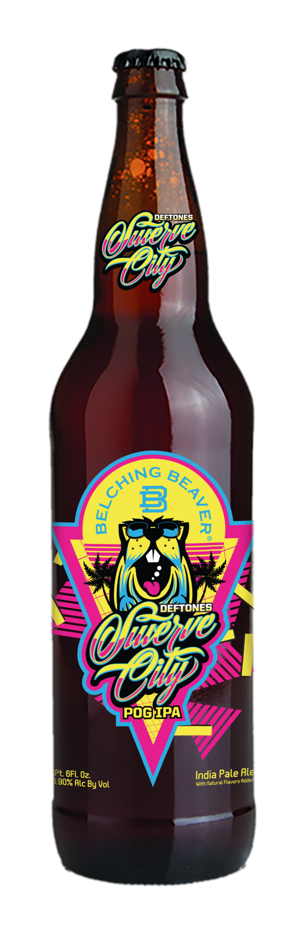

May 30, 2017 (Burbank, CA) — This summer, GRAMMY®-winning alternative rock band Deftones will introduce Swerve City IPA, a brew that enhances the easy-going vibe of the season. It marks the multi-Platinum band’s second release in partnership with Belching Beaver Brewery, which is based in Oceanside, CA.

Swerve City is an American IPA with passionfruit, guava and orange. Inspired by the famous POG juice, it’s a tropical fruit bomb with a juice-like finish. The beer has just enough bitterness and hop flavor to balance the big fruitiness. Available soon in all markets where fine craft beer is sold, it takes its name from the leadoff track of Deftones’ 2012 album, Koi No Yokan. Click here to view and share Deftones’ official video for “Swerve City.”

“We’re super excited about where this Deftones/Belching Beaver partnership is heading,” said Chino of Deftones. “Starting off with the simple idea of doing one limited run of the Phantom Bride collaboration has now turned into a full year of seasonal specialty brews to be put together by our love of beer and Belching Beaver's ability to turn out amazing product. We’re looking forward to all of you enjoying the tasty brews we have in store.”

Phantom Bride, the band’s first release with Belching Beaver Brewery, was introduced last fall just as the song of the same name – from Deftones’ 2016 album, Gore – became a Top 10 hit at rock radio. The initial run of bottled Phantom Bride sold out everywhere. Beginning this summer – the acclaimed IPA will be available in cans, launching exclusively at Southern California Albertsons and Vons locations. Distribution will widen thereafter to include all fine craft retailers. Fans can also find Phantom Bride at select venues on Deftones’ summer 2017 tour. All About Beer Magazine said, “The aromatics on this are gorgeous: tropical, with lime and passion fruit, approximating fresh-squeezed pomelo grapefruit...A notably generous, smooth and complex IPA.”

Deftones will be joining forces with Rise Against for a summer co-headline tour. The extensive North American run will kick off on June 9 in Chicago, IL at Huntington Bank Pavilion at Northerly Island. It will include shows at the Northwell Health at Jones Beach Theater in Wantagh, NY (June 13), Starplex Pavilion in Dallas, TX (June 27) and Concord Pavilion in Concord, CA (July 6). All dates will feature special guest Thrice. Deftones will also be joining Guns N’ Roses on select stadium dates of the Not In This Lifetime Tour this summer. See below for itinerary.

Formed in Sacramento, CA, Deftones have released eight studio albums to date and have sold nearly 20 million albums worldwide. “Hard rock thrives on conflict and chaos, and no band has found more beauty and soaring aggression within those ingredients than Deftones,” said the Los Angeles Times. Deftones are: vocalist/guitarist Chino Moreno, guitarist Stephen Carpenter, keyboardist/samplist Frank Delgado, drummer Abe Cunningham, and bassist Sergio Vega.

TOUR DATES:

Co-Headlining With Rise Against:
06/09 Chicago, IL Huntington Bank Pavilion at Northerly Island
6/10 Sterling Heights, MI Michigan Lottery Amphitheatre at Freedom Hill
06/11 Toronto, ON Budweiser Stage
06/13 Wantagh, NY Northwell Health at Jones Beach Theater
06/16 Boston, MA Blue Hills Bank Pavilion
06/17 Philadelphia, PA Festival Pier at Penn’s Landing
06/18 Raleigh, NC Red Hat Amphitheater
06/20 Charlotte, NC Charlotte Metro Credit Union Amphitheatre
06/22 Tampa, FL MidFlorida Credit Union Amphitheatre
06/23 Miami, FL Bayfront Park Amphitheater
06/24 Jacksonville, FL Daily’s Place Amphitheater
06/26 The Woodlands, TX The Cynthia Woods Mitchell Pavilion
06/27 Dallas, TX Starplex Pavilion
06/28 Austin, TX Austin360 Amphitheater
06/30 Denver, CO Pepsi Center
07/1 Salt Lake City, UT USANA Amphitheater
07/3 Seattle, WA White River Amphitheatre
07/4 Bend, OR Les Schwab Amphitheater
07/6 Concord, CA Concord Pavilion
07/7 Chula Vista, CA Sleep Train Amphitheatre
07/8 Las Vegas, NV Downtown Las Vegas Events Center
07/9 Phoenix, AZ Ak-Chin Pavilion

Supporting Guns N’ Roses:
07/27 St. Louis, MO The Dome At America’s Center
07/30 Minneapolis, MN U.S. Bank Stadium

# # #

Press Contacts:
National: Bobbie Gale / Warner Bros. Records
818-953-3692 / Bobbie.Gale@wbr.com

Regional: Ceri Roberts / Warner Bros. Records
212-707-2259 / Ceri.Roberts@wbr.com

Belching Beaver Contact:
Haley McHenry / Belching Beaver
760-732-1416 / Haley@belchingbeaverbrewery.com

Follow Deftones:
Website:
www.deftones.com
Facebook: Facebook.com/deftones
Twitter: @deftones
Instagram: @deftonesband

Follow Belching Beaver Brewery:
Facebook: facebook.com/belchingbeaver
Twitter: @belchingbeaver
Instagram: @belchingbeaver

Press materials:
http://press.wbr.com/deftones

