RISING SINGER/SONGWRITER ADAM MELCHOR’S DEBUT ALBUM HERE GOES NOTHING OUT OCTOBER 21

EXTENSIVE NORTH AMERICAN HEADLINE TOUR IN EARLY 2023
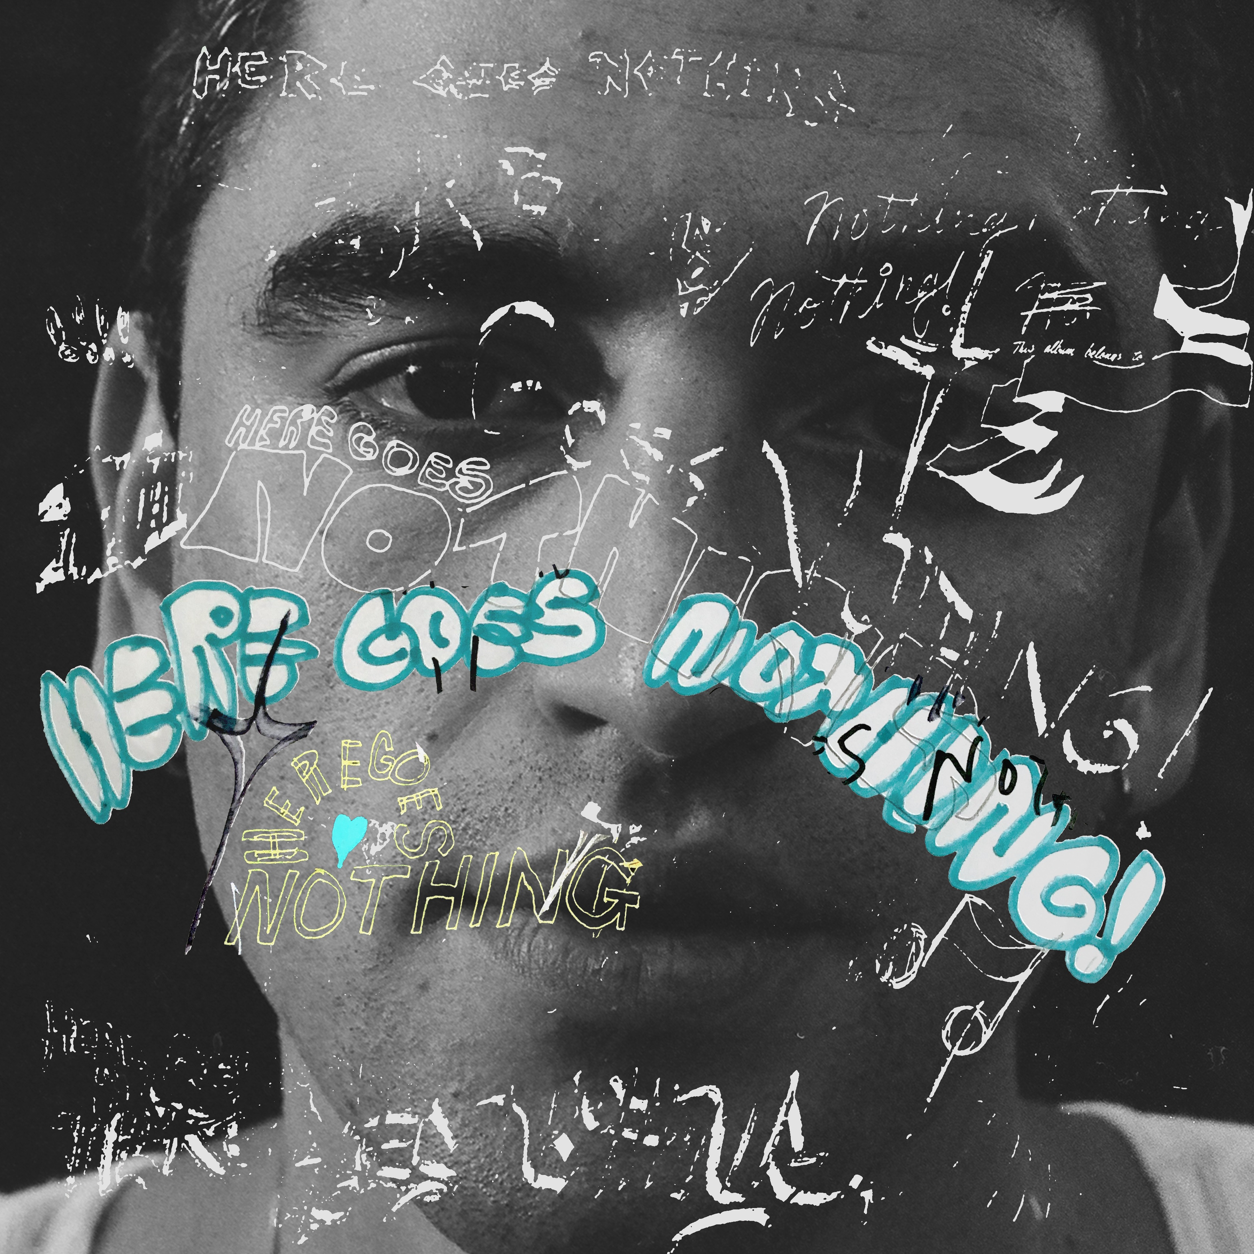
Album art photo credit: Daniel Topete, Album design credit: Henry Kwapis and Paul Dally.
“He specializes in dreamy, harmony-dense, technicolor folk-pop songs.”
“Whether it’s dancing along gently plucking acoustic guitar strings or crooning the path for backing piano keys, Adam Melchor’s calming vocal explores success and struggle, budding romance and heartbreak.”

August 12, 2022—Here Goes Nothing, the debut album from rising singer/songwriter Adam Melchor, is set for release on October 21 via Warner Records. Co-produced by Melchor and Henry Kwapis (Benny Blanco, Dijon), the album features additional production work from Andrew Sarlo, Dale Becker, and Fili Filizzola. Here Goes Nothing also features further contributions from the Fleet Foxes on the track “Let Me Know When.”
In looking further into his approach with the album, Melchor states, “The difference between a film phone and an iPhone photo - objectively, the iPhone photo is probably better, and there’s a chance that the film photo will be out of focus. But for some reason, people still love using the film photo because you’re capturing something that’s real and that’s honest, and even if you’re not capturing something that’s perfect, you can find so many things to love about it. That’s how I approach my music.”
Most recently, Melchor released the album’s lead single “Turnham Green” to early praise; V Magazine calls it “...a classic pop-folk song, with soft melodies and ethereal acoustic guitar riffs. The melancholy song highlights the beauty that can come from pain, as Melchor hears somebody’s reasoning for hurting him,” while Ones To Watch adds, “‘Turnham Green’ is a sobering moment of empathy.” Cool Hunting furthers, “[‘Turnham Green’ is] another dreamy alt-folk single from LA-based singer-songwriter… [The song] sets exquisite vocals on gently enveloping instrumentals.”
In support of the new album, Melchor confirms an extensive run of North American tour dates in early 2023. The run of shows kicks off in late January and includes performances at New York’s Brooklyn Steel, Los Angeles’ Fonda Theater, Nashville’s Brooklyn Bowl, Chicago’s Thalia Hall, Austin’s Scoot Inn, Denver’s Gothic Theatre and more. Full tour routing can be found below.
Melchor moved to Los Angeles in 2018 where he had sessions with everyone from Charlie Puth to The Chainsmokers, which subsequently led to tour dates alongside Mt. Joy, Dodie, Ashe, Chelsea Cutler and Ondara. Melchor’s previously released single “Real Estate” has garnered over 50 million streams to date and received critical praise. In 2020, Melchor launched Melchor’s Lullaby Hotline, where he sent out 40 original songs to over 10,000 fans. In conjunction, Melchor released a mixtape featuring his favorite tracks entitled Melchor Lullaby Hotline, Vol. 1, marking his first release on Warner Records.
Earlier this year, Melchor performed with Post Malone on “Saturday Night Live” where he sang backing vocals and recently completed a 30-date headlining tour across the country. Melchor’s songwriting accolades include co-writes on Ashe’s “Taylor,” The Chainsmokers’ “In Too Deep,” Alexander 23’s “Loving You Gets Hard” and Allison Ponthier’s “Faking My Own Death.” He has also collaborated with Briston Maroney, Lennon Stella, ELIO, Madeline The Person and more.

ADAM MELCHOR—HERE GOES NOTHING
- I’m Afraid I Love You
- I’m Ready
- Angel Numbers
- Cry
- Touch And Go
- Turnham Green
- Rest Of My Night
- Let Me Know When (featuring Fleet Foxes)
- Dorothy
- Sorry Adam
ADAM MELCHOR LIVE
January 27—Salt Lake City, UT—Soundwell
January 28—Denver, CO—Gothic Theatre
January 30—Minneapolis, MN—Fine Line
February 1—Madison, WI—Majestic Theatre
February 2—Chicago, IL—Thalia Hall
February 3—Detroit, MI—Magic Stick
February 4—Toronto, ON—Phoenix
February 7—Cleveland, ON—Beachland
February 9—Boston, MA—Royale
February 10—Brooklyn, NY—Brooklyn Steel
February 11—Pittsburgh, PA—Thunderbird
February 14—Philadelphia, PA—Ardmore Music Hall
February 16—Washington, DC—The Howard
February 17—Carrboro, NC—Cat’s Cradle
February 18—Charlotte, NC—The Underground
February 19—Asheville, NC—Orange Peel
February 21—Charleston, SC—Music Farm
February 22—Atlanta, GA—Terminal West
February 23—Nashville, TN—Brooklyn Bowl
February 25—Louisville, KY—Headliners
February 26—St. Louis, MO—Delmar Hall
February 28—Birmingham, AL—The Saturn
March 1—New Orleans, LA—Toulouse Theatre
March 3—Houston, TX—Studio @ Warehouse Live
March 4—Austin, TX—Scoot Inn
March 5—Dallas, TX—Granada Theatre
March 7—Phoenix, AZ—Cresent Ballroom
March 9—San Diego, CA—Music Box
March 10—Los Angeles, CA—Fonda Theater
March 11—San Francisco, CA—The Fillmore
March 15—Seattle, WA—Neumos
March 16—Vancouver, BC—Hollywood Theatre
March 17—Portland, OR—Aladdin Theater
FOLLOW ADAM MELCHOR:
Official | Instagram | TikTok | YouTube | Press Materials

For more information, please contact:

Patrice Compere | Warner Records
Patrice.Compere@warnerrecords.com

Louis D’Adamio | Sacks & Co.
louis.dadamio@sacksco.com

Carla Sacks | Sacks & Co.
carla@sacksco.com

