DISTURBED SCORE #1 SINGLE AT ROCK WITH “HEY YOU”
LISTEN HERE – WATCH VIDEO HERE
“HEY YOU” MARKS DISTURBED’S 15th #1 ROCK SINGLE

HERALDS BRAND NEW ALBUM COMING LATER THIS YEAR
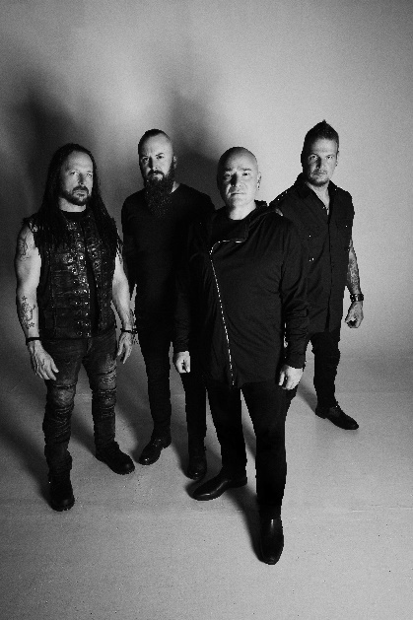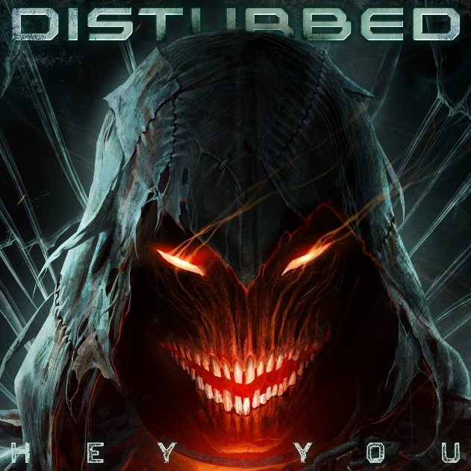
High-res assets available here

August 22, 2022 (Los Angeles, CA) – Continuing on their monumental career, multi-platinum rock band Disturbed have just scored their 15th #1 single at Rock Radio with latest release “Hey You.” The chart-topping single – which follows the footsteps of previous #1 hits “The Sound of Silence,” “Stricken,” “Indestructible,” and many more – heralds the arrival of the band’s new album coming later this year. Listen to “Hey You” here and watch the video here.
The achievement arrives on the heels of several recent RIAA certifications across Disturbed’s catalog, including Indestructible (2018) which was just certified 2X Multi-Platinum, as well as several songs, including “Down With The Sickness” (6X Multi-Platinum Digital Single) “The Sound of Silence” (7X Multi-Platinum Digital Single), “Stupify” (Gold & Platinum Digital Single), “Stricken” (2X Platinum & Multi-Platinum Digital Single), “Inside The Fire” (Platinum) and “Land of Confusion” (Gold & Platinum Digital Single).
Disturbed are performing at several upcoming festivals throughout this fall (full dates below). Tickets for all dates are available here.
Disturbed, the multiplatinum-selling quartet, accomplished the rare feat of achieving five consecutive number one debuts on the Billboard Top 200. That accolade historically elevated them to rarified air alongside Metallica, the only other hard rock group to do so in the history of the chart. Immortalized (2015) received a platinum certification and spawned the 7X platinum crossover smash “The Sound of Silence,” which garnered a nomination at the 2017 GRAMMY® Awards in the category of “Best Rock Performance.” Since their formation in 1996, the band has sold 16 million albums globally. Their 5X platinum 2000 debut, The Sickness, formally announced their arrival as hard rock leaders, with that status solidified by subsequent GRAMMY® Award nominations as well as gold-, platinum- and double platinum-certified records, as well as countless sold-out shows around the globe. Named “Best Rock Artist” during the 2017 iHeartRadioMusic Awards, Disturbed continue to boldly forge ahead and are currently working on the follow up to their aptly titled seventh offering, Evolution.

Disturbed Upcoming Tour Dates
September 11 - Blue Ridge Rock Festival - Alton, VA
September 15 - OC Bikefest - Ocean City, MD
September 22 - 99.7 The Blitz's Great Summer Smokeout - Columbus, OH
September 24 - 101.1 WRIF's Riff Fest - Detroit, MI

###

FOLLOW DUSTURBED:
Website | Facebook | Twitter | Instagram | Youtube

For more information, please contact:
Patrice Compere – Patrice.Compere@warnerrecords.com
Mary Moyer – Mary@qprime.com
Emilio Herce – Emilio@qprime.com

