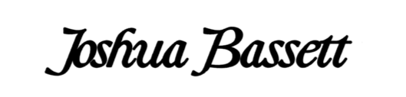

JOSHUA BASSETT RELEASES A BITTERSWEET NEW SINGLE “SMOKE SLOW” – WATCH VIDEO HERE

PLAYING SOLD OUT SHOWS THIS FALL IN NEW YORK,
LOS ANGELES, AND TORONTO

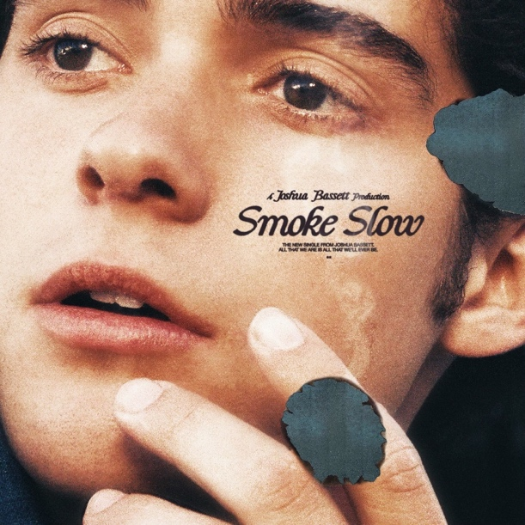

August 12, 2022 (Los Angeles, CA) – Singer, songwriter, and actor Joshua Bassett returns with the emotional new single “Smoke Slow.” Vulnerable and bare, the track delicately details the woes of an out-of-reach romance. Listen HERE via Warner Records. The raw introspection and bittersweet lyrics power the pensive video, which features Michael Cimino (Love, Victor) and Ilia Wayans, and was co-directed by Mikey Murphy and Bassett. Watch HERE.

About the song, Bassett explains, “This song is about savoring those moments together with a person you feel close to, but know you can’t be with. Since I couldn’t say it aloud, of course, I had to write a song about it – ha!”

In the song, Bassett croons over softly picked guitar on the gut-wrenching chorus. “All that we are is all that we’ll ever be, ‘cause he’s the one waiting at home,” “Next to you, but I'll never be close, so take your time while you're mine and smoke slow.”

“Smoke Slow” is destined to be a highlight on Bassett’s forthcoming live shows this year and next. The rising star’s first live dates will kick off in Toronto on September 9 before playing a two-night stand at Bowery Ballroom in New York on September 12th and 13th. He will also headline two nights at The Troubadour in Los Angeles on October 16th and 17th. Find all show dates below and HERE.

“Smoke Slow” follows “Doppelgänger,” another deeply emotional song, for which Bassett also co-directed the video. Earlier this year, Bassett also made his feature film debut in Disney+’s Better Nate Than Ever. He is currently starring in Season 3 of the hit Disney+ original series High School Musical: The Musical: The Series. He took home the 2022 Kids’ Choice Award for Favorite Kids Male TV Star for his role as Ricky. Earlier this week, Bassett was named on Variety’s 2022 Power Of Young Hollywood Impact List.

The multi-talented artist is building on the momentum he started in 2021 with the critically acclaimed “Crisis / Secret / Set Me Free.” The three songs raised money for mental health organizations, which included a $20K donation from Bassett himself. Those songs, along with gems like “Feel Something” and his self-titled debut EP helped bring Bassett’s total global streams to over 332 million.

With “Smoke Slow,” Bassett establishes himself as a singer-songwriter with a knack for crafting painstakingly honest lyrics and unforgettable melodies that simply need to be heard, over and over again.

TOUR DATES:
September 9 – Toronto, ON – Axis Lounge – SOLD OUT
September 12 – New York, NY – Bowery Ballroom – SOLD OUT
September 13 – New York, NY – Bowery Ballroom – SOLD OUT
October 16 – Los Angeles, CA – The Troubadour – SOLD OUT *rescheduled
October 17 – Los Angeles, CA – The Troubadour – SOLD OUT *rescheduled

###

FOLLOW JOSHUA BASSETT:
TikTok | Instagram | Twitter | Facebook | YouTube | Press Materials

For more information, please contact:

Darren Baber | Warner Records
Darren.Baber@warnerrecords.com

Regional: Jenny Huynh | Warner Records
Jenny.Huynh@warnerrecords.com

Alex Kahn | Relevant
akahn@relevant-pr.com

Veronica Plohoros | Relevant
Veronica@relevant-pr.com

