LILYISTHATYOU RELEASES FIERY FEMALE EMPOWERMENT ANTHEM “COMPETITION” – LISTEN HERE

DEBUT EP THE CHARACTER OUT JULY 29 – PRE-SAVE HERE

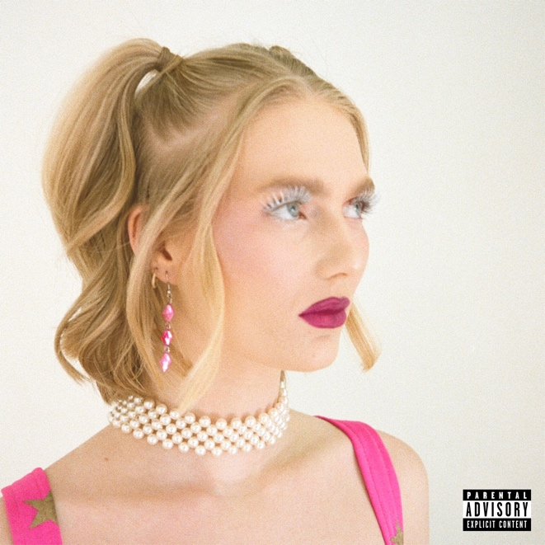

July 8, 2022 (Los Angeles, CA) – Today, rising pop artist Lilyisthatyou returns with the infectious new single “Competition.” Listen HERE via Warner Records. The woozy, danceable anthem is the perfect mixture of sexy and scandalous, allowing the 21-year-old provocateur to open up about the pressures faced by women in the music industry. “Competition” is the latest gem from her debut EP, The Character, due July 29. Pre-order it HERE.

On the feisty anthem, Lily opens up about her love/hate relationship with social media: “I can’t seem to find the meaning in the comments and the DMs / and I’d like to say I love it, but I’ve had just enough of it.” On the catchy chorus, she calls for solidarity. “I’m so sick of competition / uh-uh trying so damn hard to fit in,” the Canadian sings over slick synths. “I’m so sick of comparison, and you can’t tell me I ain’t a bad bitch and don’t you forget it.”

Lily reveals that the song was inspired by her frustration at the steep expectations and cruelty women often face in professional settings. “As a female artist, I think it’s vital I express how truly sick I am of countless industries pitting women against each other—whether it’s music, fashion, or beauty.” Instead, she calls for sisterhood. “We are all so fucking wonderful because we are unique. Embracing transparency and authenticity is the only way to move forward.”

“Competition” follows quickly on the heels of “Gorgeous Gorgeous Girls,” the singer’s call-to-arms for young, talented women everywhere to step up and help make the world a better place. It continued her hot streak of captivating singles including “ALL ABOUT ME,” “Moderation,” “Purity,” and “Party 22.” Her first-ever release in 2021 “FMRN” set the internet on fire to the tune of TikTok virality and garnered over 40 million global streams.

Lily is set to make her festival debut this fall at Austin City Limits in October and Corona Capital in Mexico City in November. With “Competition” and her upcoming The Character EP, Lily continues to deliver unforgettable music dripping with attitude.

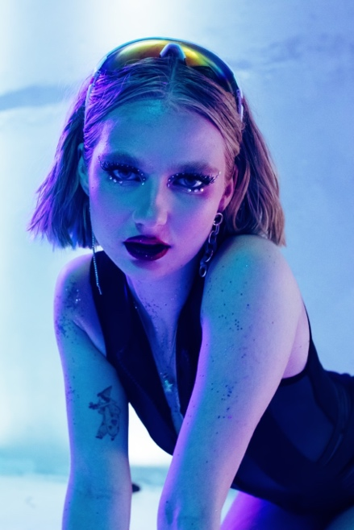
Photo credit: Daniel Barton

ABOUT LILYISTHATYOU:
Through her raw and vulnerable take on pop, Lilyisthatyou wants to be the role model she never had. Thanks to defiant, vibrant anthems like “FMRN” (a.k.a. “Fuck Me Right Now”) the 21-year-old has already established herself as a pop singer without parallel, tackling topics others won't—sex, addiction, shame—without preaching or posturing, in order to reach listeners where they are. While she employs all sorts of sounds across her diverse pop songs, she’s committed to making dynamic female-first party anthems. And on her single, “Party 22,” the freshly minted hitmaker takes a moment to let her hair down. “Party 22” follows the breakout “FMRN,” which has amassed more than 40 million global streams so far. The sex-positive, synth-heavy hit made headlines when it took off on TikTok, then was promptly removed from the platform in July, which only helped spread the song further. Lily’s frankness and confidence—which date back to a childhood of talent shows and home recording—connected with listeners, which strengthened her resolve to be completely transparent. She continues the discourse on her other singles like anti-slut-shaming anthem “Purity” and the addiction-tackling “Moderation.” Her attitude and magnetic personality ensure a common thread runs through her songs, no matter the sound. “There’s an empowered and confident woman singing to you on every track,” Lily says. “I couldn’t identify with any pop star as a teen. I'm still fighting for 15-year-old me.” With recent anthems like “ALL ABOUT ME” and “Gorgeous Gorgeous Girls,” as well as much more new music on the horizon, Davies has her eyes set on being the artist she needed when she was younger.

FOLLOW LILYISTHATYOU:
Twitter | Instagram | Spotify | YouTube | TikTok

For more information, please contact:
Darren Baber | Darren.Baber@warnerrecords.com
Ceri Roberts | Ceri.Roberts@warnerrecords.com

