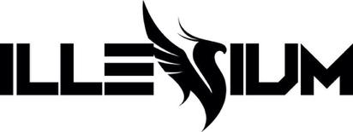

ILLENIUM AND TEDDY SWIMS TEAM FOR UPLIFTING NEW SINGLE “ALL THAT REALLY MATTERS” – WATCH VIDEO HERE

TICKETS ON SALE FOR EMBER SHORES FESTIVAL & TRILOGY: COLORADO NOW

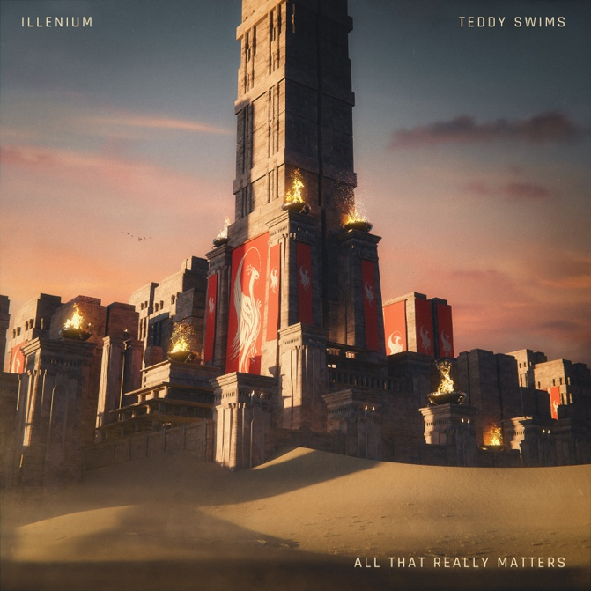

July 29, 2022 (Los Angeles, CA) – Today, GRAMMY® Award-nominated artist/producer ILLENIUM shares his latest single, “All That Really Matters,” an emotional team-up with genre-blurring vocalist Teddy Swims. Listen HERE via Warner Records. With “All That Really Matters,” ILLENIUM delivers some sorely needed hope while continuing to cement himself as a visionary producer and a keen collaborator. Watch the video HERE.

Fans who watched ILLENIUM’s electrifying Bonnaroo set last month were treated to a special live preview of “All That Really Matters” — complete with a guest appearance from Swims. “This song means so much to me,” ILLENIUM says of the collaboration. “With all that’s going on in the world, it’s great to just take a step back and find what really matters. Teddy’s voice and performance take it to the next level.”

That sentiment is echoed by Swims. “This song is just a great reminder of what truly matters,” the Atlanta, GA native says. “With the world the way it is currently it’s easy to get caught up in all the distractions. The only thing that really matters is love. I’ve always been a fan of ILLENIUM so it’s an honor to do a song with him!”

“All That Really Matters” follows FALLEN EMBERS (Remixes), a remix companion to ILLENIUM’s 2021 LP FALLEN EMBERS, which earned him a Billboard Music Award for Top Dance/Electronic Album and garnered his first GRAMMY® Award nomination for Best Dance/Electronic Album. The producer has also been on a collaborative tear, linking with artists from vastly different musical realms, including heavy metal band Spiritbox (“Shivering”), rappers Sueco and Trippie Redd (“Story of My Life”), and Thirty Seconds to Mars (“Wouldn’t Change A Thing”).

Teddy Swims is becoming a powerhouse in his own right. The singer/songwriter’s career skyrocketed in 2019 through his YouTube covers, which garnered hundreds of millions of views, before signing with Warner Records and stealing fans’ hearts with his original songs. Following 2021’s Unlearning EP and 2022’s Tough Love EP, as well as recent features on Meghan Trainor’s new single “Bad For Me” and MK, BURNS’ “Better,” he will soon embark on his sold out Australia/New Zealand tour, followed by a US Fall Tour — find tour dates HERE.

Last week, ILLENIUM announced the biggest show of his career Trilogy: Colorado at Empower Field at Mile High in Denver, CO on Saturday, June 17, 2023 for three unique sets over one night – tickets are on sale HERE. ILLENIUM recently headlined Hangout Music Festival and EDC Las Vegas, as well as staging a two-day takeover of the Gorge Amphitheatre and a Bonnaroo appearance. Upcoming festival performances this year include Outside Lands, North Coast, and more. He also has an ongoing Vegas residency at OMNIA Nightclub and Tao Beach Dayclub. This December, ILLENIUM will bring his Ember Shores festival back to Cancun, Mexico, where he will perform alongside a specially curated lineup – buy tickets HERE. More tour dates are listed below.

ILLENIUM’s total career streams have now eclipsed over 5 billion. With “All That Really Matters” and more music on the horizon, ILLENIUM cements his status as one of dance music’s most innovative and audacious producers.

ILLENIUM TOUR DATES:
Aug 5 – 6 – Breakaway Music Festival – Bonner Springs, KS
Aug 5 – 7 – Outside Lands – San Francisco, CA
Sep 3 – North Coast Music Festival – Bridgeview, IL
Dec 2 – 4 – Ember Shores Festival – Cancun, Mexico
Jun 17, 2023 – Trilogy: Colorado – Denver, CO

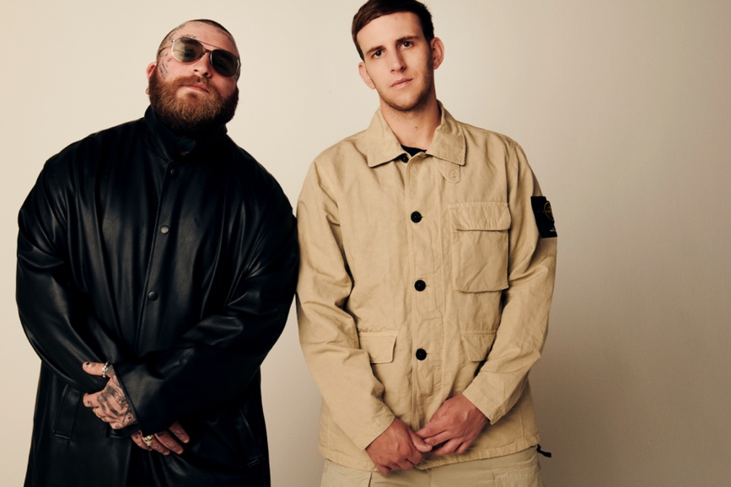
Photo credit: Lyndsey Byrnes

Follow ILLENIUM:
Official | Instagram | Twitter | TikTok | YouTube | Press Materials

Follow Teddy Swims:
Official | Twitter | Instagram | TikTok | YouTube | Press Materials

ILLENIUM & Teddy Swims Contacts:
Darren Baber | Warner Records
Darren.Baber@warnerrecords.com

Regional: Jenny Huynh | Warner Records
Jenny.Huynh@warnerrecords.com

