LILYISTHATYOU RELEASES WILD AND EMPOWERING DEBUT EP THE CHARACTER – LISTEN HERE

WATCH THE VIDEO FOR “BAD ENERGY” HERE

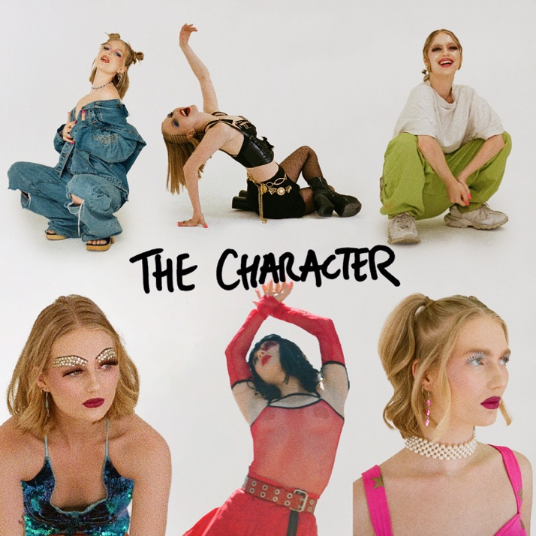

July 29, 2022 (Los Angeles, CA) – Today, breakout pop star Lilyisthatyou unveils her major-label debut EP, The Character. Listen HERE via Warner Records. The 6-track set finds the rising artist at her most ferocious and free. It includes her previously released viral breakout “FMRN,” as well as her infectious singles “Competition” and “Gorgeous Gorgeous Girls,” plus new songs: “Bad Energy,” “LSD,” and “For Eve.” Watch the video for “Bad Energy” HERE.

On The Character, Lily delivers a fresh batch of gems that explore issues she is passionate about such as toxicity between women (“Competition”) or the need to address the climate crisis (“Gorgeous Gorgeous Girls”). The EP also embraces Lily’s love of all things defiant and wild. Take the club-ready number, “Bad Energy.” “When I wake up in the morning, I feel like Kanye,” she sings. “Call me Buffy baby, all I do is slay.”

“‘Bad Energy’ is my bad bitch reminder,” Lily says of the audacious new track. “But at the same time, it’s a song about being grateful for what you already have instead of letting the negative energy the world sometimes holds, affect you.” She is equally outrageous on “LSD.” “It’s a story about a time my boyfriend and I ‘accidentally’ did acid at his house,” the newcomer reveals, “We laughed ‘til we cried, and I saw snowflakes in his eyes.”

On The Character, the 21-year-old underlines her desire to remain undefinable: “In my world, I want to play as many characters as I can and explore all the possibilities of my music sonically, conceptually, and visually.” Her ultimate goal is to empower and inspire. “I want to take control and relish what it means to be an artist of this generation,” she says. “I want to help my fans live and deeply express themselves through all the pain and pleasure that is now.”

Lily is set to make her festival debut this fall at Austin City Limits in October and Corona Capital in Mexico City in November. With live shows and the release of The Character, Lilyisthatyou establishes herself as one of pop music’s most singular stars and introduces the world to the many facets of her artistry.

Photo credit: Daniel Barton

ABOUT LILYISTHATYOU:
Through her raw and vulnerable take on pop, Lilyisthatyou wants to be the role model she never had. Thanks to defiant, vibrant anthems like “FMRN” (a.k.a. “Fuck Me Right Now”) the 21-year-old has already established herself as a pop singer without parallel, tackling topics others won't—sex, addiction, shame—without preaching or posturing, in order to reach listeners where they are. While she employs all sorts of sounds across her diverse pop songs, she’s committed to making dynamic female-first party anthems. And on her single, “Party 22,” the freshly minted hitmaker takes a moment to let her hair down. “Party 22” follows the breakout “FMRN,” which has amassed more than 40 million global streams so far. The sex-positive, synth-heavy hit made headlines when it took off on TikTok, then was promptly removed from the platform in July, which only helped spread the song further. Lily’s frankness and confidence—which date back to a childhood of talent shows and home recording—connected with listeners, which strengthened her resolve to be completely transparent. She continues the discourse on her other singles like anti-slut-shaming anthem “Purity” and the addiction-tackling “Moderation.” Her attitude and magnetic personality ensure a common thread runs through her songs, no matter the sound. “There’s an empowered and confident woman singing to you on every track,” Lily says. “I couldn’t identify with any pop star as a teen. I'm still fighting for 15-year-old me.” With recent anthems like “ALL ABOUT ME” and “Gorgeous Gorgeous Girls,” as well as much more new music on the horizon, Davies has her eyes set on being the artist she needed when she was younger.

FOLLOW LILYISTHATYOU:
Twitter | Instagram | Spotify | YouTube | TikTok

For more information, please contact:
Darren Baber | Darren.Baber@warnerrecords.com
Ceri Roberts | Ceri.Roberts@warnerrecords.com

