GRAMMY- WINNING “RÜFÜS DU SOL” ENLIST ANYMA, CARLITA, CASSIAN, MAGDALENA & MORE FOR “SURRENDER REMIXES”

LISTEN TO ADRIATIQUE’S REMIX OF “ON MY KNEES” OUT NOW
PRE-SAVE HERE

“SURRENDER REMIXES” TO BE RELEASED AUGUST 12th VIA ROSE AVE / REPRISE & WARNER RECORDS
PRE-ORDER HERE

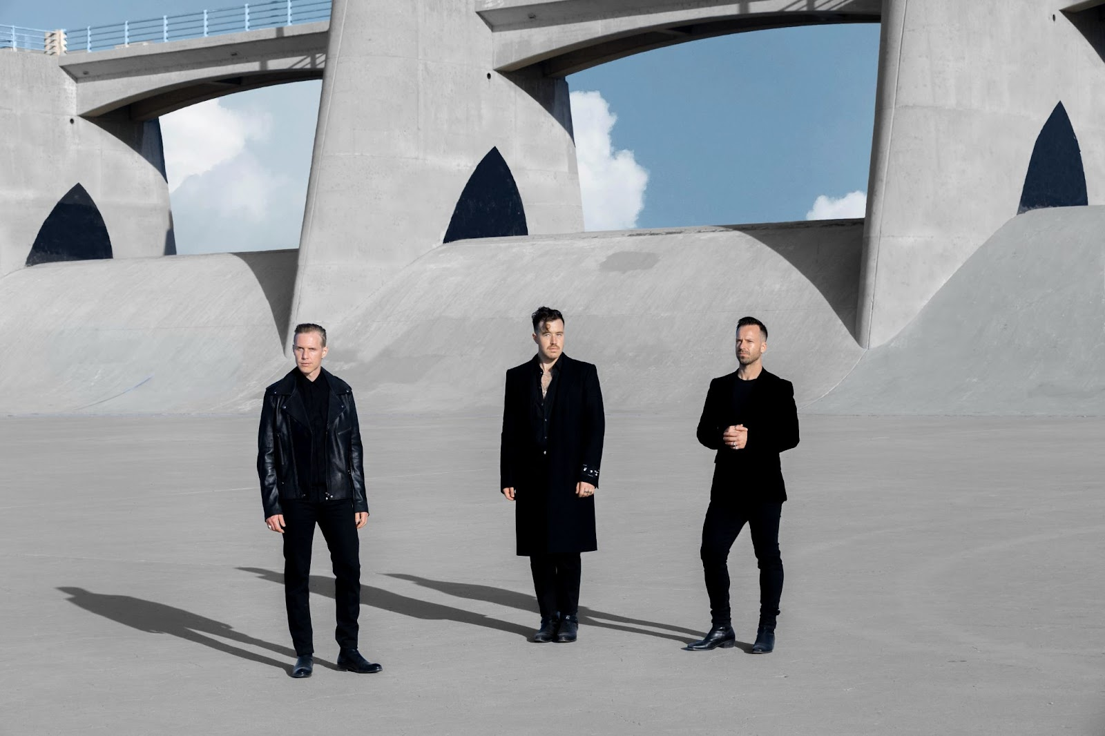

July 29, 2022 – (Los Angeles, CA ) - Grammy-winning live electronic trio James Hunt, Tyrone Lindqvist and Jon George aka RÜFÜS DU SOL announce the forthcoming release of their new curation project, “Surrender Remixes”. Set for release on August 12th via their imprint Rose Ave/Reprise and Warner Records, the band have enlisted a heavyweight assembly of world-class production talent, and friends and peers from across the spectrum of the electronic underground, to reimagine their landmark fourth studio album, “Surrender”. Pre-order the album HERE.

Released in October 2021 and featuring Grammy-winning single ‘Alive’, “Surrender” was written in the band’s studio in Hollywood. Citing Nine Inch Nails, Moderat and Radiohead as just a few of the myriad and eclectic sonic influences informing their production techniques on the record, the result was bold, brave and their most celebrated release to date. The LP has already been streamed over 1.5BN times, premiering as the #4 most popular album on Spotify in the US and #6 globally and #1 dance album on iTunes and Apple Music.

The first drop from the fourteen track “Surrender Remixes” released today, comes from Swiss production duo and CircoLoco residents Adrian Shala and Adrian Schweizr aka Adriatique. The duo step up to remix “On My Knees”, one of the standout moments from the album - a brooding insight into RÜFÜS DU SOL’s darker tendencies, which toys with honest emotions and aching lyricism, demonstrating what makes the band so unique in the electronic space. Adriatique’s remix is typically intricate, reflecting the duo’s trademark sets; long and meditative, with a relentlessly hypnotic groove throughout. Listen HERE.

The greater project features cuts from Istanbul’s hotly-tipped selector Carlita, Dynamic head-honcho Solomun and label mainstay Magdalena, the band’s longtime collaborator, Rose Ave label-mate and mix engineer Cassian and fellow Australian production talent Dom Dolla. Tale of Us’s Anyma steps up to remix the band’s track “Alive”, which won the band their first Grammy last year, along with stellar reworks from Afterlife resident Colyn, AnjunaDeep’s Monkey Safari, Adana Twins and more.

In this landmark year which has seen so many return to touring, RÜFÜS DU SOL have played a string of critically lauded and momentous live shows, including two recent sold out shows at New York’s Forest Hills Stadium. This July and August the band are heading back to their underground roots to play a select string of sets in some of clubland’s most coveted and notorious dancefloor slots - including DC10 for CircoLoco, Hi Ibiza for Afterlife opening an Scorpios Mykonos. Earlier this year the band also curated their own festival experience Sundream Tulum which saw them combine their live shows and DJ sets and invite some of the compilation collaborators - Magdalena, Carlita and Cassian - to join them in sublime Mexico settings. The band’s stacked summer schedule of shows will be a prime opportunity to unleash the full remix package next month.

We're so excited to have curated this collection of tracks geared for the dancefloor from artists we love and respect from around the world. Hearing these amazing artists all breathe new life into our music in their own ways is such a treat for us. We’ve been road-testing these in our DJ sets all year, they’ve been going off. Sad to let go of some of our secret weapons but we can’t wait for everyone to hear the full fourteen tracks. RÜFÜS DU SOL

“RÜFÜS DU SOL” SURRENDER REMIXES // TRACKLIST

Disc 1

1. Next to Me - Vintage Culture Remix
2. Make It Happen - Dom Dolla Remix
3. See You Again - Carlita Remix
4. I Don’t Wanna Leave - Innellea Remix
5. Alive - Anyma Remix
6. On My Knees - Adriatique Remix
7. Wildfire - Colyn Remix
8. Surrender feat. Curtis Harding - Magdalena Remix
9. Devotion - Luke Alessi Remix
10. Always - Monkey Safari Remix

Disc 2

1. Next to Me - Adana Twins ‘A Night At Revolver’ Version
2. Alive - Solomun Remix
3. On My Knees - Cassian Remix
4. On My Knees - Oliver Schories Remix

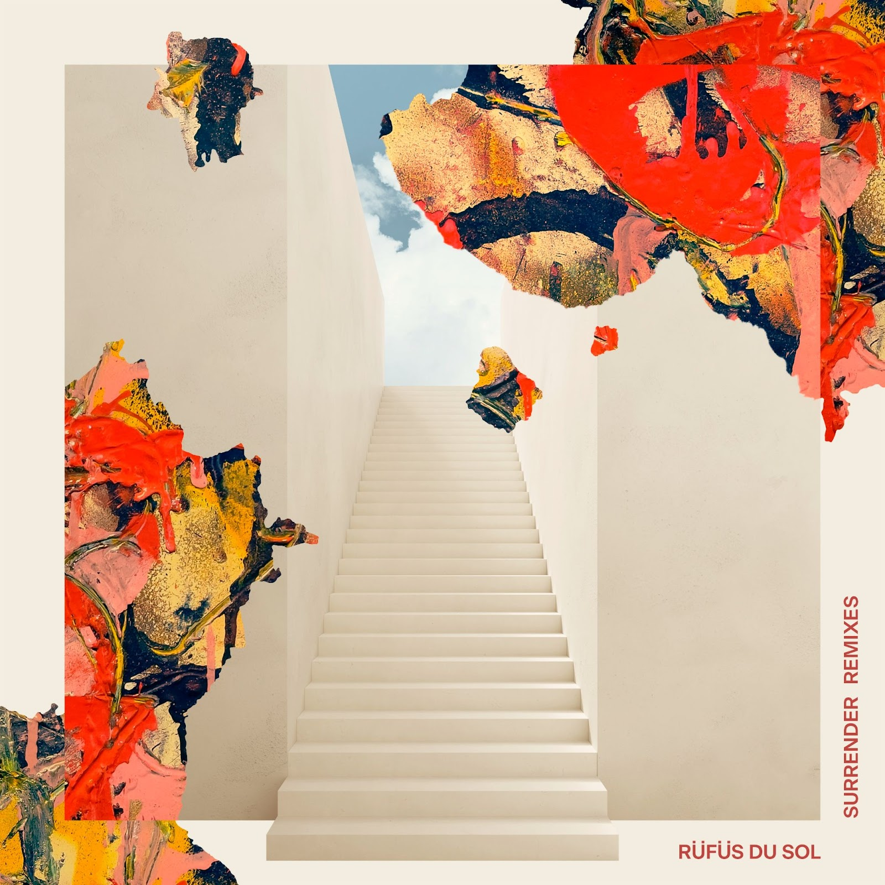

RÜFÜS DU SOL TOUR DATES JULY & AUGUST

JULY 7TH - HI IBIZA, IBIZA SPAIN
JULY 9TH - STORA SUNDBY CASTLE, SWEDEN
JULY 14TH - INDIE BEACH CLUB, ST. TROPEZ, FRANCE
JULY 15TH - MOMENTO, MARBELLA, SPAIN
JULY 17TH - BRUNCH IN THE PARK, BARCELONA SPAIN
JULY 18TH - CIRCO LOCO @ DC10, IBIZA SPAIN
JULY 21ST - SCORPOIS, MYKONOS GREECE
JULY 28TH - SCORPOIS, MYKONOS GREECE
AUGUST 10TH - SZIGET FESTIVAL, BUDAPEST HUNGARY
AUGUST 11TH - FEST FESTIVAL, CHORZOW POLAND
AUGUST 12TH - GASOMETER, VIENNA AUSTRIA
AUGUST 13TH - FORUM KARLIN, PRAGUE CZECH REPUBLIC
AUGUST 14TH - SHELLONA, ST TROPEZ FRANCE
AUGUST 17TH - FALCONER HALL, COPENHAGEN DENMARK
AUGUST 19TH - PUKKELPOP FESTIVAL, HASSELT BELGIUM
AUGUST 20TH - GUNNERSBURY PARK, LONDON UK
AUGUST 21ST - LOWLANDS FESTIVAL, BIDDINGHUIZEN NETHERLANDS
AUGUST 24TH - ZITADELLE, BERLIN GERMANY
AUGUST 25TH - PALLADIUM, COLOGNE GERMANY
AUGUST 26TH - ZURICH OPEN AIR FESTIVAL, OPFIKON SWITZERLAND
AUGUST 28TH - BEFORE SUNSET, CESME TURKEY
AUGUST 29TH - WAI BEACH CLUB, BODRUM TURKEY

FOLLOW RÜFÜS DU SOL
Official | Twitter | Instagram |Facebook | Spotify | YouTube | TikTok
For more information, please contact:
Darren Baber | Warner Records | Darren.Baber@warnerrecords.com
Max Frieser | Infamous PR | mfrieser@infamouspr.com

