GRAMMY-WINNING RÜFÜS DU SOL RELEASE SURRENDER REMIXES FEATURING MONKEY SAFARI, ANYMA, CARLITA, CASSIAN, MAGDALENA & MORE
LISTEN HERE

SURRENDER LP VINYL FEATURING GRAMMY AWARD-WINNING SONG “ALIVE” OUT SEPTEMBER 2ND - PRE-ORDER HERE

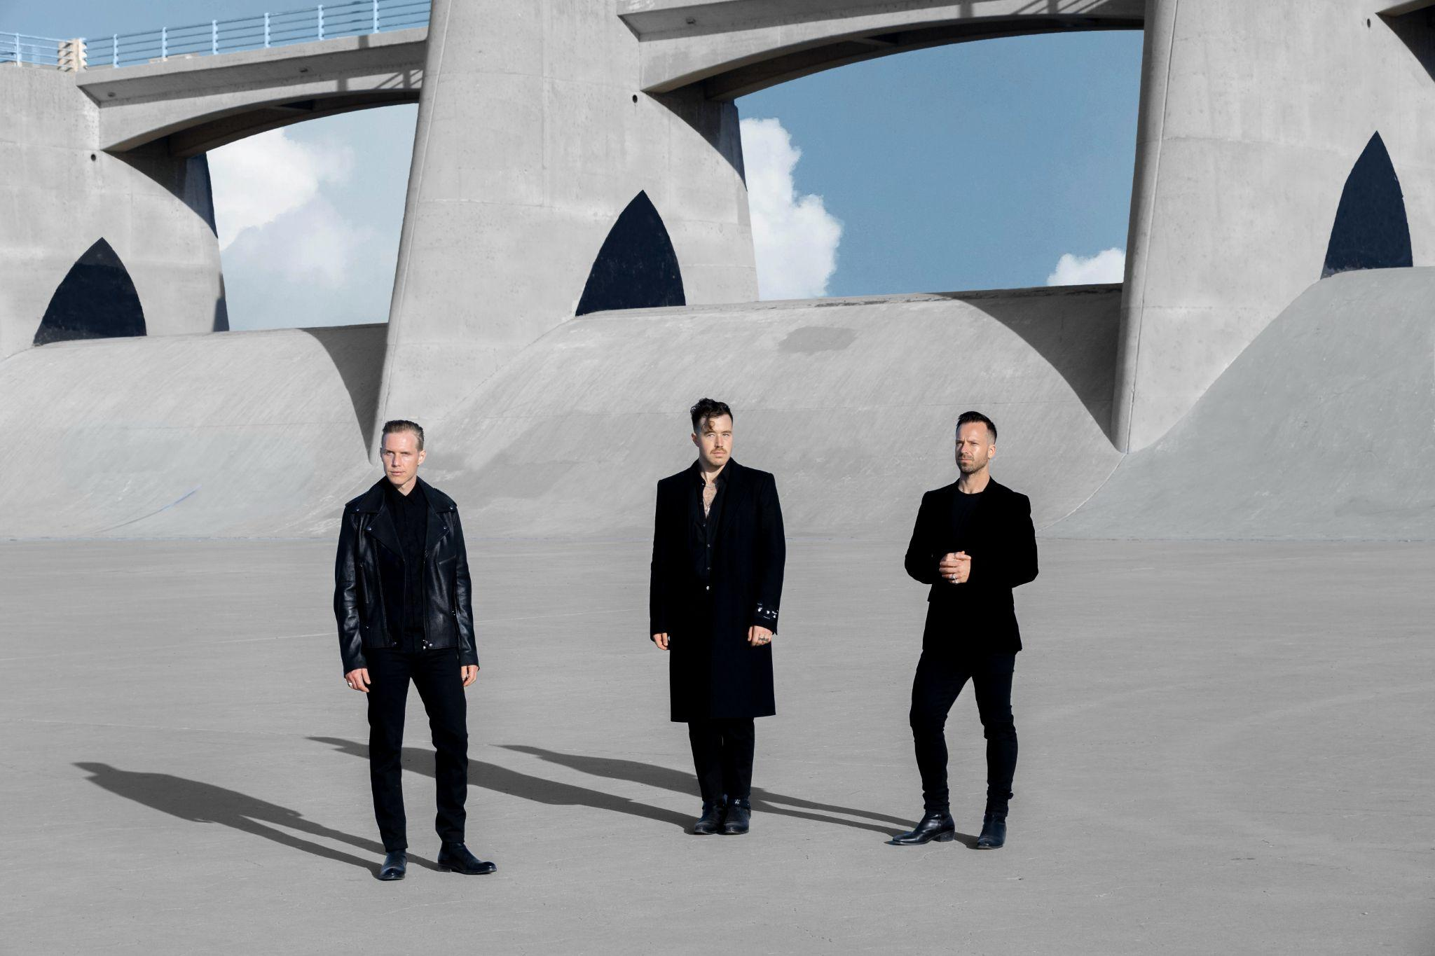

August 12, 2022 (Los Angeles, CA) - Today, Grammy-winning live electronic trio James Hunt, Tyrone Lindqvist and Jon George aka RÜFÜS DU SOL release their new curation project, Surrender Remixes. Released on their own Rose Ave/Reprise and Warner Records, the band have enlisted a heavyweight assembly of world-class production talent featuring friends and peers from across the spectrum of the electronic underground, to reimagine their landmark fourth studio album, Surrender.

Stream and Download Surrender Remixes HERE

Released in October 2021 and featuring Grammy-winning single “Alive,” Surrender was written in the band’s studio in Hollywood. Citing Nine Inch Nails, Moderat and Radiohead as just a few of the myriad and eclectic sonic influences informing their production techniques on the record, the result was bold, brave and their most celebrated release to date. The LP has already been streamed over 1.5B times, premiering as the #4 most popular album on Spotify in the US and #6 globally and #1 dance album on iTunes and Apple Music.

The greater project features key cuts from German melodic techno icons Monkey Safari, Istanbul’s hotly-tipped selector Carlita, Diymanic head-honcho Solomun and label mainstay Magdalena, the band’s longtime collaborator, Rose Ave label-mate and mix engineer Cassian and fellow Australian production talent Dom Dolla. Tale of Us’ Anyma steps up to remix the band’s track “Alive,” which won the band their first Grammy last year, along with stellar reworks from Afterlife resident Colyn, Adana Twins and more. Swiss production duo and CircoLoco residents Adrian Shala and Adrian Schweizr aka Adriatique remixed “On My Knees,” which was previously released on July 2nd and has already seen key club support from the Keinemusik crew and Camelphat.

In RÜFÜS DU SOL’s own words, “We're so excited to have curated this collection of tracks geared for the dancefloor from artists we love and respect from around the world. Hearing these amazing artists all breathe new life into our music in their own ways is such a treat for us. We’ve been road-testing these in our DJ sets all year, they’ve been going off. Sad to let go of some of our secret weapons, but we can’t wait for everyone to hear the full fourteen tracks.”

The band have also released the pre-order for the long-awaited vinyl pack of Surrender. A double disc set pressed on dramatic red wax, the package includes exclusive liner notes and single artwork sure to excite collectors and fans alike. Pre-order HERE.

As a continuation of RÜFÜS’ ethos of creating immersive worlds for their fans to explore, the band have launched a fun AR experience for fans to enjoy alongside this wave of news. Explore it now with a smartphone or tablet HERE.

In this landmark year which has seen so many return to touring, RÜFÜS DU SOL have played a string of critically lauded and momentous live shows, including two recent sold out shows at New York’s Forest Hills Stadium. This summer, the band are heading back to their underground roots to play a select string of sets in some of clubland’s most coveted and notorious dancefloor slots - including DC10 for CircoLoco, Hi Ibiza for Afterlife opening and Scorpios Mykonos. Following their European triumph, the band will return to the US to take over key venues like Los Angeles’ Hollywood Bowl, Colorado’s Red Rocks Amphitheatre, and Washington’s The Gorge Amphitheatre before bringing their iconic live-show back to the homeland for a run of dates across Australia.

RÜFÜS DU SOL SURRENDER REMIXES // TRACKLIST

Disc 1

1. Next to Me - Vintage Culture Remix
2. Make It Happen - Dom Dolla Remix
3. See You Again - Carlita Remix
4. I Don’t Wanna Leave - Innellea Remix
5. Alive - Anyma Remix
6. On My Knees - Adriatique Remix
7. Wildfire - Colyn Remix
8. Surrender feat. Curtis Harding - Magdalena Remix
9. Devotion - Luke Alessi Remix
10. Always - Monkey Safari Remix

Disc 2

1. Next to Me - Adana Twins ‘A Night At Revolver’ Version
2. Alive - Solomun Remix
3. On My Knees - Cassian Remix
4. On My Knees - Oliver Schories Remix

RÜFÜS DU SOL US TOUR DATES
SEP 22 GERMANIA INSURANCE AMPHITHEATER - DEL VALLE, TX
SEP 24 FORMAT FESTIVAL - BENTONVILLE, AR
SEP 27 ARMORY - MINNEAPOLIS, MN
SEP 30 FORD IDAHO CENTER AMPHITHEATER - NAMPA, ID
OCT 01 GORGE AMPHITHEATRE - GEORGE, WA
OCT 02 HAYDEN HOMES AMPHITHEATER - BEND, OR
OCT 05 NORTH ISLAND CREDIT UNION AMPHITHEATRE - CHULA VISTA, CA
OCT 07 SHORELINE AMPHITHEATER - MOUNTAIN VIEW, CA
OCT 08 SANTA BARBARA BOWL - SANTA BARBARA, CA
OCT 09 HOLLYWOOD BOWL - LOS ANGELES, CA
OCT 13 MAVERIK CENTER - WEST VALLEY CITY, UT
OCT 15 RED ROCKS AMPHITHEATER** - MORRISON, CO
OCT 16 RED ROCKS AMPHITHEATER** - MORRISON, CO
OCT 18 SAINT LOUIS MUSIC PARK - MARYLAND HEIGHTS, MO
OCT 20 ASCEND AMPHITHEATER - NASHVILLE, TN
OCT 21 MERIS BANK AMPHITHEATRE - ALPHARETTA, GA
OCT 22 ORLANDO AMPHITHEATER - ORLANDO, FL
OCT 23 FPL SOLAR AMPHITHEATER AT BAYFRONT PARK - MIAMI, FL

Follow RÜFÜS DU SOL
Website | Facebook | Instagram | Twitter | Spotify | SoundCloud | TikTok

For more information, please contact:
Darren Baber | Warner Records | Darren.Baber@warnerrecords.com
Max Frieser | Infamous PR | mfrieser@infamouspr.com

