EMBARGOED UNTIL AUGUST 18, 9:00PM PT
LUKAS GRAHAM RETURNS WITH NEW SINGLE “WISH YOU WERE HERE” FEATURING KHALID
LISTEN HERE
CO-WRITTEN WITH RYAN TEDDER
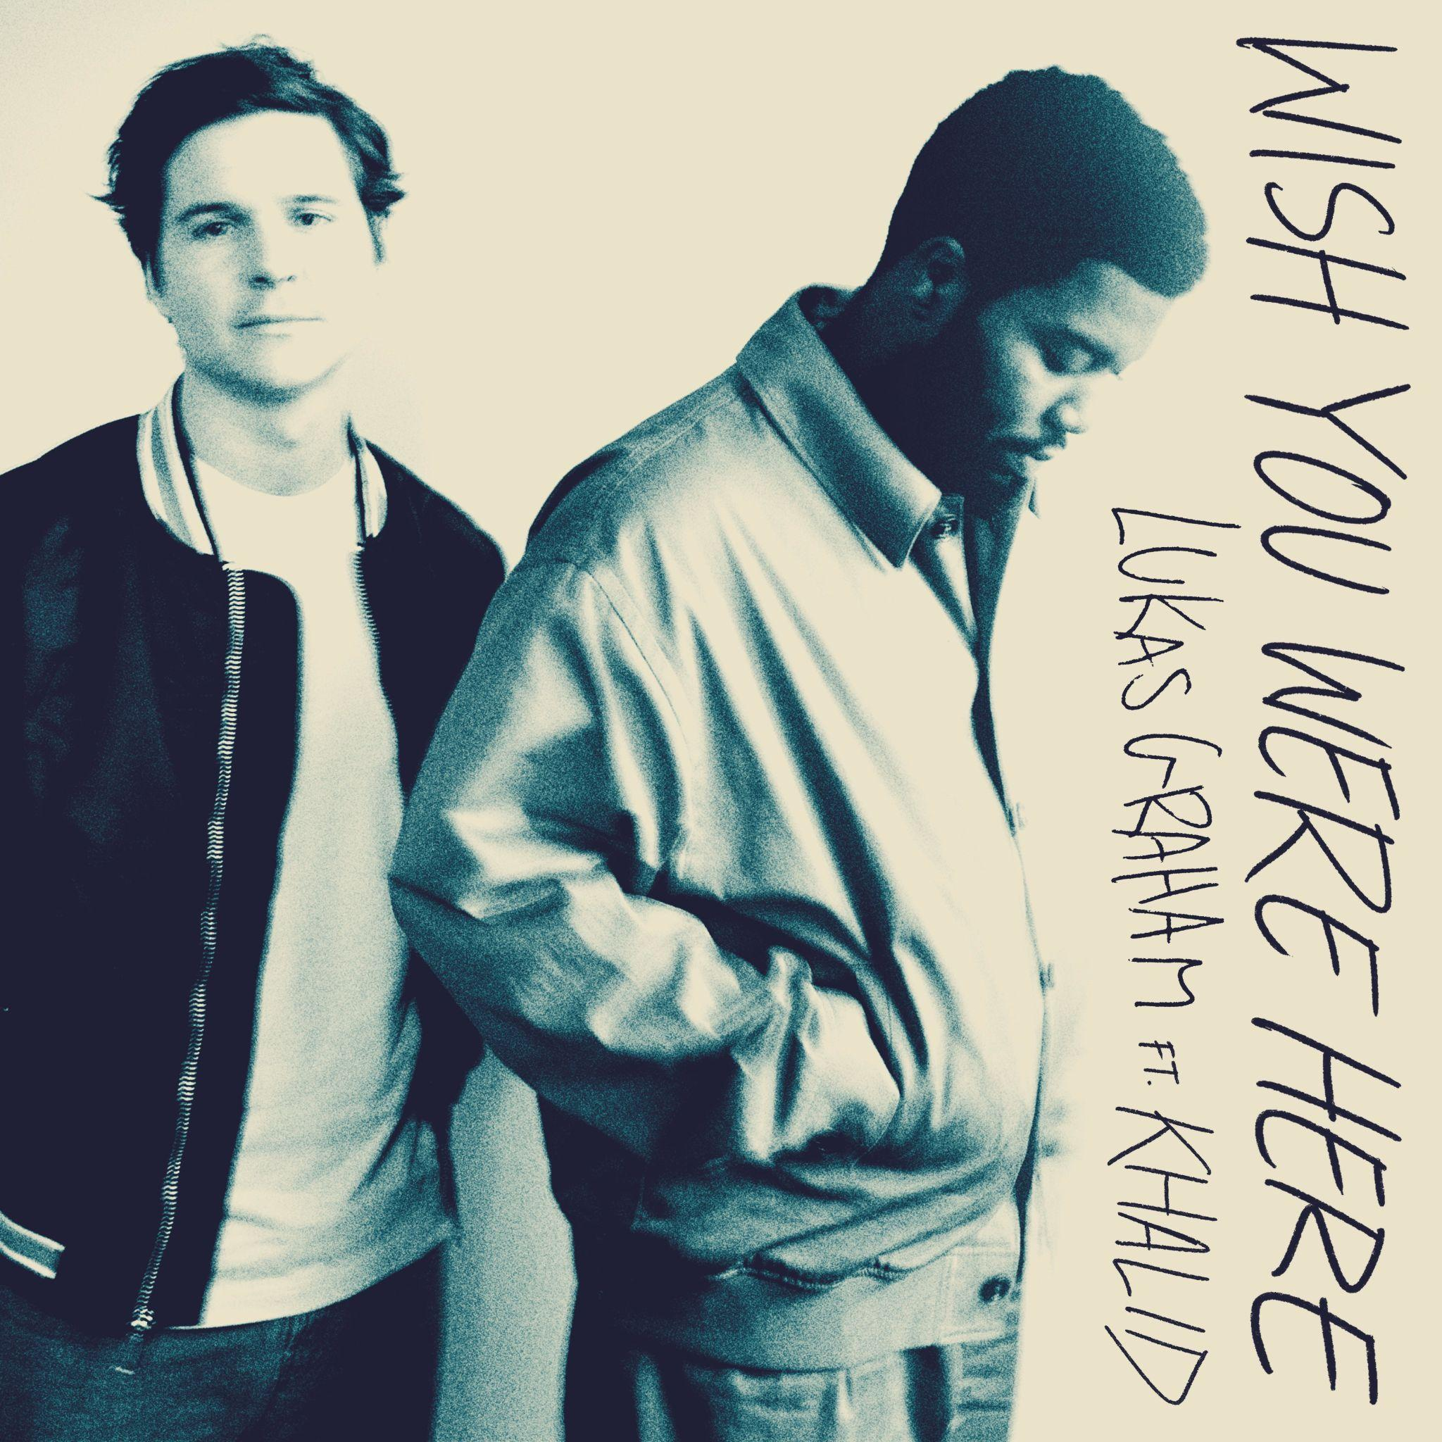

August 19, 2022 (Los Angeles, CA) – GRAMMY® Award-nominated multi-platinum artist Lukas Graham shares a brand new single entitled “Wish You Were Here” [feat. Khalid] on Warner Records. It was notably co-written with Ryan Tedder. Listen to “Wish You Were Here” HERE.

Tambourine sets the tempo for the guitar-laden track as Lukas does a bit of reflecting. Khalid rolls through with a sunny and soaring appearance as cinematic piano uplifts the undeniable refrain, “After all this time and all these years, I wish you were here.”

About “Wish You Were Here,” Lukas stated, “‘Wish You Were Here’ is an anthem to the best friends. We all know the feeling of standing on the edge or the top of the world and missing someone special. It’s always at big events and special occasions that I miss those unique people in my life that made me who I am today.”

2022 marks seven years since Lukas Graham put his hometown of Christiania, Denmark on the map and enchanted and engaged audiences worldwide with a string of anthems that resonated around the world. With a soulful signature sound punctuated with pop relatability, his hit songs “7 Years” and “Love Someone” garnered him three GRAMMY® Award nominations, billions of streams and widespread critical acclaim as he also sold out shows across Europe, North America, and beyond. After enduring the loss of his father, becoming a father himself, and weathering the ups and downs of an unimaginable rise to fame, Lukas found himself stuck in a cycle, self-medicating and in a creative rut. In 2020, he made the decision to get sober and focus on his family and music. Returning to his songwriting roots, Lukas wrote in the same old rehearsal space, a 10-minute bike ride from his house in Copenhagen, crafting his new full-length offering coming in early 2023.

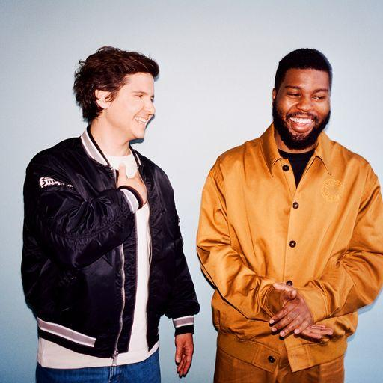

###

Follow Lukas Graham:
Website | Twitter | Facebook | Instagram | Press Site | TikTok

For further information on Lukas Graham, contact:
Jaime Rosenberg | BB Gun PR
Jaime@bbgunpr.com

Patrice Compere | Warner Records
Patrice.Compere@warnerrecords.com

