MULTIFACETED YDE CLINGS TO HOPE ON NEW SINGLE “PEOPLE CAN CHANGE”

LISTEN HERE / WATCH HERE

DEBUT EP SEND HELP COMING SOON – PRE-SAVE HERE

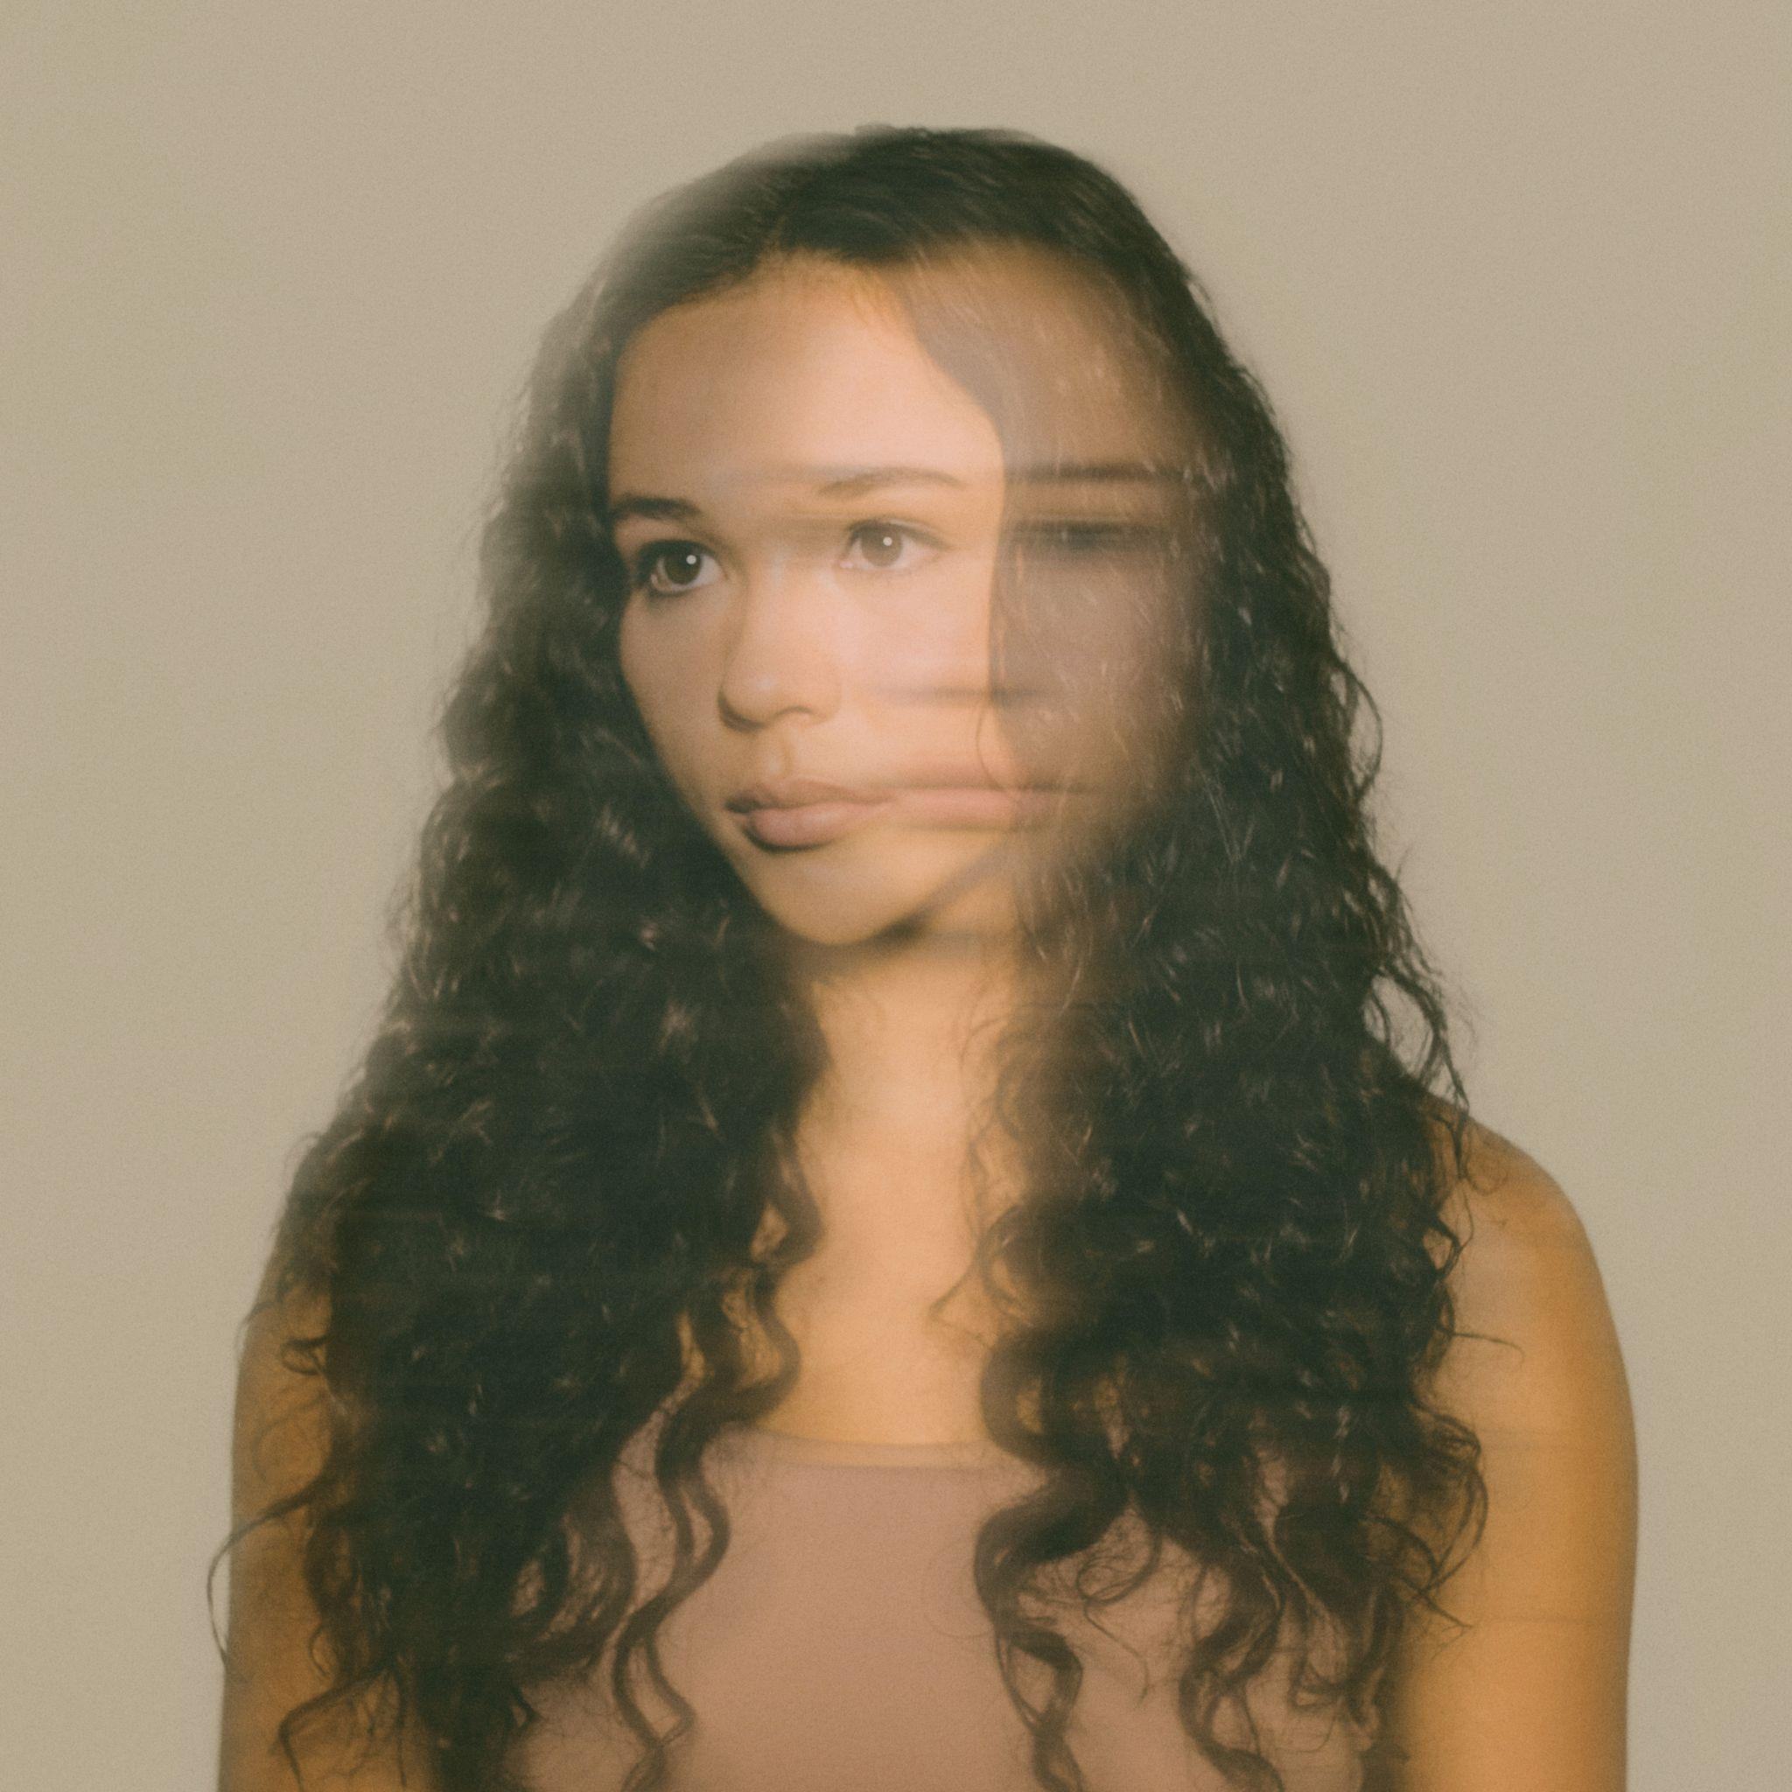

“YDE is a Voice for Her Generation” - PAPER
“YDE oozes confidence beyond her years” - Billboard

July 15, 2022 (Los Angeles, CA) – Today, multifarious storyteller YDE (​​pronounced EE-dee) reflects on the tumultuous state of the world on her moving new single, “People Can Change.” Listen HERE via Facet Records/Warner Records and watch the accompanying music video HERE. YDE’s call to action is presented as a stripped-back ballad, which is delicate in delivery but firm in its message. It’s the latest enthralling release from one of pop music’s most exciting new artists.

Beginning with swelling strings, “People Can Change” finds YDE coming to terms with crushing news stories and catastrophic world events atop acoustic guitar. She explains that it’s about maintaining optimism and figuring out the best way to trudge forward in hard times. “‘People Can Change’ is an honest conversation with myself about how I can maintain hope for the future,” YDE says. “We are facing immense division and only through conscious growth and change will we find our way through together.”

Each verse spotlights the repetitive trauma of preventable tragedy, from raging wildfires to senseless mass shootings. YDE calls out politicians — “we’ve been screamin’, we’ve been walkin’, hoping that they would do more than just talkin’” and then looks inward on the evocative chorus, focusing on what she can control. “I need to believe that people can change,” she sings. “Or else this life has all been in vain.” The accompanying music video perfectly reflects the song’s unflinching nature. There are no distractions: just a close-up shot of YDE, with raw emotions rippling across her tear-stained face as she confronts our harsh realities in real time.

“People Can Change” cements YDE’s ability to turn existential feelings into unifying pop songs. June’s piano-based, percussive “Old Her” captured the conflicting realization that adulthood has its own set of problems, including painstaking nostalgia for her childlike innocence.

With “People Can Change” and the impending arrival of YDE’s debut project titled SEND HELP, which she executive produced, the newcomer’s momentum is at an all-time high. YDE is in full control — making music with meaning and rare emotional resonance.

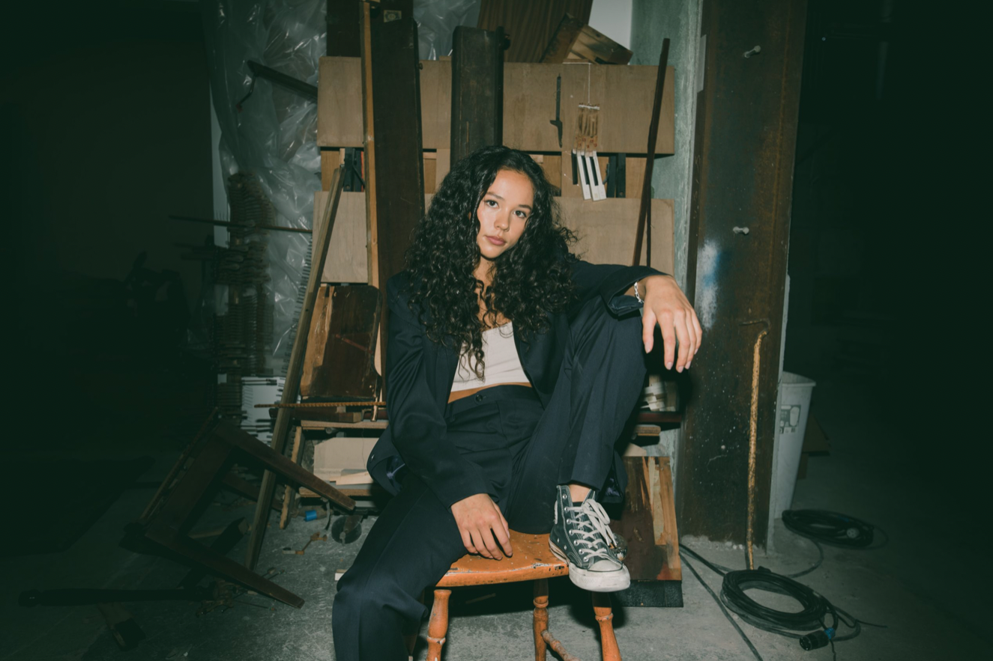
Credit: Jade DeRose
ABOUT YDE:
With razor-sharp lyrics about personal transformation, and her relationship with the future, YDE (EE-dee) writes catchy, alt-skewering pop songs about what it means to be human. Simultaneously humble and herculean the Australian-born, Filipino singer/songwriter dives even deeper into the human condition on her new single, “Old Her,” and upcoming project SEND HELP via Warner Records. “Ultimately, I really hope that people who need to hear my music, hear it,” YDE says. Born in Australia, Breanna, her real name, moved to the US with her parents as a toddler. YDE went on to land starring roles on Nickelodeon series, The Haunted Hathaways at the age of nine, and School of Rock, before landing on the Netflix Series, Malibu Rescue. Most recently, the multi-faceted artist starred in the live production of WILD: A Musical Becoming alongside Idina Menzel.

FOLLOW YDE:
Instagram | YouTube | TikTok | Press Website

For more information, please contact:
Darren Baber | Warner Records
Darren.Baber@warnerrecords.com

Connor Hunt | Warner Records
Connor.Hunt@warnerrecords.com

