ZACH BRYAN’S SUMMERTIME BLUES RIDES HIGH ON BILLBOARD CHARTS

COUNTRY STAR CELEBRATES WITH NEW TRACK
“TIL BROOKLYN”

WATCH VIDEO HERE

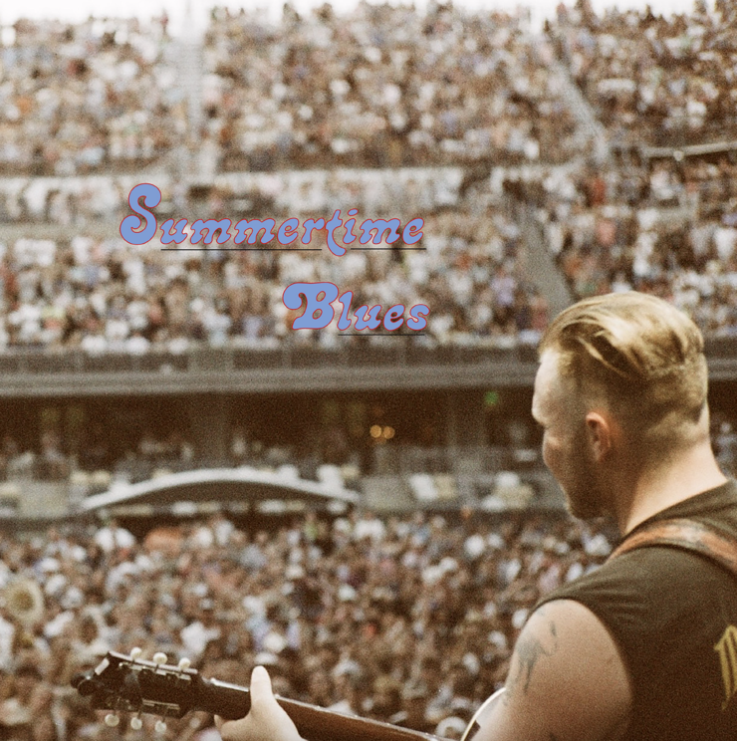
(Click HERE for Hi-Res cover art: photo by Louie Nice, designed by Zach Bryan)

August 1, 2022 (Los Angeles, CA) – Two months after releasing his modern classic AMERICAN HEARTBREAK, Oklahoma storyteller Zach Bryan cemented his reputation as a bonafide country superstar with the July release of SUMMERTIME BLUES, which has already made a huge impression on the Billboardcharts. Listen HERE via Warner Records. The Navy veteran’s new 9-track EP has connected massively with fans across the world, but even that success hasn’t stopped his prolific streak, which recently continued with the reflective new, non-album single “Til Brooklyn.” Watch the moving music video HERE.

The scale of the reception of SUMMERTIME BLUES is hard to overstate. The EP debuted at #7 on Billboard’s Top Country Albums, #2 on the Top Americana/Folk Albums list, #4 on the Top Rock Albums chart, and #4 on Top Rock & Alternative Albums. Bryan celebrated this success with one of the highest attended performances at Lollapalooza’s Discord Stage on July 28.

Over acoustic guitars and lush instrumentation, Bryan showcases his signature raw lyricism on the stripped-back track “Til Brooklyn.” “So no rest ‘til Brooklyn, no sleep at all,” he sings. “Until I’m dead or until I’m rich, or until the Lord comes to call.” The track is accompanied by a grainy, DIY-styled music video that underlines the hitmaker’s authenticity and no-frills approach to music.

Bryan’s Warner Records debut AMERICAN HEARTBREAK already earned him a spot in the canon of great American narrative songwriters. The album has incited passionate and wide-reaching critical acclaim for its earthy sound and poignant lyricism. It caps five years of living what Bryan himself has called, “a true tall-tale.” Listen HERE.

In total, Bryan has now achieved over 1.5B streams globally—proof that his moving songs have resonated around the world. Bryan recently announced a new run of domestic tour dates including stops at Bonnaroo, Palomino Festival, and the prestigious Red Rocks Amphitheater in Colorado on November 3rd. All headline dates sold out in under an hour. Click HERE for tour dates and details. With AMERICAN HEARTBREAK continuing to dominate playlists and radio stations, SUMMERTIME BLUES is proving to be just as much of a runaway success. But more than anything, this run is a reminder that he’s just getting started.

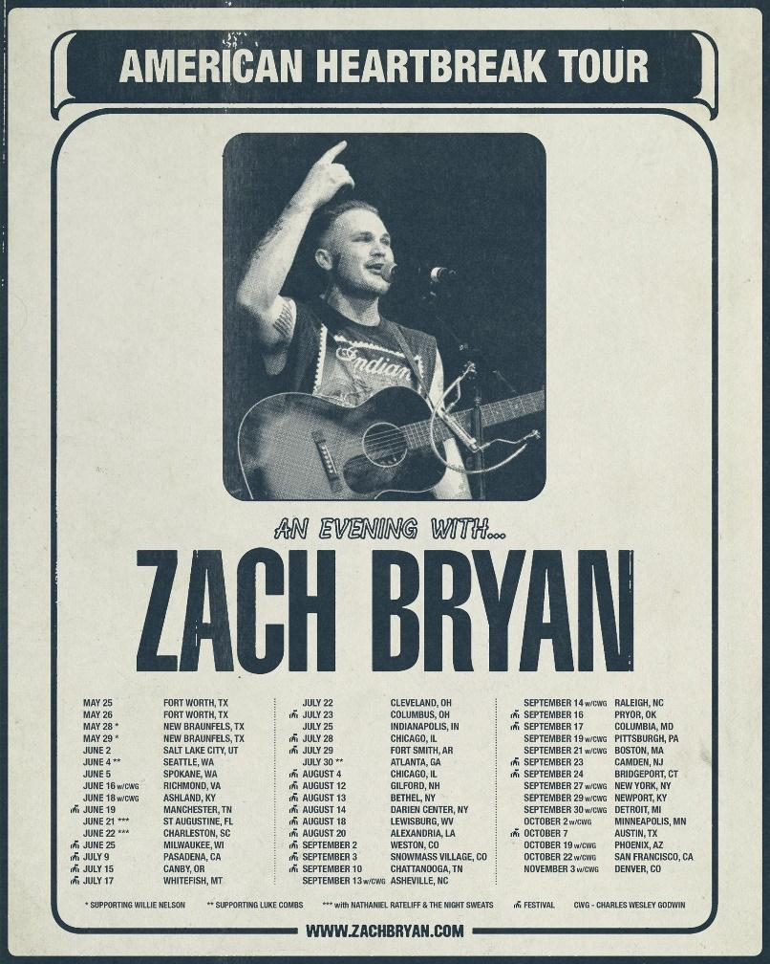

About Zach Bryan:
Zach Bryan is a singer/songwriter from Oologah, Oklahoma, proud of his small-town roots and whose music is fueled by a desire to stay true to himself. The 24-year-old is a recent active-duty member of the US Navy, previously stationed in Washington state—a family tradition that has instilled a sense of honor and humility that is clear in his music. His success is found in his raspy voice, a mix of classic folk melody and outlaw country with a raw edge that cuts to the bone. His breakthrough moment makes all that clear as day. In the video for “Heading South,” shot by phone outside of his Navy barracks in humid 95-degree heat, Bryan’s passion echoes off the strings of his trusted Guild. Drenched in sweat and belting words that he had written minutes earlier, the moment is authentic, brutal, and real. Millions of fans have now seen that video without any sort of industry assist, and millions more have connected to the tender, sincere songs found on both Bryan’s 2019 debut album DeAnn—dedicated to his late mother—and his 2020 follow-up, Elisabeth, an ode to those he loves. His recent show at Nashville’s famed Ryman Auditorium sold out in record time and now finds Bryan amidst a headline tour of sheds and festivals through summer 2022. His recent hit single “From Austin” topped both the Spotify and Apple Music’s Country charts. Most recently his Warner Records album debut AMERICAN HEARTBREAK has topped the Billboard County Album chart at #1 and debuted at #5 on Billboard’s Top 200 Album chart making it one of the most success full country album debuts in the history of the genre. A man of simple words, Bryan’s ability to create depth in his work is rivaled by few artists. He believes that who you are only extends to the person you are today, an ideology reflected in everything he creates. Zach Bryan is on tour in 2022 – all dates SOLD OUT in record time.

# # #
For more information, please contact:
Rick Gershon | Warner Records
Rick.Gershon@warnerrecords.com

FOLLOW ZACH BRYAN:
Website | Instagram | TikTok | Twitter | YouTube | Press Materials
