COUNTRY STAR ZACH BRYAN RELEASES NEW NINE-SONG EP
SUMMERTIME BLUES JUST WEEKS AFTER HIS CRITICALLY ACCLAIMED AMERICAN HEARTBREAK ALBUM

PRE-SAVE HERE / WATCH THE VIDEO FOR THE TITLE TRACK HERE

TICKETS ON SALE FOR EXTENDED SUMMER TOUR HERE

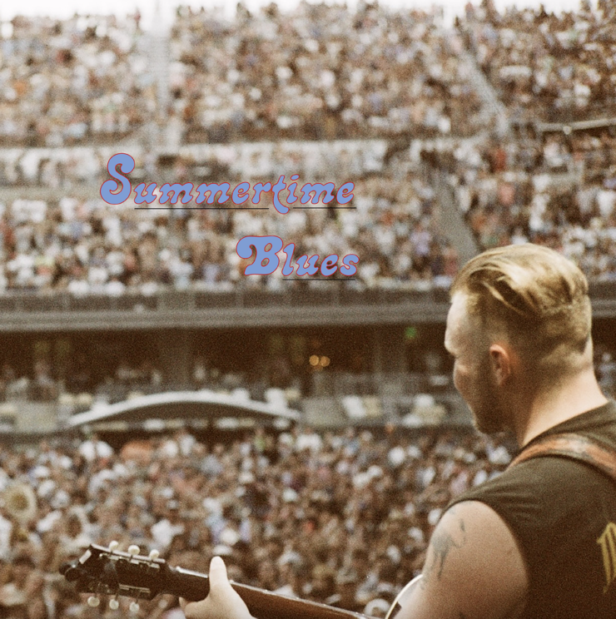
(Click HERE for Hi-Res cover art: photo by Louie Nice, designed by Zach Bryan)

July 14, 2022 (Los Angeles, CA) – Tomorrow, Oklahoma country star Zach Bryan releases Summertime Blues, a new 9-track EP, which arrives only a couple of months after his record-breaking, critically-acclaimed Warner Records debut AMERICAN HEARTBREAK. Pre-save/order Summertime Blues HERE and watch the video for the title track HERE. Summertime Blues follows in the footsteps of AMERICAN HEARTBREAK with its honest and poignant storytelling, further underscoring Bryan’s reputation as one of the most vital and singular songwriters of his, or any other generation.

Over the course of Summertime Blues, Bryan sings about working class lifestyle; (the dark and muscular “Quittin’ Time”); paints a bittersweet portrait of a summer night across America on the title track; tells a longing story about the one that got away (“Oklahoma Smoke Show”); and dives deep into the frustrations of a relationship gone sour (the fiery “All The Time”). He shifts from epic to intimate with the songwriting mastery fans have become accustomed to, exploring the many textures of life without flinching at their complexities.

Bryan also announces a handful of new concert dates, including his first proper headlining gig in Los Angeles at The Wiltern on October 18. His summer tour thus far has found him forging profound connections with fans thanks to his simple, undiluted, genuine, and captivating music. A local ticket pre-sale for the new dates begins today at 8:00AM PT. General on-sales begin tomorrow, July 15 at 10:00AM local time. See all of Bryan’s upcoming tour dates below and buy tickets HERE.

AMERICAN HEARTBREAK, the Navy veteran’s third album and first for Warner Records as well as his first studio-recorded album, made the second-highest streaming country music album debut in history, breaking the 2022 record for single album streams in a 24-hour period and pushing Bryan well past 1 billion streams globally. Capping five years of what Bryan himself called “a true tall-tale,” AMERICAN HEARTBREAK’s unforgettable vignettes of modern life in America—the rambling “From Austin,” stirring “Something In The Orange,” and down-home “Highway Boys,” to name just a few—earned him a spot in the canon of the country’s great narrative songwriters.

“Something in the Orange” peaked at #11 on the Billboard Hot Country charts and was the #18 global streaming track overall. “From Austin” claimed #1 Country Song on Apple Music and debuted at #4 on Spotify’s Global Country chart. On the strength of its deeply personal story, the track has garnered over 37 million global streams. Bryan is now a regular presence on the most coveted playlists in country music.

Summertime Blues proves that the once-in-a-lifetime songwriter has a deep well to pull from, and AMERICAN HEARTBREAK was just the beginning.

2022 Tour Dates:
# Indicates newly added date

July 15 Canby, OR Wild Hare Music Festival
July 15-17 Whitefish, MT Under The Big Sky Music & Arts Festival (Sold Out)
July 22 Cleveland, OH Jacobs Pavilion at Nautica
July 23 Columbus, OH Buckeye Country Superfest
July 25 Indianapolis, IN T CU Amphitheater at White River State Park
July 28 Chicago, IL Lollapalooza
July 29 Fort Smith, AR Peacemaker Music & Arts Festival
July 30 Atlanta, GA Mercedes-Benz Stadium
Aug 04 Chicago, IL Windy City Smoke Out
Aug 12 Gilford, NH Band of NH Pavilion
Aug 13 Bethel, NY Bethel Woods Center
Aug 14 Darien Center, NY Darien Lake Amphitheater
Aug 18 Lewisburg, WV The State Fair of West Virginia
Aug 20 Alexandria, LA Bulls, Bands, Barrels
Sep 02 Weston, CO Caveman Music Festival
Sep 03 Snowmass Village, CO Jas Aspen Snowmass Labor Day Experience
Sep 10 Chattanooga, TN Moon River Music Festival
#Sep 11 Franklin, TN FirstBank Amphitheater
Sep 13 Asheville, NC Exploreashville.com Arena
Sep 14 Raleigh, NC Red Hat Amphitheater
Sep 16 Pryor, OK Born & Raised Festival
Sep 17 Columbia, MD Merriweather Post Pavilion
Sep 19 Pittsburgh, PA Stage AE
Sep 21 Boston, MA Roadrunner
Sep 23 Camden, NJ Waterfront Music Pavilion
Sep 24-25 Bridgeport, CT Sound On Sound Festival
Sep 27 New York, NY The Rooftop at Pier 17
Sep 29 Newport, KY Promo West Pavilion at Ovation
Sep 30 Detroit, MI The Fillmore Detroit
Oct 02 Minneapolis, MN Surly Brewing Festival Field
Oct 07 Austin, TX Austin City Limits
#Oct 18 Los Angeles, CA The Wiltern
Oct 19 Phoenix, AZ Arizona Federal Theatre
Oct 22 San Francisco, CA The Warfield
#Oct 25 Seattle, WA WAMU Theater
Nov 3 Denver, CO Red Rocks Amphitheater
#Nov 11 San Diego, CA Gallagher Square at Petco Park

About Zach Bryan:
Zach Bryan is a singer/songwriter from Oologah, Oklahoma, proud of his small-town roots and whose music is fueled by a desire to stay true to himself. The 24-year-old is a recent active-duty member of the US Navy, previously stationed in Washington state—a family tradition that has instilled a sense of honor and humility that is clear in his music. His success is found in his raspy voice, a mix of classic folk melody and outlaw country with a raw edge that cuts to the bone. His breakthrough moment makes all that clear as day. In the video for “Heading South,” shot by phone outside of his Navy barracks in humid 95-degree heat, Bryan’s passion echoes off the strings of his trusted Guild. Drenched in sweat and belting words that he had written minutes earlier, the moment is authentic, brutal, and real. Millions of fans have now seen that video without any sort of industry assist, and millions more have connected to the tender, sincere songs found on both Bryan’s 2019 debut album DeAnn—dedicated to his late mother—and his 2020 follow-up, Elisabeth, an ode to those he loves. His recent show at Nashville’s famed Ryman Auditorium sold out in record time and now finds Bryan amidst a headline tour of sheds and festivals through summer 2022. His recent hit single “From Austin” topped both the Spotify and Apple Music’s Country charts. AMERICAN HEARTBREAK, is Bryan’s first official studio album and first for Warner Records. Upon release in May of 2022, it became the second-highest streaming country music album debut in history, breaking the 2022 record for single album streams in a 24-hour period and pushing Bryan well past 1 billion streams globally. A man of simple words, Bryan’s ability to create depth in his work is rivaled by few artists. He believes that who you are only extends to the person you are today, an ideology reflected in everything he creates.

# # #

For more information, please contact:
Rick Gershon | Warner Records | Rick.Gershon@warnerrecords.com
Regional/Tour: Jenny Huynh | Warner Records | Jenny.Huynh@warnerrecords.com

FOLLOW ZACH BRYAN:
Website | Instagram | TikTok | Twitter | YouTube

