**ADAM MELCHOR DEBUTS   
NEW SONG “CRY”**

OPENING NOAH KAHAN’S SOLD-OUT   
NORTH AMERICAN FALL TOUR

DEBUT ALBUM *HERE GOES NOTHING!* OUT  
OCTOBER 21 VIA WARNER RECORDS

*Photo credit: Daniel Topete*

“He specializes in dreamy, harmony-dense, technicolor folk-pop songs.”

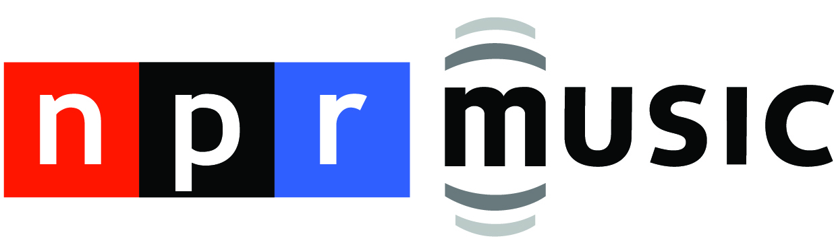

“Whether it’s dancing along gently plucking acoustic guitar strings or crooning the path for backing piano keys, Adam Melchor’s calming vocal explores success and struggle, budding romance and heartbreak.”



September 30, 2022—“**Cry**,” the new song from rising singer/songwriter **Adam Melchor**, is premiering now; listen to/share it [HERE](https://adammelchor.lnk.to/cry) and watch/share the lyric video [HERE](https://www.youtube.com/watch?v=q02gcdRzeHM). Co-written by Melchor, **Nick Long** (The Chainsmokers, Avril Lavigne), **Michael Pollock** (Lizzo, John Legend) and **Ian Fitchuk** (Kacey Musgraves, Maren Morris), “Cry” is the latest song from Melchor’s forthcoming debut album, [***Here Goes Nothing***](https://adammelchor.lnk.to/heregoesnothing)***!***, set for release **October 21** via **Warner Records**.

Of the track,Melchor recalls, “Cry is a song about not wanting to cry in front of someone you love and not exactly knowing why. Crying always feels like a sign of weakness even if it’s a sign of truth, and we’re taught from a young age that we shouldn’t do it. This song is about navigating those feelings and asking myself why I’m not fully open with myself or someone else.”

Prior to embarking on an extensive headline tour starting January 2023, Melchor will be hitting the road with **Noah Kahan** on his sold-out fall tour. The run of dates includes performances at **New York**’s **Pier 17**, **Los Angeles**’ **The Wiltern**, **Chicago**’s **Riviera Theatre**, **Philadelphia**’s **The Fillmore** and more. Full tour routing can be found below.

Co-produced by Melchor and **Henry Kwapis** (Benny Blanco, Dijon), *Here Goes Nothing!* features additional contributions from**Charlie Puth, Lennon Stella, Emily Warren** and **Andrew Sarlo**. *Here Goes Nothing!* also features **Robin Pecknold** (Fleet Foxes) on the track “Let Me Know When.”

The album’s lead single “[**Turnham Green**](https://adammelchor.lnk.to/turnhamgreen)” has already been the subject of early praise; ***V Magazine*** calls it “a classic pop-folk song, with soft melodies and ethereal acoustic guitar riffs. The melancholy song highlights the beauty that can come from pain, as Melchor hears somebody’s reasoning for hurting him,” while **Ones To Watch** adds, “‘Turnham Green’ is a sobering moment of empathy.” Most recently, **Consequence** premiered Melchor’s track “**I’m Ready**,” proclaiming, “The dreamy indie-folk tune doubles down on Melchor’s knack for warm harmonies and frames him as wholeheartedly in love.” Watch/share a live performance of “I’m Ready,” performed alongside **Ashe**, [HERE](https://www.youtube.com/watch?v=7o9cN3uqzP0).

Melchor moved to Los Angeles in 2018 where he had sessions with everyone from Charlie Puth to The Chainsmokers, which subsequently led to tour dates alongside Mt. Joy, Dodie and Ashe, over 50 million streams to date and extensive critical praise. In 2020, Melchor launched *Melchor’s Lullaby Hotline*, sending out 40 original songs to over 10,000 fans. In conjunction, Melchor released a mixtape featuring his favorite tracks entitled *Melchor Lullaby Hotline, Vol. 1*, marking his first release on Warner Records.

Earlier this year Melchor performed with Post Malone on “Saturday Night Live,” where he sang backing vocals, and recently completed a 30-date headlining tour across the country. Melchor’s songwriting accolades include co-writes on Ashe’s “Taylor,” The Chainsmokers’ “In Too Deep,” Alexander 23’s “Loving You Gets Hard” and Allison Ponthier’s “Faking My Own Death.” He has also collaborated with Briston Maroney, Lennon Stella, ELIO, Madeline The Person and more.

**ADAM MELCHOR—*HERE GOES NOTHING!***

1. I’m Afraid I Love You

1. I’m Ready
2. Angel Numbers
3. Cry
4. Touch And Go
5. Turnham Green
6. Rest Of My Night
7. Let Me Know When (featuring Fleet Foxes)
8. Dorothy
9. Sorry Adam

**ADAM MELCHOR LIVE**

September 30—Sydney, AU—The Metro Theatre*

October 1—Melbourne, AU—Melbourne Recital Centre*

October 2—Brisbane, AU—The Princess Theatre*

October 5—Auckland, NZ—Tuning Fork*

**October 12—Charleston, SC—Charleston Music Hall†**

**October 13—Atlanta, GA—The Eastern†**

**October 15—Charlotte, NC—The Fillmore Charlotte†**

**October 16—Silver Spring, MD—The Fillmore Silver Spring†**

**October 19—Philadelphia, PA—The Fillmore Philadelphia†**

**October 20—New York, NY—Pier 17†**

**October 21—Northampton, MA—Calvin Theater†**

**October 22—Boston, MA—MGM Music Hall Fenway†**

**October 25—Portland, ME—State Theatre†**

**October 27-30—South Burlington, VT—Higher Ground†**

**November 1—Toronto, ON—HISTORY†**

**November 3—Chicago, IL—Riviera Theatre†**

**November 4—Madison, WI—The Sylvee†**

**November 5—Minneapolis, MN—First Avenue†**

**November 8-9—Boulder, CO—Boulder Theater†**

**November 11-12—Fort Collins, CO—Washington’s†**

**November 13—Salt Lake City, UT—The Depot†**

**November 15—Seattle, WA—Showbox SoDo†**

**November 16—Portland, OR—McMenamins Crystal Ballroom†**

**November 18—San Francisco, CA—The Regency Ballroom†**

**November 19—Los Angeles, CA—The Wiltern†**

**November 20—San Diego, CA—The Observatory North Park†**

January 27—Salt Lake City, UT—Soundwell

January 28—Denver, CO—Gothic Theatre

January 30—Minneapolis, MN—Fine Line

February 1—Madison, WI—Majestic Theatre

February 2—Chicago, IL—Thalia Hall

February 3—Detroit, MI—Magic Stick

February 4—Toronto, ON—Phoenix

February 7—Cleveland, ON—Beachland

February 9—Boston, MA—Royale

February 10—Brooklyn, NY—Brooklyn Steel

February 11—Pittsburgh, PA—Thunderbird

February 14—Philadelphia, PA—Ardmore Music Hall

February 16—Washington, DC—The Howard

February 17—Carrboro, NC—Cat’s Cradle

February 18—Charlotte, NC—The Underground

February 19—Asheville, NC—Orange Peel

February 21—Charleston, SC—Music Farm

February 22—Atlanta, GA—Terminal West

February 23—Nashville, TN—Brooklyn Bowl

February 25—Louisville, KY—Headliners

February 26—St. Louis, MO—Delmar Hall

February 28—Birmingham, AL—The Saturn

March 1—New Orleans, LA—Toulouse Theatre

March 3—Houston, TX—Studio @ Warehouse Live

March 4—Austin, TX—Scoot Inn

March 5—Dallas, TX—Granada Theatre

March 7—Phoenix, AZ—Cresent Ballroom

March 9—San Diego, CA—Music Box

March 10—Los Angeles, CA—Fonda Theater

March 11—San Francisco, CA—The Fillmore

March 15—Seattle, WA—Neumos

March 16—Vancouver, BC—Hollywood Theatre

March 17—Portland, OR—Aladdin Theater

*supporting Jeremy Zucker

†supporting Noah Kahan

**BOLD—sold out**

*Album art photo credit: Daniel Topete, album design credit: Henry Kwapis and Paul Dally*

[**Official**](https://www.adammelchor.com/) **|** [**Instagram**](https://www.instagram.com/adammelchor/) **|** [**TikTok**](https://www.tiktok.com/@adammelchor) **|** [**YouTube**](https://www.youtube.com/c/AdamMelchor) **|** [**Press Materials**](https://press.warnerrecords.com/adam-melchor/)

**For more information, please contact   
Louis D’Adamio or Carla Sacks at Sacks & Co.,   
212.741.1000, louis.dadamio@sacksco.com or carla@sacksco.com.**