POP BREAKOUT MAUDE LATOUR DROPS UPBEAT
ODE TO FRIENDSHIP "CYCLONE"

NEW EP 001 DUE SEPTEMBER 30 – PRE-SAVE HERE

U.S. HEADLINE TOUR KICKS OFF SEPTEMBER 29

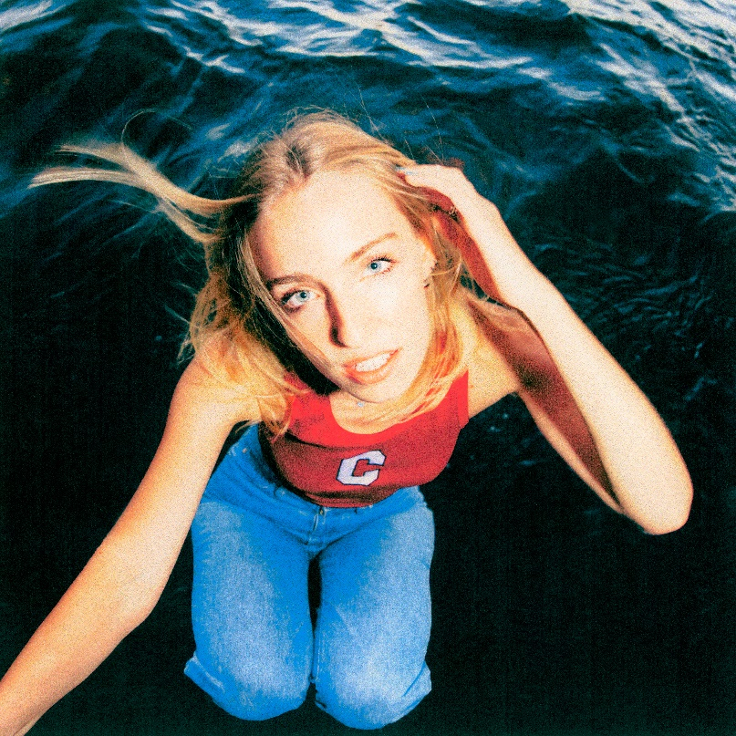

September 2, 2022 (Los Angeles, CA) – Capping off a massive summer, rising alt-pop star Maude Latour unveils "Cyclone," the latest hook-filled single off her highly-anticipated EP 001, due out September 30th via Warner Records. Listen to “Cyclone” HERE and pre-save 001 HERE.

On "Cyclone," Maude pairs an insistent electronic beat with repentant lyrics, realizing that a fractured friendship is essential to her well-being and hoping that any damage can be repaired. The track will appear on Maude's forthcoming EP 001, which she worked on with longtime collaborator Mike Adubato. The release will continue a momentous year for Maude, whose Lollapalooza appearance landed her on the front page of the Chicago Tribune; her "plush indie pop" was hailed in The New York Times, while other tracks off the EP like "Headphones,” “Lola," and “Probabilities” received praise from outlets like NPR, Rolling Stone, and V Magazine, who stated, “Maude Latour is quickly becoming the indie-pop girl to know.”

Maude's fall promises to be just as busy. The night before 001 comes out, she kicks off her headlining what is this feeling? tour in Boston. Check out the 001 tracklist and Maude's tour dates below.

001 EP TRACKLIST:
1. Headphones
2. Lola
3. Trees
4. Probabilities
5. Cyclone
6. 001
7. Living It

MAUDE LATOUR FALL TOUR DATES
September 29 Boston, MA Paradise Rock Club
October 1 Washington, DC All Things Go Music Festival
October 2 Philadelphia, PA The Foundry
October 4 Atlanta, GA Terminal West
October 5 Nashville, TN The End
October 7-9 Austin, TX Austin City Limits
October 11 Houston, TX The Bronze Peacock at House of Blues
October 12 Dallas, TX The Cambridge Room at House of Blues
October 14 Denver, CO Globe Hall
October 15 Salt Lake City, UT Kilby Court
October 17 Phoenix, AZ The Rebel Lounge
October 18 Los Angeles, CA El Rey Theatre
October 20 Sacramento, CA Harlow's
October 21 San Francisco, CA The Chapel
October 23 Seattle, WA Neumos
November 2 New York, NY Irving Plaza

FOLLOW MAUDE LATOUR:
TikTok | Instagram | Twitter | Facebook | YouTube | Press Materials

For more information, please contact:
Patrice Compere | Warner Records
Patrice.Compere@warnerrecords.com
