**ADAM MELCHOR’S DEBUT ALBUM *HERE GOES NOTHING!* OUT TODAY VIA WARNER RECORDS**

**ON TOUR NOW WITH NOAH KAHAN**

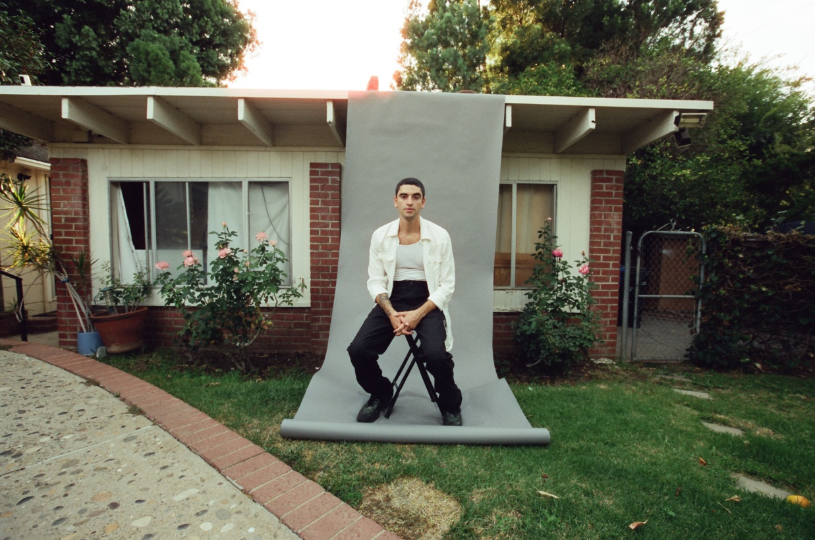  
*Photo credit: Daniel Topete*

October 21, 2022—***Here Goes Nothing!***, the highly anticipated debut album from rising singer/songwriter **Adam Melchor**,is out now on Warner Records; listen to/share the record [HERE](https://adammelchor.lnk.to/heregoesnothing). Co-produced by **Melchor** and **Henry Kwapis** (Benny Blanco, Dijon), the record features additional contributions from**Charlie Puth**, **Lennon Stella**, **Emily Warren** and **Andrew Sarlo**. *Here Goes Nothing!* also features **Robin Pecknold** (Fleet Foxes) on the track “Let Me Know When.”

The new music has already begun to receive early praise:

“…a classic pop-folk song, with soft melodies and ethereal acoustic guitar riffs. The melancholy song highlights the beauty that can come from pain, as Melchor hears somebody’s reasoning for hurting him.”

“The dreamy indie-folk tune doubles down on Melchor’s knack for warm harmonies and frames him as wholeheartedly in love.”   


“‘Turnham Green’ is a sobering moment of empathy.”  


“Another dreamy alt-folk single from LA-based singer-songwriter Adam Melchor, ‘Turnham Green,’ sets exquisite vocals on gently enveloping instrumentals.”

“Pulling on complex emotions with the warmest transparency, Melchor combines sparkling musicality alongside his dreamy vocals and forthright lyricism.”

“Adam Melchor wears his heart on his sleeve in the delicate new single ‘Cry’”  


“phenomenal”

In conjunction with the new release, **Melchor** debuts live performance videos for “[**I’m Ready**](https://nam04.safelinks.protection.outlook.com/?url=https%3A%2F%2Fwww.youtube.com%2Fwatch%3Fv%3D7o9cN3uqzP0&data=05%7C01%7CPatrice.Compere%40warnerrecords.com%7C7fe94bd6fa2748254b5808daae0d3060%7C8367939002ec4ba1ad3d69da3fdd637e%7C0%7C0%7C638013668925257800%7CUnknown%7CTWFpbGZsb3d8eyJWIjoiMC4wLjAwMDAiLCJQIjoiV2luMzIiLCJBTiI6Ik1haWwiLCJXVCI6Mn0%3D%7C3000%7C%7C%7C&sdata=eGu4nSvW4NZ7Wzl9NQQPCpgQANYdh0CIF6Rn7jsn%2BuM%3D&reserved=0),” “[**Cry**](https://nam04.safelinks.protection.outlook.com/?url=https%3A%2F%2Fwww.youtube.com%2Fwatch%3Fv%3DX-CILEt0OVE&data=05%7C01%7CPatrice.Compere%40warnerrecords.com%7C7fe94bd6fa2748254b5808daae0d3060%7C8367939002ec4ba1ad3d69da3fdd637e%7C0%7C0%7C638013668925257800%7CUnknown%7CTWFpbGZsb3d8eyJWIjoiMC4wLjAwMDAiLCJQIjoiV2luMzIiLCJBTiI6Ik1haWwiLCJXVCI6Mn0%3D%7C3000%7C%7C%7C&sdata=15UTiaOsf15VDioPYr201w8yAt6IDlmzb9lk98FGOuk%3D&reserved=0)” and “**I’m Afraid I Love You**,” featuring special guests **Ashe**, **Alexander 23** and **Kenny Beats**,respectively.

Prior to embarking on an extensive headline tour starting January 2023, Melchor continues to tour with **Noah Kahan** on his sold-out run of dates. The shows include performances at Los Angeles’ **The Wiltern**,Chicago’s **Riviera Theatre**, Boston’s **MGM Music Hall Fenway**, Minneapolis’ **First Avenue** and more. Additionally, **Melchor** is slated to open for **Holly Humberstone** in early December during a select run of U.K. dates. Full tour routing can be found below.

**Melchor** moved to Los Angeles in 2018 where he had sessions with everyone from Charlie Puth to The Chainsmokers, which subsequently led to tour dates alongside Mt. Joy, Dodie and Ashe, over 50 million streams to date and extensive critical praise. In 2020, **Melchor** launched *Melchor’s Lullaby Hotline*, sending out 40 original songs to over 10,000 fans. In conjunction, **Melchor** released a mixtape featuring his favorite tracks entitled *Melchor Lullaby Hotline, Vol. 1*, marking his first release on Warner Records.

Earlier this year **Melchor** performed with Post Malone on “Saturday Night Live,” where he sang backing vocals, and recently completed a 30-date headlining tour across the country. **Melchor’s** songwriting accolades include co-writes on Ashe’s “Taylor,” The Chainsmokers’ “In Too Deep,” Alexander 23’s “Loving You Gets Hard” and Allison Ponthier’s “Faking My Own Death.” He has also collaborated with Briston Maroney, Lennon Stella, ELIO, Madeline The Person and more.

**ADAM MELCHOR—*HERE GOES NOTHING!***

1.   I’m Afraid I Love You

1. I’m Ready
2. Angel Numbers
3. Cry
4. Touch And Go
5. Turnham Green
6. Rest Of My Night
7. Let Me Know When (featuring Fleet Foxes)
8. Dorothy
9. Sorry Adam

**ADAM MELCHOR LIVE**

**October 21—Northampton, MA—Calvin Theater\***

**October 22—Boston, MA—MGM Music Hall Fenway\***

**October 25—Portland, ME—State Theatre\***

**October 27-30—South Burlington, VT—Higher Ground\***

**November 1—Toronto, ON—HISTORY\***

**November 3—Chicago, IL—Riviera Theatre\***

**November 4—Madison, WI—The Sylvee\***

**November 5—Minneapolis, MN—First Avenue\***

**November 8-9—Boulder, CO—Boulder Theater\***

**November 11-12—Fort Collins, CO—Washington’s\***

**November 13—Salt Lake City, UT—The Depot\***

**November 15—Seattle, WA—Showbox SoDo\***

**November 16—Portland, OR—McMenamins Crystal Ballroom\***

**November 18—San Francisco, CA—The Regency Ballroom\***

**November 19—Los Angeles, CA—The Wiltern\***

**November 20—San Diego, CA—The Observatory North Park\***

December 1—London, GB—O2 Academy Brixton†

December 3—Norwich, GB—Norwich Nick Rayns LCR UEA†

December 4—Nottingham, GB—Rock City†

January 27—Salt Lake City, UT—Soundwell

January 28—Denver, CO—Gothic Theatre

January 30—Minneapolis, MN—Fine Line

February 1—Madison, WI—Majestic Theatre

February 2—Chicago, IL—Thalia Hall

February 3—Detroit, MI—Magic Stick

February 4—Toronto, ON—Phoenix

February 7—Cleveland, ON—Beachland

February 9—Boston, MA—Royale

February 10—Brooklyn, NY—Brooklyn Steel

February 11—Pittsburgh, PA—Thunderbird

February 14—Philadelphia, PA—Ardmore Music Hall

February 16—Washington, DC—The Howard

February 17—Carrboro, NC—Cat’s Cradle

February 18—Charlotte, NC—The Underground

February 19—Asheville, NC—Orange Peel

February 21—Charleston, SC—Music Farm

February 22—Atlanta, GA—Terminal West

February 23—Nashville, TN—Brooklyn Bowl

February 25—Louisville, KY—Headliners

February 26—St. Louis, MO—Delmar Hall

February 28—Birmingham, AL—The Saturn

March 1—New Orleans, LA—Toulouse Theatre

March 3—Houston, TX—Studio @ Warehouse Live

March 4—Austin, TX—Scoot Inn

March 5—Dallas, TX—Granada Theatre

March 7—Phoenix, AZ—Cresent Ballroom

March 9—San Diego, CA—Music Box

March 10—Los Angeles, CA—Fonda Theater

March 11—San Francisco, CA—The Fillmore

March 15—Seattle, WA—Neumos

March 16—Vancouver, BC—Hollywood Theatre

March 17—Portland, OR—Aladdin Theater

*supporting Noah Kahan

†supporting Holly Humberstone

**BOLD—sold out**

*Album art photo credit: Daniel Topete, album design credit: Henry Kwapis and Paul Dally*

[**Official**](https://nam04.safelinks.protection.outlook.com/?url=https%3A%2F%2Fwww.adammelchor.com%2F&data=05%7C01%7CPatrice.Compere%40warnerrecords.com%7C7fe94bd6fa2748254b5808daae0d3060%7C8367939002ec4ba1ad3d69da3fdd637e%7C0%7C0%7C638013668925257800%7CUnknown%7CTWFpbGZsb3d8eyJWIjoiMC4wLjAwMDAiLCJQIjoiV2luMzIiLCJBTiI6Ik1haWwiLCJXVCI6Mn0%3D%7C3000%7C%7C%7C&sdata=7bXefUhK3rdgITCyvt5NotuNDb3x9D%2BNGuoeGI28pmI%3D&reserved=0) **|** [**Instagram**](https://nam04.safelinks.protection.outlook.com/?url=https%3A%2F%2Fwww.instagram.com%2Fadammelchor%2F&data=05%7C01%7CPatrice.Compere%40warnerrecords.com%7C7fe94bd6fa2748254b5808daae0d3060%7C8367939002ec4ba1ad3d69da3fdd637e%7C0%7C0%7C638013668925257800%7CUnknown%7CTWFpbGZsb3d8eyJWIjoiMC4wLjAwMDAiLCJQIjoiV2luMzIiLCJBTiI6Ik1haWwiLCJXVCI6Mn0%3D%7C3000%7C%7C%7C&sdata=IpvLI7RxZfNPMwIOKWYKmSYzM2gSmJjaSRIR%2FXnDyTY%3D&reserved=0) **|** [**TikTok**](https://nam04.safelinks.protection.outlook.com/?url=https%3A%2F%2Fwww.tiktok.com%2F%40adammelchor&data=05%7C01%7CPatrice.Compere%40warnerrecords.com%7C7fe94bd6fa2748254b5808daae0d3060%7C8367939002ec4ba1ad3d69da3fdd637e%7C0%7C0%7C638013668925257800%7CUnknown%7CTWFpbGZsb3d8eyJWIjoiMC4wLjAwMDAiLCJQIjoiV2luMzIiLCJBTiI6Ik1haWwiLCJXVCI6Mn0%3D%7C3000%7C%7C%7C&sdata=qBZDjFeFKI0%2FoM089cCojE1dgerS2PLRFGY9dwclpVw%3D&reserved=0) **|** [**YouTube**](https://nam04.safelinks.protection.outlook.com/?url=https%3A%2F%2Fwww.youtube.com%2Fc%2FAdamMelchor&data=05%7C01%7CPatrice.Compere%40warnerrecords.com%7C7fe94bd6fa2748254b5808daae0d3060%7C8367939002ec4ba1ad3d69da3fdd637e%7C0%7C0%7C638013668925257800%7CUnknown%7CTWFpbGZsb3d8eyJWIjoiMC4wLjAwMDAiLCJQIjoiV2luMzIiLCJBTiI6Ik1haWwiLCJXVCI6Mn0%3D%7C3000%7C%7C%7C&sdata=KAFYpDNP0tYFwclbyHpPhLv1U372b3JIz0%2F1b2ernkE%3D&reserved=0) **|** [**Press Materials**](https://nam04.safelinks.protection.outlook.com/?url=https%3A%2F%2Fpress.warnerrecords.com%2Fadam-melchor%2F&data=05%7C01%7CPatrice.Compere%40warnerrecords.com%7C7fe94bd6fa2748254b5808daae0d3060%7C8367939002ec4ba1ad3d69da3fdd637e%7C0%7C0%7C638013668925414039%7CUnknown%7CTWFpbGZsb3d8eyJWIjoiMC4wLjAwMDAiLCJQIjoiV2luMzIiLCJBTiI6Ik1haWwiLCJXVCI6Mn0%3D%7C3000%7C%7C%7C&sdata=OIqc7Lj%2BMij%2FT4ROFr78BdAE3fENHruByOb78rjCn64%3D&reserved=0)