CARLIE HANSON SALUTES HER HOMETOWN ON TOUCHING NEW SINGLE “608”

LISTEN HERE | WATCH VIDEO HERE

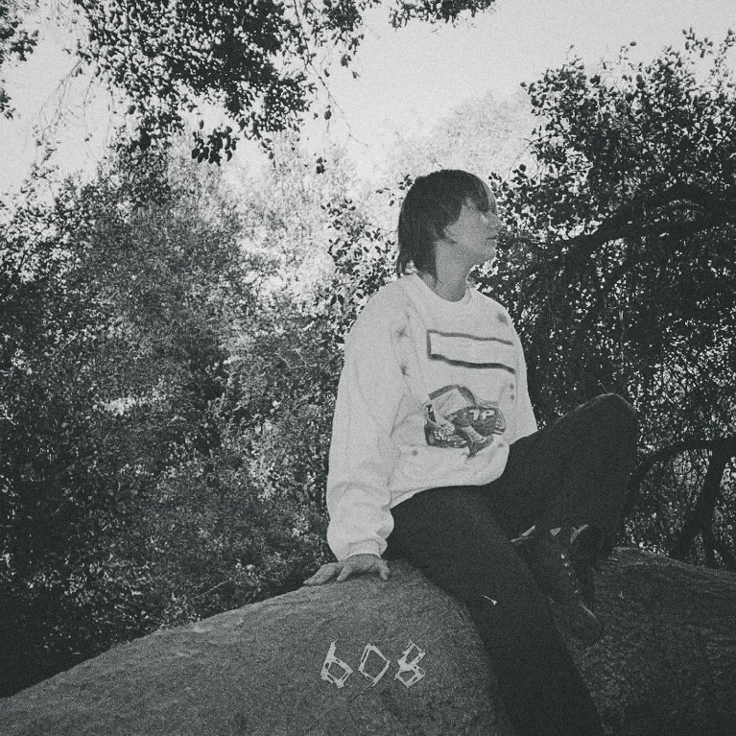

October 7, 2022 (Los Angeles, CA) – Today, rising singer-songwriter Carlie Hanson returns with “608,” a brand-new single about her roots. Listen HERE and watch the accompanying wistful video HERE via Warner Records. Named after the town of Onalaska, Wisconsin from which she hails, the ethereal track explores Hanson’s complicated yet utterly relatable relationship with her old stomping ground. “608” is the 22-year-old’s first release since dropping her critically acclaimed debut album, Tough Boy, in February.

Weaving tones and textures amid rhythmic guitar plucking, Hanson paints a hazy portrait of longing. “Green eyes match the hillside, snow falls when your tears dry,” she sings over minimal production. “Summertime ain’t a longtime, I’mma meet you on the northside.” Intimate details of home crystallize as the song progresses: “Passenger seat of my boyfriend’s car, windshield too cracked I can’t see.” “608” manages to be sweet, sad, and full of wisdom despite her age.

Hanson says the song is about leaving home at 17 to move to Los Angeles — a city that still doesn’t feel like home. “Every day, I reminisce about the past,” she reveals, “imagining what it would be like to sit in the passenger seat of my best friend’s car in the middle of winter.” Despite her blossoming career, the hitmaker knows where her heart lies. “No matter how successful I become, no matter how much money I have, I’m still very much the same girl from small-town Wisconsin that I’ve always been.”

ABOUT CARLIE HANSON:
From day one, Carlie Hanson has marched to her own beat, and not surprisingly, an ever-growing legion of fans has followed. Earlier this year, she released her debut album, Tough Boy, a project as exciting and experimental as it is addictive. It followed an already celebrated music career boasting nearly 200 million streams. Hanson’s first EP, JUNK, arrived in 2019 while her sophomore EP, DestroyDestroyDestroyDestroy, debuted in October 2020 to wide acclaim.

Most recently, Hanson was featured on the cover of Alternative Press - check that out HERE as “An Artist to Watch for 2022.” She was also named as one of Billboard’s 21 Under 21 last year and has co-signs from artists like Taylor Swift and Demi Lovato. Now, with “608,” Hanson offers fans a glimpse of the locale and small-town upbringing that shaped her prodigious talent.

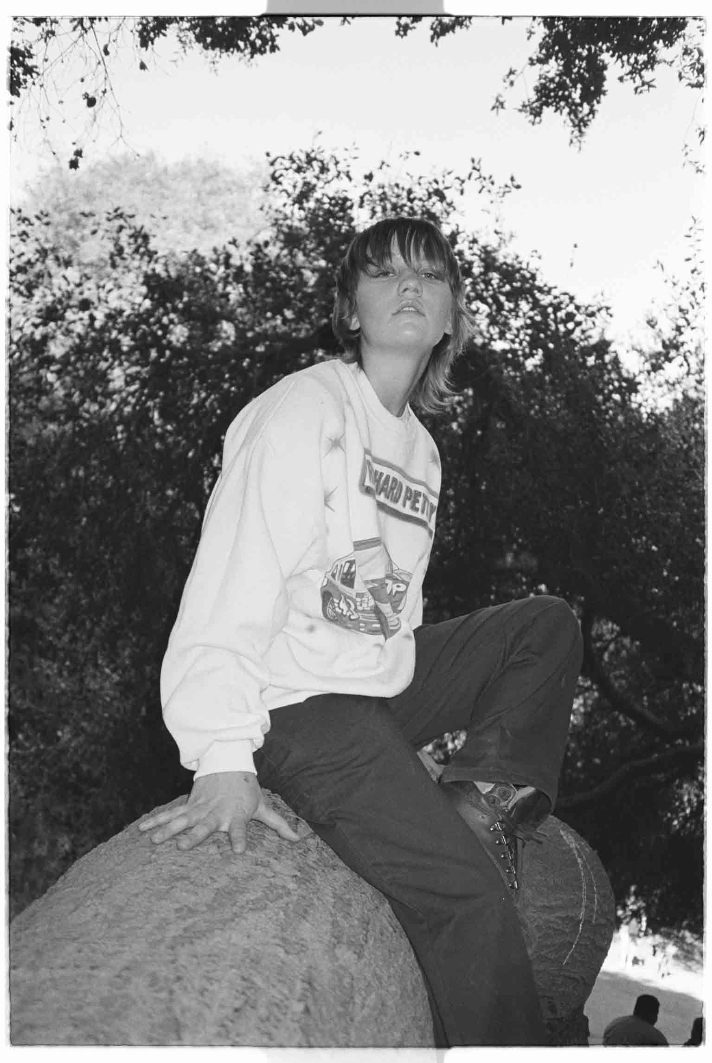
Download hi-res art here
Follow Carlie Hanson
Official | Instagram | Twitter | Facebook | YouTube

For more information, please contact:
Ceri Roberts | Warner Records
Ceri.Roberts@warnerrecords.com

