LUKAS GRAHAM TO RELEASE NEW FULL-LENGTH LP
4 (THE PINK ALBUM) ON JANUARY 20, 2023
OFFICIAL VIDEO FOR “WISH YOU WERE HERE”
FEATURING KHALID OUT TODAY
WATCH HERE
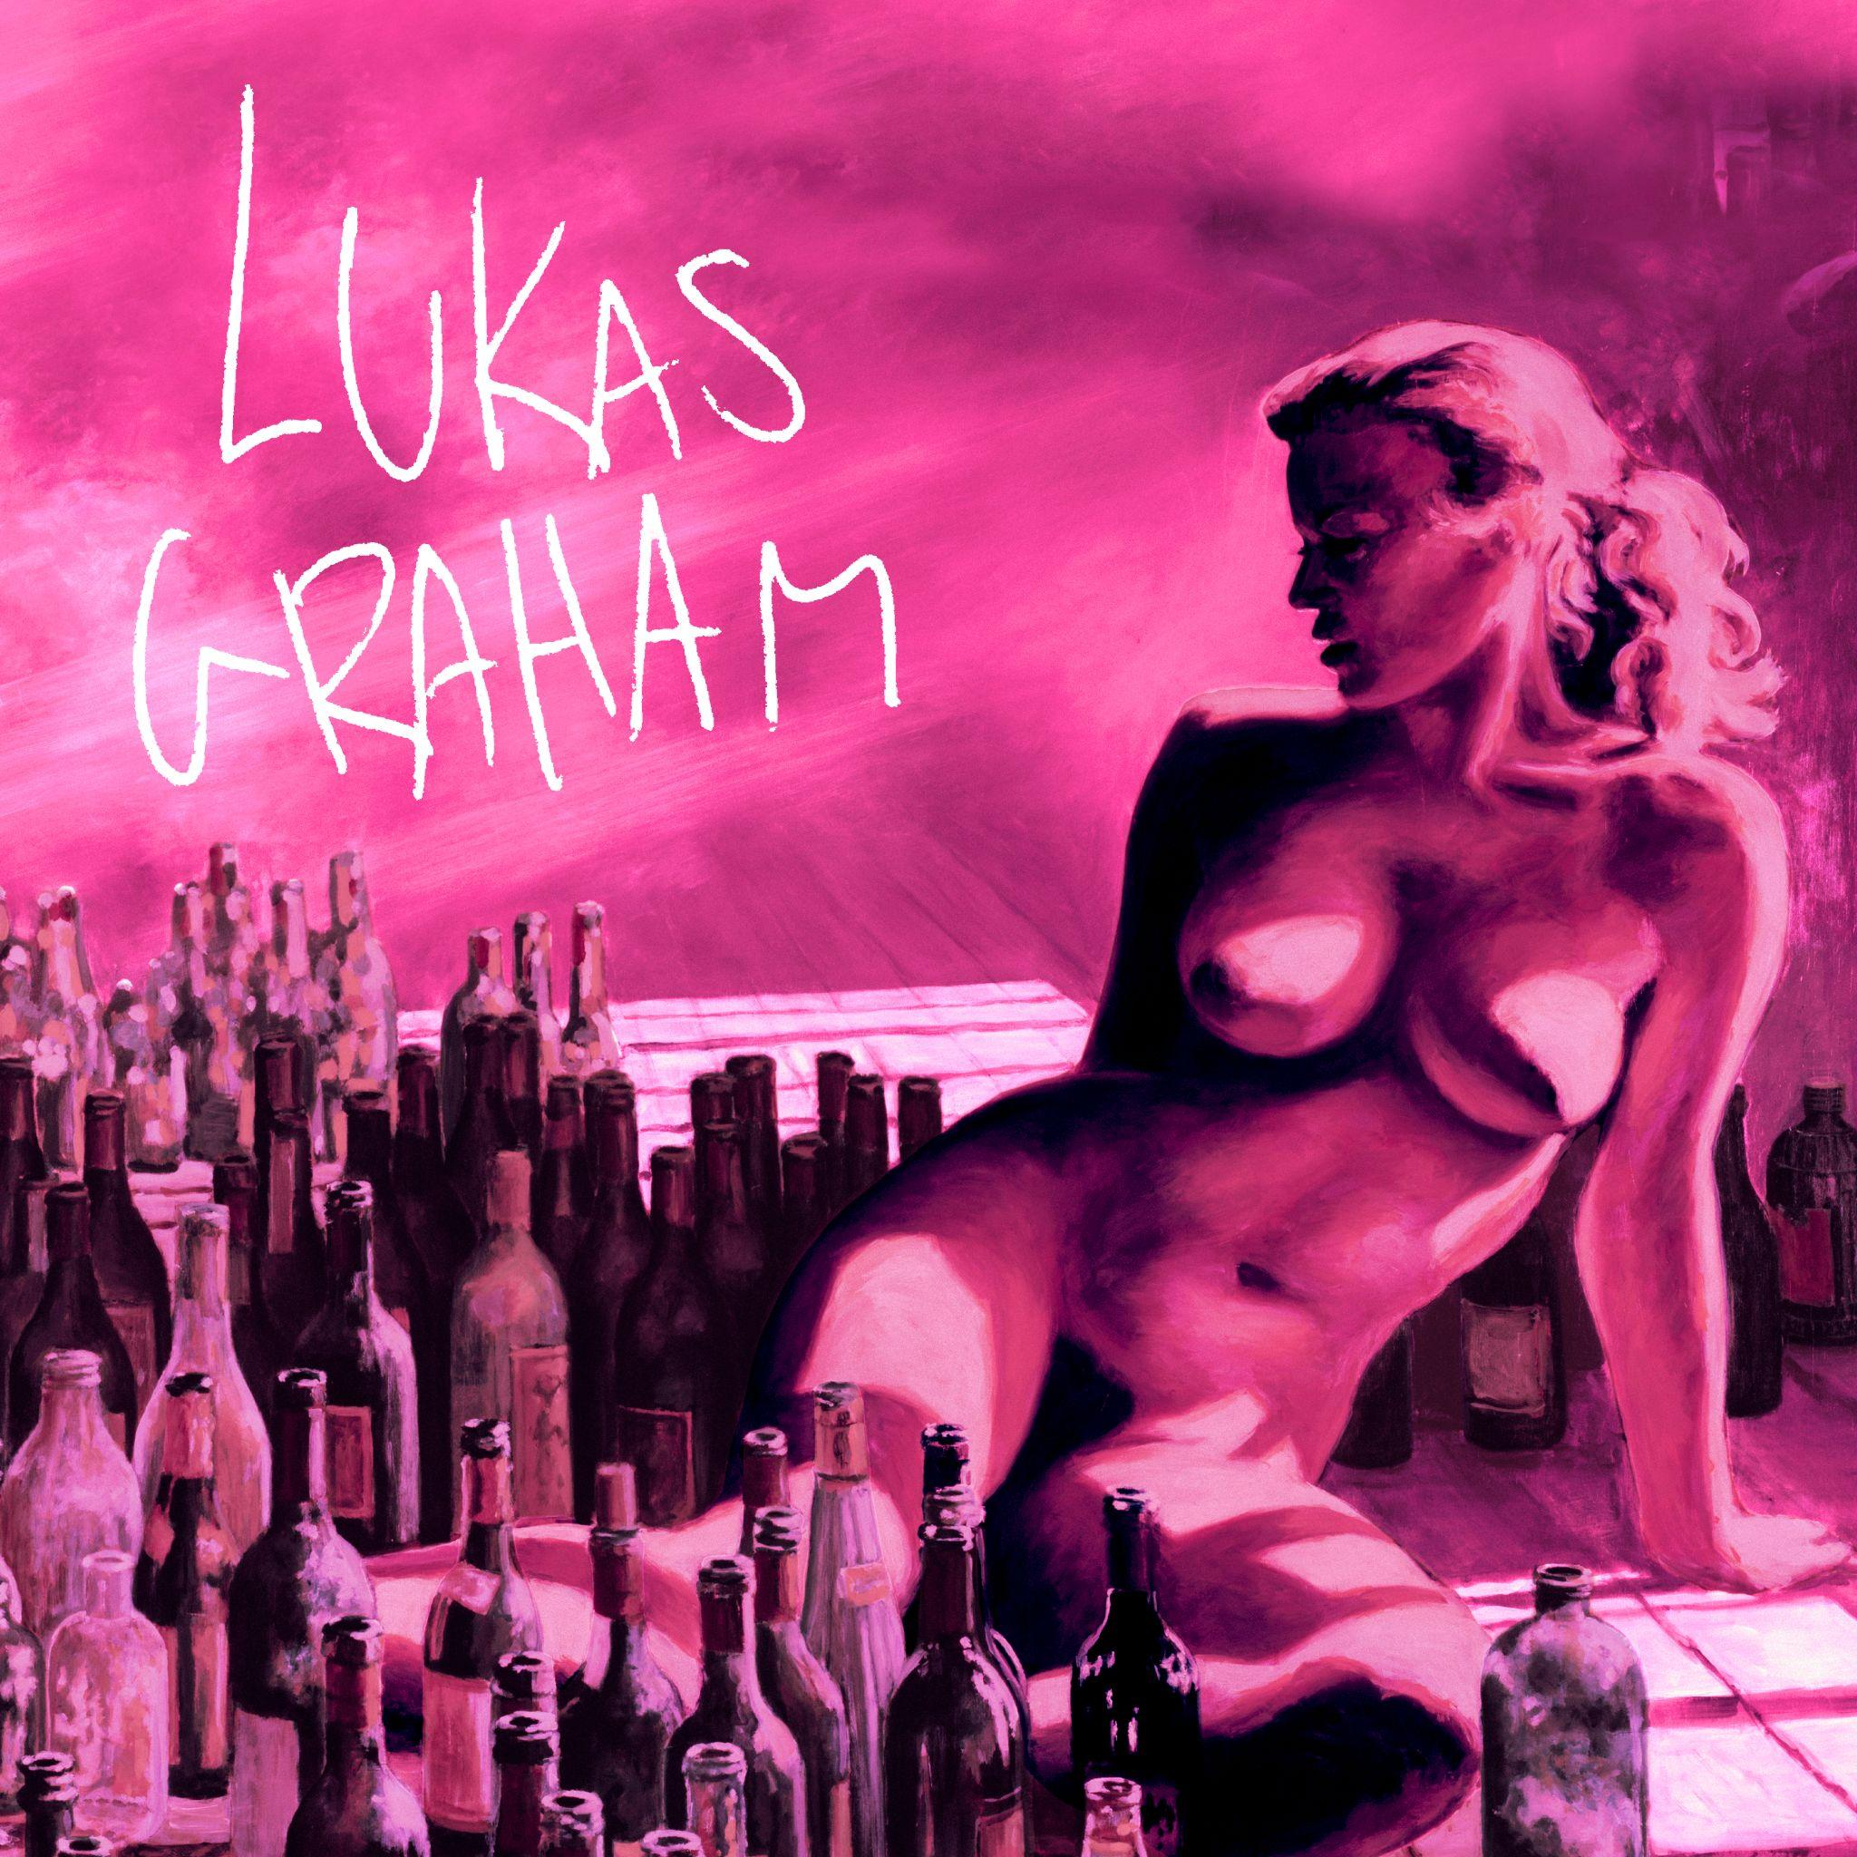

November 22, 2022 (Los Angeles, CA) – GRAMMY® Award-nominated multi-platinum artist Lukas Graham will release his long-awaited full-length record, 4 (The Pink Album), on January 20, 2023 via Warner Records. The 11-song set details the Danish soul-pop singer-songwriter’s journey of self-discovery over the years, making this his most authentic and reflective work to date. Pre-order/Pre-save 4 (The Pink Album)—HERE.

Alongside the announcement, Lukas has released the official video for his single “Wish You Were Here” [feat. Khalid], directed by Blythe Thomas. Co-written and produced by Ryan Tedder, the anthem to best friends is steadily rising the Hot AC charts. Watch the video HERE.

After enduring the loss of his father, becoming a father himself, and weathering the ups and downs of an unimaginable rise to fame, Lukas found himself stuck in a cycle, self-medicating and in a creative rut. In 2020, he made the decision to get sober and focus on his family and music. Returning to his songwriting roots, Lukas wrote in the same old rehearsal space, a 10-minute bike ride from his house in Copenhagen, crafting his new full-length offering. On 4 (The Pink Album), he finally takes stock of everything that happened during that time, not only reflecting, but also evolving into just who he’s meant to be. It ultimately represents everything he’s been working towards—and more.

Of the album, Lukas said, “4 (The Pink Album) is pure self-reflection. I’m not saying I’ll never have a drink ever again, but I went clean. It had gotten to the point of self-medicating, so I stopped. Over the past couple of years, it became fun to write songs again, go to rehearsal, and work with music. I embraced the art of it. I’m not trying to be a professional anymore, because all I want to do is be a happy amateur.”

2022 marks seven years since Lukas Graham put his hometown of Christiania, Denmark on the map and enchanted and engaged audiences worldwide with a string of anthems that resonated around the world. With a soulful signature sound punctuated with pop relatability, his hit songs “7 Years” and “Love Someone” garnered him three GRAMMY® Award nominations, billions of streams and widespread critical acclaim as he also sold out shows across Europe, North America, and beyond.

4 (The Pink Album) Tracklist:
- “Stay Above”
- “Wish You Were Here (feat. Khalid)”
- “This Is Me Letting You Go”
- “Share That Love” (feat. G-Eazy)”
- “Home Movies” (feat. Mickey Guyton)”
- “All Of It All”
- “By The Way”
- “Lie”
- “Never Change”
- “Say Forever”
- “One By One”
###

Follow Lukas Graham:
Website | Twitter | Facebook | Instagram | Press Site | TikTok

For further information on Lukas Graham, contact:
Jaime Rosenberg | BB Gun PR
Jaime@bbgunpr.com

Jenny Huynh | BB Gun PR
Jenny@bbgunpr.com

Patrice Compere | Warner Records
Patrice.Compere@warnerrecords.com

