DISTURBED’S EIGHTH STUDIO ALBUM, DIVISIVE, OUT NOW
VIA REPRISE RECORDS
UNLEASH NEW, AI-GENERATED MUSIC VIDEO FOR “BAD MAN”
READ TRACK-BY-TRACK VIA REVOLVER

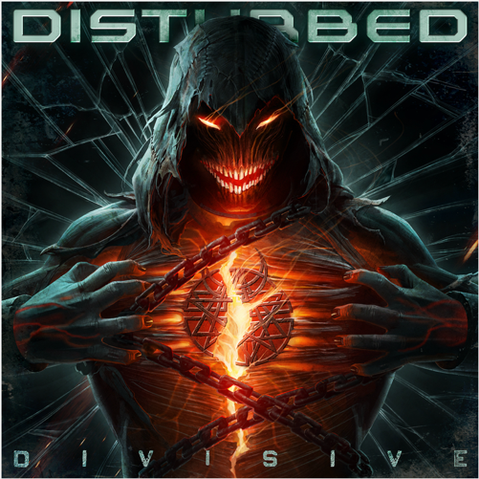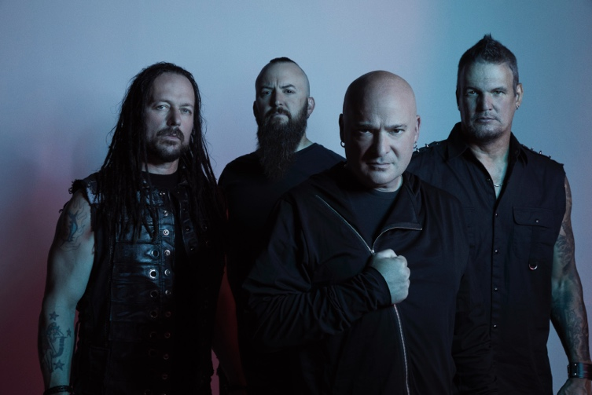

“Disturbed are undoubtedly one of the most popular metal bands of the 21st century.”
– Revolver

"‘Divisive’ pulls no punches as a precise, pummeling, and powerful hard rock opus.”
– Blabbermouth

“classic Disturbed, with crunchy riffs, David Draiman’s powerful vocals, and a soaring, melodic chorus.”
– Consequence

November 18, 2022 (Los Angeles, CA) – Today, multi-platinum rock band Disturbed release Divisive, their eighth full-length album, via Reprise Records. Bulldozing the way for the record, the group have previously released the unpredictable and undeniable new singles “Unstoppable” “Hey You,” and “Divisive.” “Hey You,” the album’s first single, emerged as their 15th #1 single at Rock Radio. At the same time, it has already gathered 25 million-plus streams and counting, only increasing anticipation for Divisive. Divisive is available on all formats HERE.

The band today also share their new, AI-generated music video for “Bad Man,” directed by Tristan Holmes. The video was created using Midjourney AI and includes roughly 10,000 frames which took approx. a month of image generation entering prompts and creating frames to link together. Watch it HERE and watch a behind the scenes look at the creation of the video HERE.
Revolver recently spoke to guitarist Dan Donegan, who provided a track-by-track guide to the album. Read it HERE.
Divisive pulls no punches as a precise, pummeling, and powerful hard rock opus. Over the last year, the quartet cut these ten tracks with producer Drew Fulk [Motionless In White, Lil Peep, Highly Suspect] in Nashville, TN. After Donegan shared initial ideas with the rest of the group, they locked in like never before with the groove as the backbone. Drummer Mike Wengren bolted down some of the strongest and boldest rhythms of their career punctuated by John Moyer’s punchy bass. Together, the musicians collectively conjured the focus and fire of their seminal early output augmented by airtight songcraft and a heightened level of musical chemistry that could only be forged by years of writing and touring together. As a result, Divisive finds Disturbed at their most dynamic, defiant, and dangerous.

Breaking ground, it also notably marks the first time the band included a guest feature on an album, boasting the epic emotionally charged duet “Don’t Tell Me” with Ann Wilson. Meanwhile, “Bad Man” ranks amongst the band’s heaviest material. At the same time, they infuse the likes of “Won’t Back Down” with uplifting melodies.

Check out the full track listing below.
TRACKLISTING:
- Hey You
- Bad Man
- Divisive
- Unstoppable
- Love To Hate
- Feeding The Fire
- Don’t Tell Me [feat. Ann Wilson]
- Take Back Your Life
- Part Of Me
- Won’t Back Down

ABOUT DISTURBED:
Emerging out of Chicago at the turn of the century with an insidious, infectious, and inimitable vision without comparison, Disturbed have quietly dominated hard rock on their own terms. They make the kind of music that pushes you to hold on tighter, fight harder, and persevere forever. It’s why they’ve quietly claimed a place at the forefront of 21st century rock with record-breaking success, sales of over 17 million-plus units, nearly 8 billion streams, and sold out shows around the globe. The two-time GRAMMY® Award-nominated quartet have notched five consecutive #1 debuts on the Billboard Top 200, occupying rarified air alongside Metallica—the only other hard rock group to accomplish this feat. Since their influential 5x-platinum debut The Sickness in 2000, they have built a bulletproof catalog highlighted by a procession of smashes, including the platinum “Stupify,” “Inside The Fire,” and “Land of Confusion,” 2x-platinum “Stricken,” 6x-platinum “Down With The Sickness,” and 7x-platinum “The Sound of Silence,” to name a few. The latter notably received a GRAMMY® Award nomination in the category of “Best Rock Performance” as the band earned “Best Rock Artist” at the 2017 iHeartRadioMusic Awards. Still, Disturbed never stop, igniting their next chapter with their 2022 album Divisive featuring their 15th #1 at Rock Radio “Hey You,” “Unstoppable,” and more.
###

FOLLOW DISTURBED:
Website | Facebook | Twitter | Instagram | Youtube

For more information, please contact:
Patrice Compere – Patrice.Compere@warnerrecords.com
Mary Moyer – Mary@qprime.com
Emilio Herce – Emilio@qprime.com

