HITMAKER MIKE SABATH SHARES VULNERABLE NEW SINGLE “BEING HUMAN” TODAY
LISTEN HERE | WATCH HERE

MORE MUSIC COMING SOON

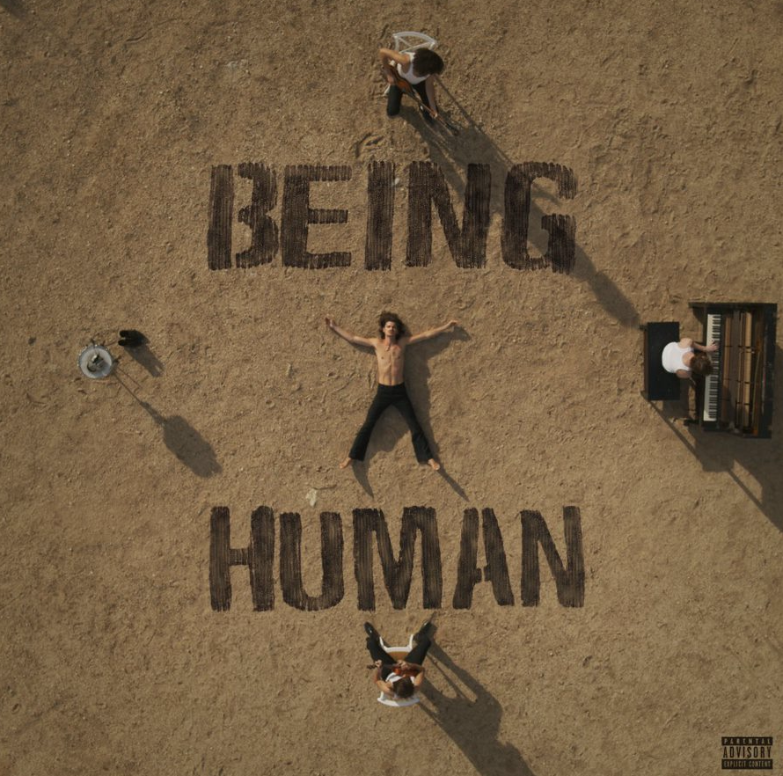
Credit: Corey Gegner - High Res HERE

December 16, 2022 (Los Angeles, CA) – Gearing up for the next chapter, GRAMMY nominated artist, producer, songwriter, and multi-instrumentalist Mike Sabath returns with a new single entitled “Being Human” today via Warner Records. It marks the hitmaker’s first solo release since 2020 and sets the stage for more new music in 2023. Listen to “Being Human” HERE and watch the music video HERE.

The track sways back and forth in waves of blissful yet heart-wrenching nostalgia accented by cinematic strings, delicate percussion, and gritty bass. Mike’s soaring vocals take hold as the hypnotic hook assures, “That’s part, part of being human, your minds gotta F**k you sometimes… but it always works out in the end.” It once again illuminates his knack for a timeless melody.

About “Being Human,” he commented, “We are all human. We all go up and we all go down and we have to accept both. It makes it so much easier…I love you.”

His previous single “Good Energy” notably arrived to widespread critical acclaim and secured a coveted spot on EA Games’ FIFA 2021 soundtrack. Meanwhile, 2021 saw the prolific collaborator expand his discography once again by co-writing and co-producing the international smash “Don’t Go Yet” for Camila Cabello.

Born and raised in upstate New York, Mike Sabath has had music flowing out of him since before he knew how to work a computer. He naturally started to create music in 4th grade with his first song “The Carlie Song” which he wrote for his elementary school crush to express how he felt about her before they both left for the summer. In 7th grade, he wrote a song titled "Hand in Hand" which he recorded with a chorus of 140 local kids and raised more than $10,000 for the charity Ability Beyond Disability. In 10th grade he composed his first symphony entitled “Wings” sonically representing the lifecycle of a honeybee hive for his high school wind ensemble. Throughout middle school and high school, Mike wrote and recorded songs in his basement daily, which eventually brought him to Los Angeles where he and his manager at the time would sneak into studios to have recording sessions before anybody in the industry knew who he was.

By the time he was 18, Mike had some high-profile studio sessions under his belt and was featured in The New Yorker who called him “The teenage hitmaker from Westchester County.” Mike has written and produced hundreds of songs and is one of the industry’s most sought after songwriters and producers, working with artists such as Lizzo, J Balvin, Shawn Mendes and Pharrell.

It’s time for the world to get to know Mike Sabath as the artist that he is and the artist that he will become.

High Res HERE - Credit: Shervin Lainez

Follow Mike Sabath:
Official | Instagram | Twitter | Facebook | YouTube | Press Materials

# # #

For further information, please contact Warner Records Publicity:
Darren Baber | Darren.Baber@warnerrecords.com

Connor Hunt | Connor.Hunt@warnerrecords.com

