NEIL YOUNG WITH CRAZY HORSE RELEASE NEW STUDIO ALBUM
WORLD RECORD
10 New Songs Of Our Times Produced By Rick Rubin And Neil Young On Reprise Records Available Now

WATCH “CHEVROLET” HERE

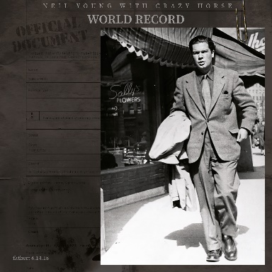
(Click HERE for Hi-Res image)
November 18, 2022 — (Los Angeles, CA) Today, NEIL YOUNG with Crazy Horse release World Record, recorded at Shangri-La Studio and produced by Rick Rubin and Neil Young. WORLD RECORD is available on vinyl, CD, and cassette formats via The Greedy Hand Store at Neil Young Archives (NYA) and music retailers everywhere. A video for album track “Chevrolet” directed by Bernard Shakey for Shakey Pictures, is out now. Click HERE to view and share.
As Young himself said in a message on the Times-Contrarian during the making of World Record: “Real magic lasts and we think we have it.”
Recorded live to capture the Horse’s long-running spirit, the album was mixed to analog tape at Shangri-La.
Optimizing the audio quality, the vinyl format of World Record is available as a three-sided double album with an etching on side four. A limited-edition version of the album pressed on clear vinyl is also available via Young’s webstore, The Greedy Hand Store, and indie retailers. World Record is also issued on cassette and as a double CD set (duplicating the art presentation of the double LP). All Greedy Hand Store purchases of World Record (LP, CD or cassette) come with free hi-res digital audio downloads from the Xstream Store © at NYA.
Additionally, World Record is available in multiple digital formats, including XStream Hi-Res Audio and Atmos/Spatial. The album’s hi-res streaming format is fully supported at Amazon, Apple, and Qobuz. Find It digitally at Neil Young Archives and most major DSPs
World Record track listing:
1. Love Earth
2. Overhead
3. I Walk With You (earth ringtone)
4. This Old Planet (changing days)
5. The World (is in trouble now)
6. Break The Chain
7. The Long Day Before
8. Walkin’ On The Road (to the future)
9. The Wonder Won’t Wait
10. Chevrolet
11. This Old Planet reprise

# # #

For further information, contact Rick Gershon at Warner Records:
818-953-3473 / Rick.Gershon@warnerrecords.com

Official Site/NYA:
neilyoungarchives.com

Press materials:
https://press.warnerrecords.com/neilyoung/

