NESSA BARRETT DROPS EXTENDED EDITION OF DEBUT ALBUM YOUNG FOREVER

FEATURING FIVE NEW TRACKS: “DEATHMATCH,” “GOD’S FAVORITE,” “NOOSE,” “DO YOU REALLY WANT TO HURT ME?” AND HER INVENTIVE COVER OF ARCTIC MONKEYS’ “505”

STREAM HERE

Download Hi-Res artwork HERE

November 18, 2022 (Los Angeles, CA) – Today, pop breakout Nessa Barrett releases a special extended edition of her debut album young forever. Listen HERE via Warner Records. The five new tracks build upon the pristine production and myriad of songwriting speeds that made the standard edition so impressive, delivering a rich, complex collection of tracks that showcases the full extent of Barrett’s artistry.

A standout on the extended edition is the 20-year-old’s striking cover of Arctic Monkeys’ newly viral “505,” which trades in the Sheffield group’s understated swagger for an ethereal, propulsive rendering dripping with sex appeal. The other four tracks, all originals, range from the darkly upbeat “deathmatch” to the gorgeously haunting “god’s favorite.” Barrett then veers into goth-pop territory on “noose” and “do you really want to hurt me.”

"Each and every song on this album is so personal to me,” Barrett says of the critically acclaimed young forever. “Music is how I cope and writing this album was my therapy. I’ve questioned why I had to go through so much pain in life and always felt like it was a curse. But now I’ve realized it was so I could make songs like these to help others go through theirs." That willingness to look inward is on full display on the extended edition.

After being named as one of Billboard’s “21 Under 21” — as well being among Ones to Watch’s list of “25 Artists to Watch in 2022”, on Uproxx’s “Next Hitmakers List” and People Magazine’s Emerging Artist List — Barrett has gone on to accumulate close to one billion streams. She was also nominated for Push Performance of the Year at the 2022 MTV Video Music Awards. As her star rises, the singer-songwriter is determined to use her fame for good.

From February 2021’s Gold-certified smash “la di die” featuring jxdn and Travis Barker on drums to February’s “dying on the inside,” released to raise awareness about eating disorders, Barrett has only become more dedicated to using her platform as a source of healing. Now, with the expanded edition of young forever, Barrett shares more of her journey than ever before.

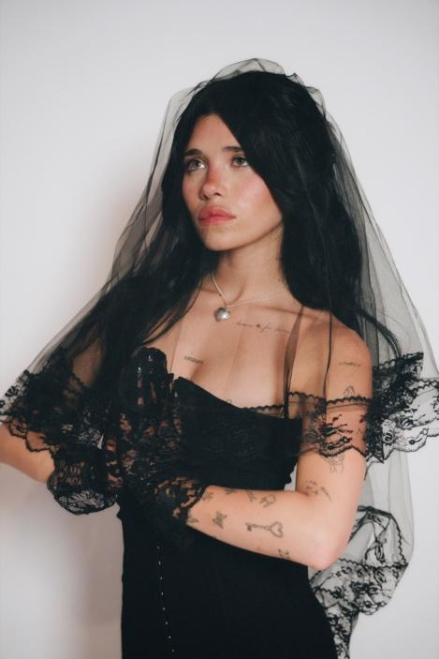
Photo credit: Beth Saravo

Follow Nessa Barrett:
Official | TikTok | Instagram | Twitter | Facebook | YouTube | Press Materials | Store

Nessa Barrett contact:
Darren Baber | Warner Records
Darren.Baber@warnerrecords.com

