LUKAS GRAHAM UNVEILS LONG-AWAITED LP
4 (THE PINK ALBUM) TODAY – LISTEN HERE
PERFORMING “HOME MOVIES” WITH MICKEY GUYTON ON GOOD MORNING AMERICA TODAY
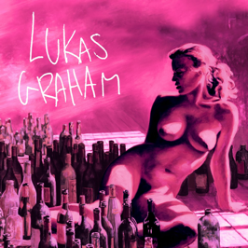

January 20, 2023 (Los Angeles, CA) – Today, GRAMMY® Award-nominated singer-songwriter Lukas Graham unveils his long-awaited full-length album 4 (The Pink Album) via Warner Records – listen HERE. The album comes on the heels of Lukas’ new single, the country-tinged ballad “Home Movies” featuring Mickey Guyton, released last week to widespread acclaim from Rolling Stone, Billboard, Associated Press, The Washington Post, American Songwriter, and Music Row –who touted it as “a duet to die for.”

To celebrate the release, Lukas and Mickey Guyton will be performing “Home Movies” on Good Morning America later this morning. Be sure to tune in to ABC at 7 AM!

After enduring the loss of his father, becoming a father himself, and weathering the ups and downs of an unimaginable rise to fame, Lukas found himself stuck in a cycle, self-medicating and in a creative rut. In 2020, he made the decision to get sober and focus on his family and music. Returning to his songwriting roots, Lukas wrote in the same old rehearsal space, a 10-minute bike ride from his house in Copenhagen, crafting his new full-length offering.

On 4 (The Pink Album), he finally takes stock of everything that happened during that time, not only reflecting and evolving into just who he’s meant to be. It ultimately represents everything he’s been working towards—and more. The 11-song set details the Danish soul-pop singer-songwriter’s journey of self-discovery over the years, making this his most authentic and reflective work to date.

2022 marked seven years since Lukas Graham put his hometown of Christiania, Denmark on the map and enchanted and engaged audiences worldwide with a string of anthems that resonated around the world. With a soulful signature sound punctuated with pop relatability, his hit songs “7 Years” and “Love Someone” garnered him three GRAMMY® Award nominations, billions of streams, and widespread critical acclaim as he also sold out shows across Europe, North America, and beyond.

With the release of 4 (The Pink Album) and an international spring tour on the horizon, 2023 is looking to be an exciting year for Lukas Graham!

4 (The Pink Album) Tracklist:
- “Stay Above”
- “Wish You Were Here” (feat. Khalid)
- “This Is Me Letting You Go”
- “Share That Love” (feat. G-Eazy)
- “Home Movies” (feat. Mickey Guyton)
- “All Of It All”
- “By The Way”
- “Lie”
- “Never Change”
- “Say Forever”
- “One By One”

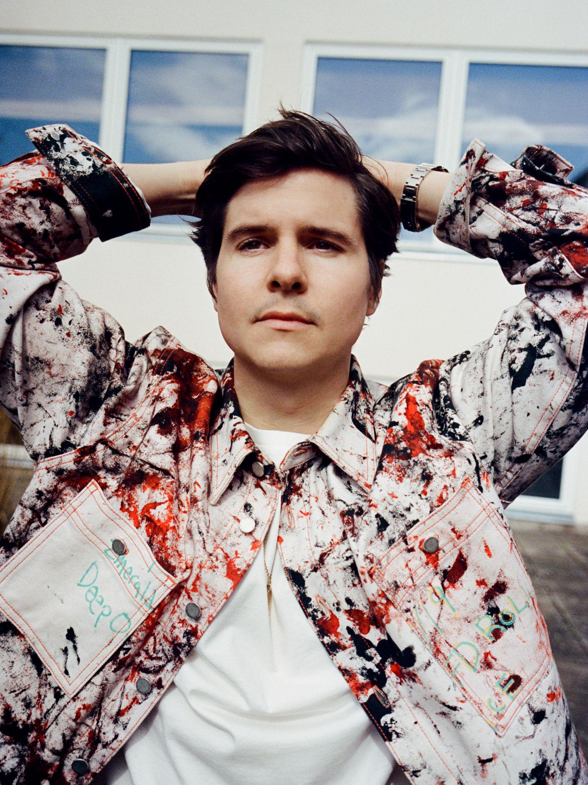
Photo credit: Petra Kleis

###

Follow Lukas Graham:
Website | Twitter | Facebook | Instagram | Press Site | TikTok

For further information on Lukas Graham, contact:
Jaime Rosenberg | BB Gun PR
Jaime@bbgunpr.com

Jenny Huynh | BB Gun PR
Jenny@bbgunpr.com

Patrice Compere | Warner Records
Patrice.Compere@warnerrecords.com

