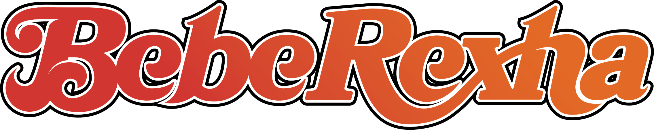

If there’s one refrain that follows Bebe Rexha, one massive reverberation that continues to chime year after year; one that serves as throughline and guiding principle across her multiple smash hit singles, collaborations, and studio albums; one larger and louder than the countless choruses she’s penned and sung over the past decade that have become utterly inextricable from the global cultural consciousness, it’s this: expect greatness, and expect it constantly.

The guiding force, singer, songwriter, and sound-shaper behind such hits as the smashes “Hey Mama” and “I’m Good (Blue)” with David Guetta, diamond-certified “Meant to Be” with Florida Georgia Line, “Me, Myself, & I” with G-Eazy, “In the Name of Love” with Martin Garrix, Eminem and Rihanna’s chart-topping, 6x Platinum “The Monster,” and countless more which have accumulated over 16 billion streams and counting, Bebe has become as core to music as a chorus itself. But there’s more ground to cover yet, and Bebe’s ready to take everyone along for a new ride. “With what comes next, I’m building out a new world and solidifying myself as an artist in this business and this world,” she says with a glint in her eye.

With her impending, self-titled third studio album Bebe, she’ll take fans and new listeners to even higher highs with a body of work that demonstrates a confident, eminently listenable self-assuredness that dips into a new sonic palate for the multi-hyphenate. Inspired by a dive into the shapes, sights, and sounds of the ‘70s – a new journey for Bebe, who’d been raised on hip-hop and traditional Albanian music as a child – Bebe plumbs the era for its greatest exports (free spirit, earth-rattling harmonies, and a profound emphasis on razor-sharp songwriting), resulting in a project that’s singularly, expertly Bebe. With a mood board that sports touches of disco, Fleetwood Mac’s impeccable storytelling, and Bebe’s challenge to herself to “write better than I ever had before,” the joyous and commanding Bebe – which features legends like Dolly Parton, Stevie Nicks, and Snoop Dogg among its guests – will give listeners everything they never knew they wanted out of a pop album.

Calling her songwriting sessions for the album “therapy, and the thing that drives me every single day,” Bebe calls Bebe – the follow-up to her critically acclaimed 2018 debut, Expectations, and her utterly beloved 2021 follow-up Better Mistakes – “the album I needed to make.” A gorgeous, sumptuously woven tapestry of sounds and influences, Bebe finds the singer at her most introspective and mature, tracing her growth through life, love, and everything in between over the past several years. Heavy on dance but anchored in its entirety by Bebe’s career-best songwriting and singing, Bebe is one of those rare albums that works as strongly as an artistic statement as it does a fan-friendly career highlight.

An album brimming with highlights makes it near-impossible to spotlight just a few, but we’d be remiss not to start with those collaborations. “Seasons” features country icon Dolly Parton, who heard the song, recorded her verse, and sent it back without a second thought. “I cried when I heard her voice on the song,” Bebe remembers. “We’d met before but I never imagined she would’ve loved one of my songs enough to want to sing on it. Having her on ‘Seasons’ – a song that’s so personal to me – is a career highlight.”

Similarly, rap titan Snoop Dogg joins Bebe on “Satellite,” an absolute sparkler about chasing highs both literal and metaphorical. Lyrical twists and turns take listeners on an interstellar journey but listen closely for some of Bebe and Snoop’s most enthralling and quick-witted bars – it’s a trip you’ll want to take over and over again, just like you’ll be buying repeat tickets to the Stevie Nicks remix of lead single “Heart Wants What It Wants,” an “empowering look as the changes we all go through in relationships, the ebbs and flows of love that nobody talks about.”

When not joined by literal legends, Bebe shines just as bright, as she does with aforementioned career highlight and Grammy-nominated “I’m Good (Blue)” which took global audiences by storm upon its surprise release last summer. “Miracle Man” shimmers and shakes with a call-and-response chorus that kicks the album off in sleek, stunning fashion. “Call On Me” – an uptempo, guitar-driven disco dagger that reunites her with fan-favorite “Sacrifice” architect Burns – shoots for the moon and sticks the landing. “When It Rains” anthemically follows Bebe as she embarks upon a… slick tryst (pun intended – check out those lyrics and report back), marrying nostalgic feelings and propellant production.

“Visions (Don’t Go)” and “I’m Not High (I’m In Love)” will satisfy dancers worldwide, even those with two left feet, with Bebe delivering floor-filling vocals and polished, pop-perfected production that’ll get you up and out of your seat before you even know what’s happening. “Blue Moon,” co-written by Joe Janiak, gives Rumors reincarnated, a harmony-driven track that cocoons the timeless “once in a blue moon” idiom in swirling, shimmering bass guitar and throbbing drums. Late-album standouts “Born Again” (inspired by her love of Aerosmith, and Prince’s Purple Rain) and “I Am” (a song whose resounding, impactful lyrics came “more immediately than anything I’ve ever written”) don’t lose an iota of that energy, instead foregrounding Bebe’s voice, an in-demand instrument as muscular and powerful as it is emotionally affecting.

Surrounding herself entirely by “only the songwriters and producers I find myself wowed by, in awe of what they bring and how they’re able to elevate everything they do,” Bebe has hand-crafted an album that seems primed to – in typical Bebe Rexha fashion – take the world by storm and surprise. “I feel like I'm more grown now –I'm a woman, and I feel so much more settled in who I am as a person,” she says. “This album feels like a progression. I love dance music, but I love rock music, and I love country, and I love guitars, so all the songs on this album feel like a natural progression and evolution to me. It’s still me, but a new era of me, through and through.”

Stay tuned for more Bebe Rexha in the months ahead, including a planned Bebe tour that she promises “will be a journey through all the eras of my career – a journey through all things Bebe.”

