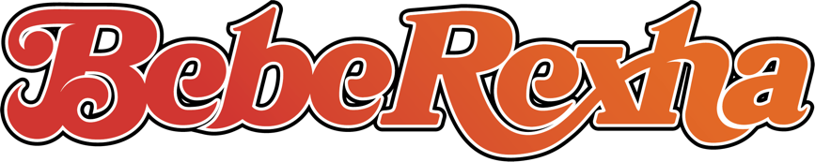

BEBE REXHA BEGINS NEW ERA WITH ‘70s INFUSED POP ANTHEM “HEART WANTS WHAT IT WANTS”

WATCH THE SULTRY VIDEO HERE

NEW SINGLE FOLLOWS THE SUCCESS OF #1 GLOBAL SMASH HIT “I’M GOOD (BLUE)” WITH DAVID GUETTA

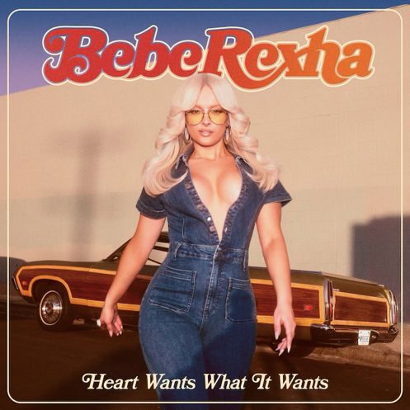
Hi-Res download HERE

February 17, 2023 (Los Angeles, CA) – Today, multi-platinum pop sensation Bebe Rexha returns with the undeniable new single “Heart Wants What It Wants.” Listen HERE via Warner Records. Bold, addictive and filled to the brim with attitude, the ‘70s-inflected pop anthem is a love letter to the crowd-pleasing pop of yesteryear with a very modern twist. The song’s throwback theme is reflected in the feel-good video. Watch the sultry clip HERE.

“‘Heart Wants What It Wants’ is about the time in relationships where you fall out of love with your partner,” Rexha says of her new single. “It’s an anthem about wanting what you want and not being apologetic for it. It could be anything you feel conflicted about wanting and not specific to romance.” Moreover, the hitmaker just wants to make people dance: “At a place in life after a pandemic where sad songs are of the past, I just want everyone to have a good time.”

“Already met a man like you, already seen all of your moves,” she coos over propulsive beats and driving guitar. “One step ahead, I’m onto you — I feel nothing when we’re loving, when we’re touching.” Rexha drives the point on the defiant chorus: “My heart only wants what it wants ‘til it doesn’t.” It’s another arena-ready anthem to add to a discography bursting with radio hits and unforgettable earworms.

“Heart Wants What It Wants” follows the singer-songwriter’s global smash “I’m Good (Blue),” a David Guetta-assisted riff on Eiffel 65’s “Blue (Da Ba Dee)” that exploded on TikTok, before topping the charts in more than 20 countries and amassing over 1.1 billion streams. It reached #1 at Top 40, Hot AC and Dance radio, is certified Platinum and was nominated for a GRAMMY Award along with winning an MTV European Music Award.

After cutting her teeth as an in-demand songwriter (she penned Eminem and Rihanna’s “The Monster,” among other hits), Rexha started churning out smashes of her own including multi-platinum G-Eazy collaboration “Me, Myself & I” and Martin Garrix-produced club sensation “In The Name Of Love.” In 2017, she struck gold with “Meant To Be,” a country duet with Florida Georgia Line that was certified Diamond (10x Platinum). Rexha has since garnered over 16 billion cumulative streams.

“Meant To Be” earned Rexha a nomination for Best Country Duo/Group Performance at the 61st Annual GRAMMY Awards, where she was also up for Best New Artist. The pop star has released two critically acclaimed albums, 2018’s Expectations and 2021’s Better Mistakes. If “Heart Wants What It Wants” is any indication, Rexha’s hotly-anticipated third album will be her most ambitious and intoxicating body of work yet.

FOLLOW BEBE REXHA:
Official | Twitter | Instagram | Facebook | TikTok | Press Site

For more information on Bebe Rexha, please contact:
Darren Baber | Warner Records
darren.baber@warnerrecords.com

