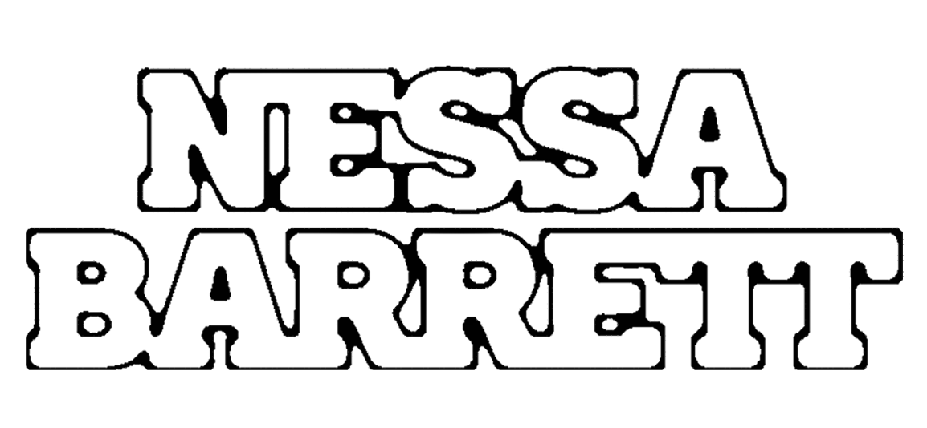

RISING POP STAR NESSA BARRETT COMES FOR BLOOD ON NEW SINGLE “BANG BANG!”

LISTEN HERE | WATCH HERE

YOUNG FOREVER HEADLINE TOUR KICKS OFF FEB 22ND

OVER 1 BILLION CAREER STREAMS!

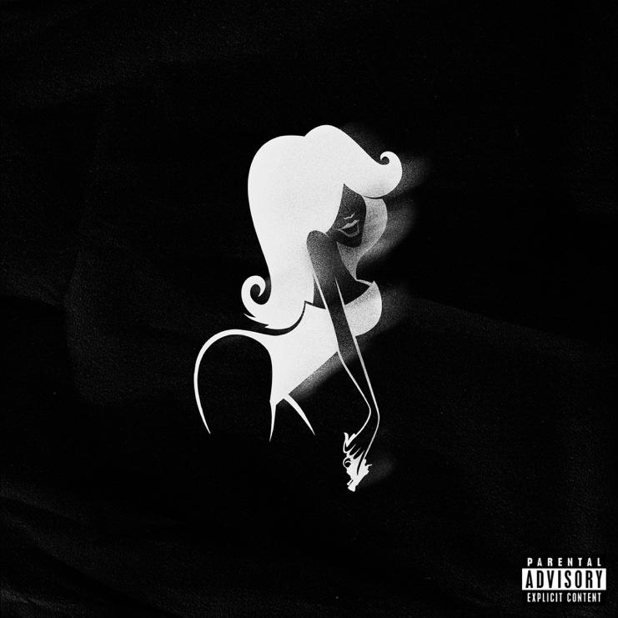
Hi-Res Download HERE

February 17, 2023 (Los Angeles, CA) – Today, breakout pop artist Nessa Barrett unleashes her menacing new track “BANG BANG!”. Listen HERE via Warner Records. Boasting a pulse-pounding beat and an insidious bassline, the punk-infused anthem showcases Barrett’s razor-sharp lyrics and knack for unforgettable hooks. It’s the newcomer’s first release since dropping the extended edition of her debut album young forever in late 2022.

“I know that it sounds absurd, but sometimes I just get the urge,” the 20-year-old begins the track over raucous guitars. “That if there really was a purge, you’re the one that I’d kill first.” Barrett excels at crafting infectious tracks tinged with playful, swirling darkness — and “BANG BANG!” is no exception. In fact, she embraces the impulse even more, giving fans a slice of delicious depravity that demands to be played again and again.

“The song was written about my borderline personality rage,” Barrett says of “BANG BANG!” “There’s times where I just get so mad that I think about the craziest things I want to do in that moment, I feel like everyone deep down has intrusive thoughts even though they don’t want to admit it.” That sense of fury is perfectly captured in the grainy, black-and-white video which finds the pop artist embracing her crazy as she poses for a mugshot. Watch it HERE.

“BANG BANG!” is sure to be a highlight of Barrett’s first-ever headlining tour of North America, which kicks off in Phoenix, AZ on February 22, followed by stops in Atlanta, Philadelphia, Boston, New York, and Chicago. The young forever tour draws to a close in Los Angeles on March 25 at the historic Hollywood Palladium. Buy tickets HERE and see all the dates below. Later this year, she will also perform at the prestigious Reading and Leeds Festival in the UK.

After being named as one of Billboard’s “21 Under 21” — as well as being featured on Ones to Watch’s list of “25 Artists to Watch in 2022,” Uproxx’s “Next Hitmakers List,” and People Magazine’s “Emerging Artist List” — Barrett has gone on to accumulate more than 1.2 billion audio streams to date. She was also nominated for Push Performance of the Year at the 2022 MTV VMAs, performed at When We Were Young Festival and gave a one-off show at LA’s El Rey Theatre.

With unapologetic ear candy like “BANG BANG!” and a critically acclaimed debut album under her belt, Barrett is destined to reach even greater heights in 2023.

Nessa Barrett’s 2023 young forever Tour:

Feb 22 – Phoenix, AZ @ Crescent Ballroom
Feb 23 – Phoenix, AZ @ Crescent Ballroom
Feb 25 – Houston, TX @ RISE Rooftop
Feb 26 – Dallas, TX @ HOB – Cambridge Room/Echo Lounge & Music Hall
Feb 28 – Atlanta, GA @ The Eastern
Mar 2 – Philadelphia, PA @ The Fillmore
Mar 3 – Washington, D.C. @ The Anthem
Mar 5 – New York @ Terminal 5
Mar 6 – Boston, MA @ Roadrunner
Mar 8 – New York @ Irving Plaza
Mar 9 – New York @ Irving Plaza
Mar 11 – Toronto, ON @ Phoenix Concert Theatre
Mar 13 – Chicago, IL @ Byline Bank
Mar 14 – St. Paul, MN @ Palace Theatre
Mar 16 – Denver, CO @ Mission Ballroom
Mar 17 – Magna, UT @ The Great Saltair
Mar 19 – San Francisco, CA @ The Masonic
Mar 21 – Los Angeles, CA @ Fonda Theatre
Mar 22 – Los Angeles, CA @ Fonda Theatre
Mar 25 – Hollywood, CA @ Palladium
Aug 23 – Wetherby, UK @ Reading and Leeds Festival
Aug 27 – Wetherby, UK @ Reading and Leeds Festival

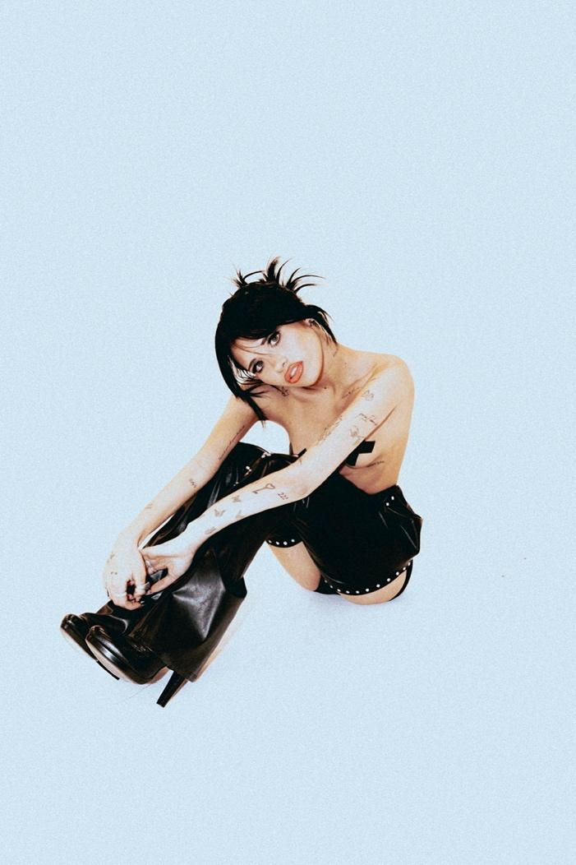
Photo credit: Colin Miller

Follow Nessa Barrett:
Official | TikTok | Instagram | Twitter | Facebook | YouTube | Press Materials | Store

Nessa Barrett contact:
Darren Baber | Warner Records
Darren.Baber@warnerrecords.com

Tour press:
Delanee Wilson | Warner Records
Delanee.Wilson@warnerrecords.com

