GLOBAL SUPERSTAR ANNE-MARIE RELEASES NEW SINGLE “SAD B!TCH”

LISTEN HERE | WATCH THE OFFICIAL VIDEO HERE
THIRD ALBUM DUE OUT THIS YEAR

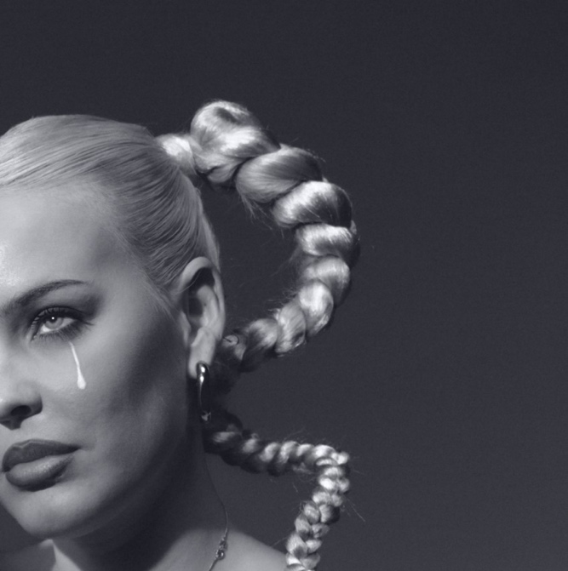
Hi-Res Download HERE
February 3, 2023 (Los Angeles, CA) — Global superstar Anne-Marie shares her unapologetic new single “Sad B!tch” today via Warner Records — listen HERE. The official video, shot in Southend-on-Sea, Essex, follows an exuberant Anne-Marie around an empty theme park, fully embracing her own happiness — watch HERE.
About the song, Anne-Marie explains, “’Sad B!tch’ is a song about not being sad anymore. Whether you’ve had a break-up, lost someone, you’re feeling down, or just hate your boss. It’s time for happiness. It’s time for a change of plan. Time to put yourself first. Time to turn the page. Leave it behind and start again. A new chapter, a new storyline. A new you.”
Produced by Evan Blair (Dove Cameron), BillenTed (Little Mix, Tom Grennan) and Upsahl (Iann Dior) – with the latter also penning the track alongside Anne-Marie – “Sad B!tch” timestamps a period in Anne-Marie’s life when she looked inward and reassessed her self-worth. A track that comes packaged with the wit and directness that has only added to the telling-it-as-it-is star’s enormous ascent, “Sad B!tch” knocks self-loathing on its head and finds her taking back the reigns on her feelings.
Today’s release is the official follow-up to Anne-Marie’s smash hit “Psycho” feat. Aitch, which permeating TikTok and has amassed over 120M global streams to date.
Crowned with the ‘Music Award’ at Glamour UK’s Women of the Year Awards in November 2022 proved a triumphant one for Anne-Marie. Selling-out an arena tour, including a show at London’s Wembley Arena, Anne-Marie also returned to TV screens as a lead coach on The Voice UK.
Anne-Marie is currently recording her third album, which is set for release later this year.

About Anne-Marie
Anne-Marie has become one of the globe’s most successful pop stars since her breakthrough in 2016. She has over 7 billion streams to her name, a platinum debut album alongside seven Top 10 UK singles and two Billboard Hot 100 hits. She has garnered dozens of award nominations, sold out her global headline tour and supported Ed Sheeran in stadiums everywhere. In 2020, alongside charitable work and recording, Anne-Marie released her first-ever documentary titled ‘How To Be Anne-Marie’ exclusively with YouTube. In 2021, she released her sophomore album Therapy which includes her hit singles "Don't Play" with KSI and Digital Farm Animals, "Way Too Long" featuring Nathan Dawe and MoStack, and “Our Song” with Niall Horan. In 2022, she saw immense success with her most recent hit, “Psycho” with Aitch.

Follow Anne-Marie
Official | Instagram | Twitter | Facebook | YouTube | TikTok | Press Materials

For more information, please contact:
Darren Baber | Warner Records
Darren.Baber@warnerrecords.com

