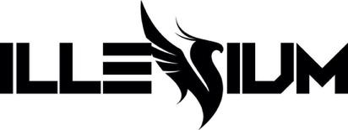

ILLENIUM RETURNS WITH NEW SINGLE “LUV ME A LITTLE” FEATURING NINA NESBITT

ANNOUNCES HIGHLY ANTICIPATED 5th STUDIO ALBUM ILLENIUM OUT APRIL 28TH

REVEALS MASSIVE ILLENIUM LIVE 2023 WORLD TOUR DATES

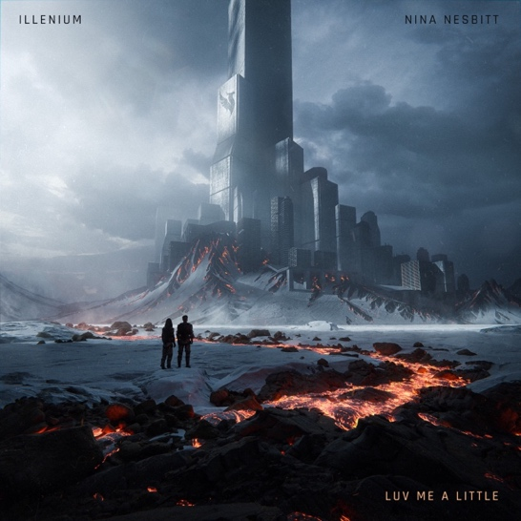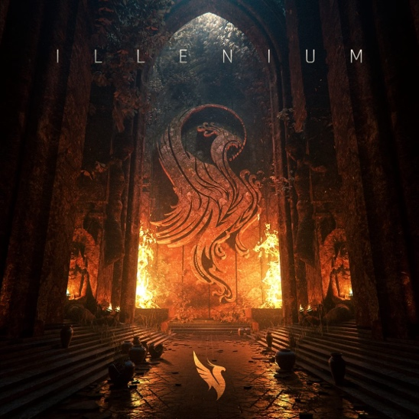
“Luv Me A Little” single art | ILLENIUM album art
Hi-Res Downloads HERE

January 20, 2023 (Los Angeles, CA) – Today, GRAMMY® Award-nominated artist/producer ILLENIUM returns with his first release of 2023, an entrancing and engaging new single entitled “Luv Me A Little” [feat. Nina Nesbitt]. The song heralds the arrival of ILLENIUM’s anxiously awaited fifth full-length self-titled album, ILLENIUM, out April 28th. Listen to “Luv Me A Little” HERE / Pre-order ILLENIUM HERE.

Also today, ILLENIUM announced his massive 2023 headlining world tour ILLENIUM LIVE. Throughout the year, he will take his biggest and boldest blockbuster live set on the road through North America, Europe, and Australia. The tour kicks off in North America at The Gorge in George, WA on May 27 and includes stops in his hometown of San Francisco,Minneapolis, Dallas, Atlanta, Brooklyn (NY) and Chicago (Bridgeview). The tour winds through Europe and Australia with shows in Milan, Paris, London, and Sydney, before wrapping up in Brisbane on December 2.

For North America: presales begin January 24 at 10AM local time. Sign up for early access at Illenium.live. Fans who sign up for early access to tickets via Illenium.live will also get access to a special offer on the double LP orange translucent vinyl (while supplies last). Public on sale begins January 27 at 10AM local time. A limited number of exclusive VIP packages will also be available starting Tuesday January 24 at 10AM local time. These exclusive offers can include amazing general admission tickets (with early-entry and first access to the floor), crowd free merchandise shopping, limited-edition merchandise and more. Full list of tour dates below.

On sale details for Europe and Australia will be announced soon.

“Luv Me A Little” lands in the wake of his 2022 releases, “Worst Day” [feat. MAX], “From The Ashes” [feat. Skylar Grey], the #1 US dance radio hit “All That Really Matters” [feat. Teddy Swims] and “Shivering” [feat. Spiritbox]. The dance music superstar also closed out the year with a remix of Taylor Swift’s #1 Billboard Hot 100 smash “Anti-Hero.” Very soon, he will reveal the full scope and line-up of collaborators on ILLENIUM and shine a light on his sonic, visual, and emotional evolution once again. This is ILLENIUM’s first full length offering since 2021’s FALLEN EMBERS, which earned him a Billboard Music Award for Top Dance/Electronic Album, garnered his first GRAMMY® Award nomination for Best Dance/Electronic Album, and pushed his total career streams to over 7 billion.

Making a statement with his most powerful, passionate, and pure work to date, get ready to experience ILLENIUM like never before in 2023.

ILLENIUM LIVE 2023 TOUR DATES

NORTH AMERICA
May 27 – George, WA @ The Gorge*
May 28 – George, WA @ The Gorge*
Jun 2 – San Francisco, CA @ Chase Center
Jun 4 – Stateline, NV @ Lake Tahoe Outdoor Areana at Harveys
Jun 8 – Bonner Springs, KS @ Azura Amphitheater
Jun 9 – Minneapolis, MN @ The Armory
Jun 10 – Minneapolis, MN @ The Armory
Jun 17 – Denver, CO @ Empower Field at Mile High*
Jun 20 – Cleveland, OH @ Jacobs Pavilion
Jun 21 – Newport, KY @ MegaCorp Pavilion
Jun 23 – Rothbury, MI @ Electric Forest*
Jun 27 – St. Louis, MO @ The Factory
Jun 28 – Huntsville, AL @ The Orion Amphitheater
Jun 30 – Austin, TX @ Moody Center
Jul 1 – Dallas, TX @ Dos Equis Pavilion
Jul 2 – Houston, TX @ 713 Music Hall
Jul 7 – Atlanta, GA @ Lakewood Amphitheatre
Jul 8 – Orlando, FL @ Orlando Amphitheater
Jul 13 – Pittsburgh, PA @ Stage AE Outdoors
Jul 14 – Brooklyn, NY @ Barclays Center
Jul 15 – Columbia, MD @ Merriweather Post Pavilion
Jul 20 – Indianapolis, IN @ TCU Amphitheater at White River State Park
Jul 21 – Detroit, MI @ Masonic Temple Theatre
Jul 22 – Bridgeview, IL @ SeatGeek Stadium
*on sale

EUROPE
Oct 11 – Barcelona, Spain
Oct 13 – Milan, Italy
Oct 20 – Amsterdam, Netherlands
Oct 21 – Brussels, Belgium
TBA – London, England
TBA – Paris, France

AUSTRALIA
Nov 25 – Sydney, Australia
Dec 1 – Melbourne, Australia
Dec 2 – Brisbane, Australia

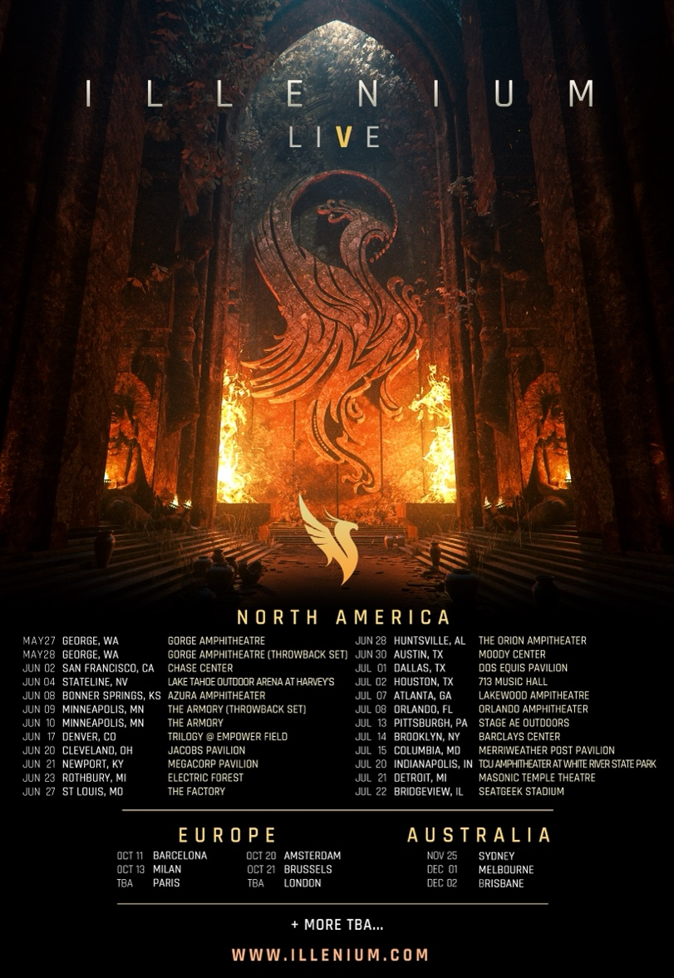

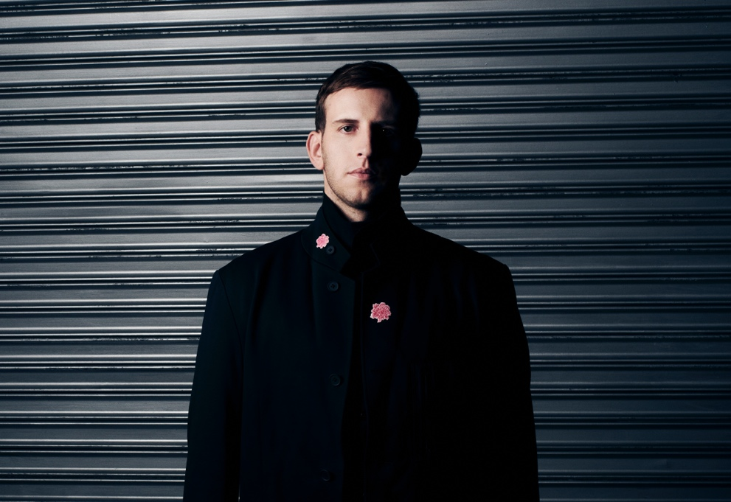
Credit: Lindsey Byrnes | Hi-Res Download HERE

Follow ILLENIUM:
Official | Instagram | Twitter | TikTok | YouTube | Press Materials

ILLENIUM Contact:
Darren Baber | Warner Records
Darren.Baber@warnerrecords.com

Regional: Delanee Wilson | Warner Records
Delanee.Wilson@warnerrecords.com

