THE BLESSED MADONNA RELEASES FIRST
SINGLE IN 5 YEARS “SEROTONIN
MOONBEAMS” WITH UFFIE
— LISTEN HERE

SIGNS TO WARNER RECORDS

HEADLINES HER LEGENDARY WE STILL BELIEVE PARTY
IN LONDON ON NOVEMBER 18TH

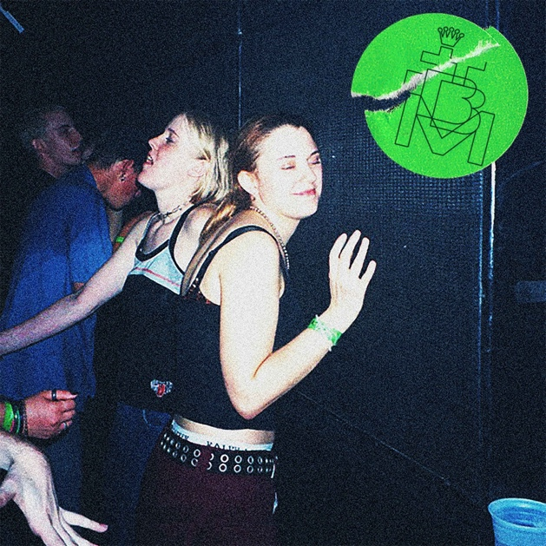
Download Hi-Res artwork HERE

November 11, 2022 (Los Angeles, CA) — Today, Marea Stamper, aka Kentucky-born, London-based artist, DJ, producer and club culture iconoclast The Blessed Madonna, releases her brand new single “Serotonin Moonbeams”. Her first solo release since 2017’s sumptuous disco house anthem “He Is The Voice I Hear,” the track sees her teaming up with vocalist Uffie on a track that’s been tearing up dance floors in TBM sets throughout the summer. The clue is absolutely in the title: “Serotonin Moonbeams” is house music at its most wide-eyed, celebratory, communal and, most importantly, fun. Listen to “Serotonin Moonbeams” HERE.

On “Serotonin Moonbeams,” The Blessed Madonna says:

“We talked about what it was like to fall in love in the Vicks Vapo-rub, candy soaked raves of the 90s. It's about "cuddle puddles" and the intense emotional, physical and spiritual connections that can form when serotonal conditions are right. Barriers that might exist in a normal dating atmosphere evaporate and strangers can become intimate and beloved figures in an instant. It's gotten an incredible response since I tested it the first time in Brazil on tour. It was written on one of those days where I was running from the production console to the sofa to bang out lyrics with Uffie and Jin Jin. I remember being so embarrassed to suggest, "Bet I hit you with that bad bitch, thunder lightning, super frightening yeah!" But when I did, they just howled and we knew we were onto something.”

An overnight sensation two decades in the making, The Blessed Madonna is an artist whose career is woven into the fabric of dance music past, present and future. Whether promoting illegal raves to 50 people in sweaty Kentucky basements as a teenager, headlining the biggest stages and festivals around the world, working alongside house legends like Frankie Knuckles or fearlessly taking on one of the most improbable, ambitious remix projects in recent times with Club Future Nostalgia (her collaborative album with pop icon Dua Lipa), The Blessed Madonna is synonymous with inclusive, unifying, cathartic dance music.

In recent years, The Blessed Madonna has channeled the emotions of millions as the vocalist on Fred again..’s lockdown anthem “Marea (We Lost Dancing)”, become the voice of Saturday night radio, been immortalized as a GTA5 character and provided remixes for the likes of The Chemical Brothers, Florence & The Machine and, improbably, Elton John. With “Serotonin Moonbeams,” she is set to usher in a whole new era. A stop-you-in-your-tracks moment in its own right, it’s also the starting pistol for a run of new releases over the coming months; the first results from a year’s worth of blood, sweat, tears and joy in the studio for 50 hours a week with some of her best friends. There are even rumors of a debut album. Watch this space.

Meanwhile, following a summer of live appearances that have taken her around the world, The Blessed Madonna returns to her adopted London hometown this month to headline another of her legendary We Still Believe parties. The event takes place on Friday 18th November at Koko and features a personally curated line that also features Young Marco, Paula Tape and Ruby Savage.

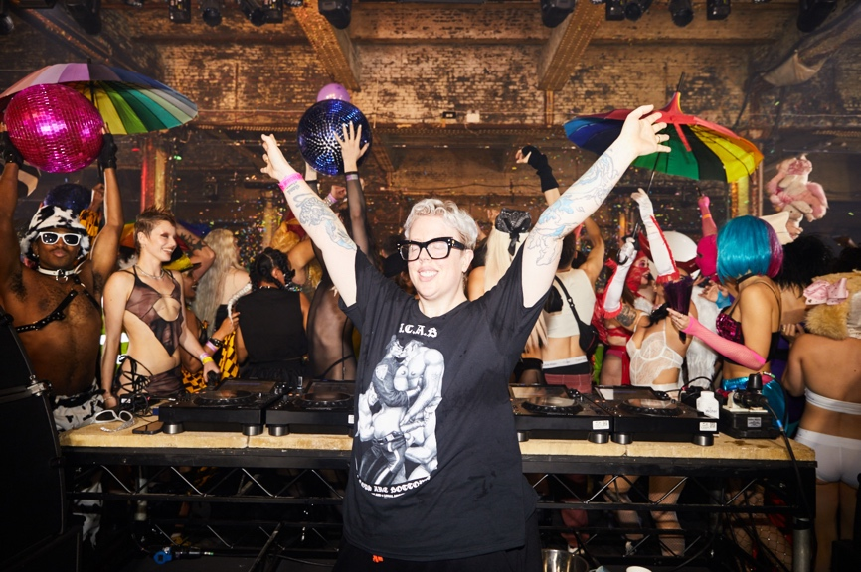
(The Blessed Madonna, credit Eva Pentel, Hi-Res)

FOLLOW THE BLESSED MADONNA:
Official | Instagram | Facebook | Twitter

For more information, please contact:

Darren Baber | Warner Records
Darren.Baber@warnerrecords.com

Judy Miller Silverman | Motormouth Media
Judy@motormouthmedia.com

