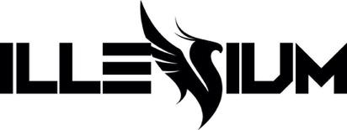

ILLENIUM LINKS WITH AMERICAN TEETH FOR EXPLOSIVE ANTHEM “INSANITY”
LISTEN HERE

ILLENIUM LIVE WORLD TOUR KICKS OFF MAY 27

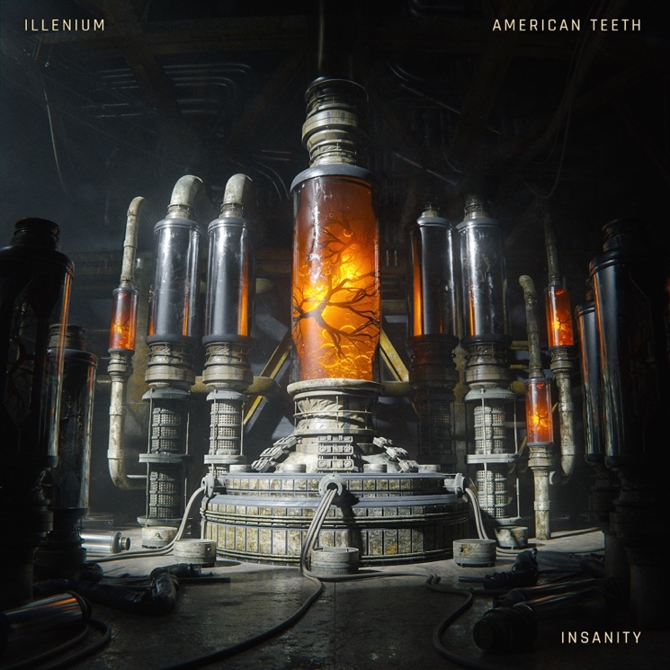
Hi-res download HERE

March 3, 2023 (Los Angeles, CA) – Today, GRAMMY® Award-nominated artist and producer ILLENIUM unleashes “Insanity,” a soaring electronic-rock collaboration with American Teeth. Listen HERE via Warner Records. The track is the genre-fusing hitmaker’s follow-up to recent hit “Luv Me A Little (feat. Nina Nesbitt).” Watch the lyric video HERE.

Self-sabotage is the theme of “Insanity,” which American Teeth’s Elijah Noll drives home in the defiant lyrics. “If there’s a whip, well then I might crash it,” he belts over acoustic guitar strums and shimmery synths. “If there’s a hotel, then I might smash it.” That pattern of behavior also applies to relationships. “You get too close, that’s when I let go,” Noll warns, “You say it’s insanity, but I say that’s my life.”

“Everything about this song just feels so anthemic to me,” ILLENIUM says of the latest tantalizing taste of his upcoming fifth album ILLENIUM (pre-save HERE). “Elijah sounds absolutely epic and killed his performance on this record. It feels so nostalgic and I can’t get it out of my head.” Noll is similarly proud of the song, which he describes as “a journey through the dangers of living life on the edge.” For him, it’s about “getting lost in a reckless lifestyle and the inevitable chaos that ensues when trying to navigate a relationship.”

ILLENIUM will kick off his ILLENIUM LIVE world tour on May 27th with a 2-night stint at the Gorge Amphitheatre. The tour runs in the US through July 22nd before heading to Europe—where new dates have been added—and Australia. Tickets for the Australian leg will be available March 7th at 11am local time, and the European leg will go on sale March 10th at 10am local time. Get tickets HERE.

“Insanity” follows ILLENIUM’s recent single “Luv Me A Little” featuring Nina Nesbitt. Prior to that, he reached #1 at US dance radio with the Teddy Swims-assisted “All That Really Matters” and rolled out “From The Ashes” featuring Skylar Grey. The tracks will all feature on ILLENIUM’s forthcoming self-titled album, to be released April 28th. Pre-order HERE. This summer, the producer will perform the biggest show of his career — Trilogy: Colorado at Empower Field at Mile High in Denver, CO on Saturday, June 17 for three unique sets over one night.

With “Insanity,” ILLENIUM once again demonstrates his ability to craft songs that defy genre and convention, while resonating emotionally and lodging instantly in your brain.

ILLENIUM LIVE 2023 TOUR DATES

NORTH AMERICA
May 27 – George, WA @ The Gorge
May 28 – George, WA @ The Gorge
Jun 2 – San Francisco, CA @ Chase Center
Jun 3 – San Francisco, CA @ Chase Center
Jun 4 – Lake Tahoe, NV @ Lake Tahoe Outdoor Areana at Harveys
Jun 8 – Bonner Springs, KS @ Azura Amphitheater
Jun 9 – Minneapolis, MN @ The Armory
Jun 10 – Minneapolis, MN @ The Armory
Jun 17 – Denver, CO @ Empower Field at Mile High
Jun 20 – Cleveland, OH @ Jacobs Pavilion
Jun 21 – Newport, KY @ MegaCorp Pavilion Outdoor
Jun 23 – Rothbury, MI @ Electric Forest
Jun 27 – St. Louis, MO @ The Factory
Jun 28 – Huntsville, AL @ The Orion Amphitheater
Jun 30 – Austin, TX @ Moody Center
Jul 1 – Dallas, TX @ Dos Equis Pavilion
Jul 2 – Houston, TX @ 713 Music Hall
Jul 7 – Atlanta, GA @ Lakewood Amphitheatre
Jul 8 – Orlando, FL @ Orlando Amphitheater
Jul 13 – Pittsburgh, PA @ Stage AE Outdoors
Jul 14 – Brooklyn, NY @ Barclays Center
Jul 15 – Columbia, MD @ Merriweather Post Pavilion
Jul 20 – Indianapolis, IN @ TCU Amphitheater at White River State Park
Jul 21 – Detroit, MI @ Masonic Temple Theatre
Jul 22 – Bridgeview, IL @ SeatGeek Stadium
Aug 4 – Toronto, ON @ Veld Music Festival

EUROPE
Oct 11 – Barcelona, Spain @ Razzmatazz
Oct 13 – Milan, Italy @ Fabrique
Oct 14 – Warsaw, Poland @ Progresja
Oct 18 – Paris, France @ Elysée Montmartre
Oct 20 – Amsterdam, Netherlands @ MELKWEG
Oct 21 – Brussels, Belgium @ La Madeleine
Oct 26 – London, England @ Electric Brixton

AUSTRALIA
Nov 25 – Sydney, Australia @ Hordern Pavillion
Dec 1 – Melbourne, Australia @ John Cain Arena
Dec 2 – Brisbane, Australia @ The Fortitude Music Hall

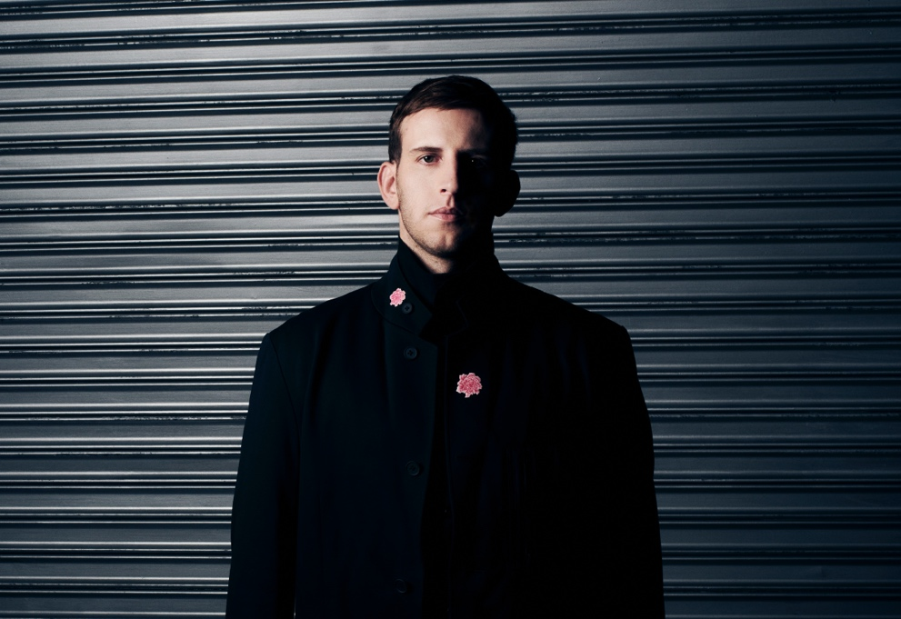
Credit: Lindsey Byrnes | Hi-Res Download HERE

FOLLOW ILLENIUM:
Website | Twitter | Instagram | Facebook | YouTube

For more information, please contact:
Darren Baber | Darren.Baber@warnerrecords.com

