COUNTRY STAR WARREN ZEIDERS RELEASES NEW SINGLE
“WEST TEXAS WEATHER”

LISTEN HERE / WATCH HERE

PRETTY LITTLE POISON TOUR UNDERWAY NOW!

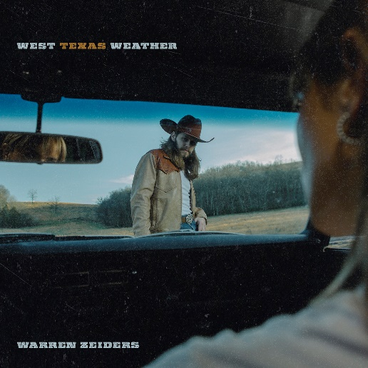
(Click HERE for Hi-Res Image)

February 24, 2023 (Los Angeles, CA) – Country music’s fastest rising star Warren Zeiders unveils a new single entitled “West Texas Weather” today via Warner Records. It notably marks his first release of 2023 and paves the way for much more to come in the near future. Listen HERE and watch HERE.

The track clearly illustrates his exponential advances as both a powerhouse vocalist and songwriting force to be reckoned with. During the verses, a vibrant acoustic guitar brushes up against his gruff and gritty delivery. Meanwhile, it culminates on a chantable chorus, “She’s as wild as West Texas Weather.” As the hook rings out, a burning guitar solo lifts off to underscore the songs emotional intention. Zeiders comments on the track, “Hard to believe this was the 3rd song I had ever written in my life, but I’m super excited to share this tune with y’all from my forthcoming debut album.”

Gearing up for another chapter, Zeiders is in the thick of putting together his anxiously awaited full-length debut for Warner Records later this year.

Zeiders is currently on the road for his biggest headline run to date, the Pretty Little Poison Tour. Tickets are available HERE. Canvasing North America for nearly three months coast-to-coast, the run concludes with his 100th show to date at Stagecoach Festival 2023 in Indio, CA on April 30. Additionally, he’ll perform outside the US for the first time in Australia at the CMC Rocks QLD on March 16.

In 2022, 717 Tapes: The Album notably collected all of Zeiders’ critically acclaimed 717 Tapes singles, EP tracks and a few new songs in a single package including his recently released “Up To No Good”
and “One Hell Of An Angel,” propelling him to the next chapter of his career and cementing the 717 Tapes legacy. He also made his Grand Ole Opry debut in the Summer of 2022—a rite of passage for country’s best and brightest. The 23-year-old burst onto the country music scene only a few years ago, emerging as one of the genre’s fastest rising success stories in recent history, garnering over 1.4 billion views on TikTok and leading People Magazine to observe “Warren Zeiders is a ‘Wild Horse’ who sings about "the truth.’"

2023 Pretty Little Poison Tour Dates:
Feb 24 Atlanta, GA Variety Playhouse
Feb 25 Corinth, MS Crossroads Arena
Mar 02 Fayetteville, AR George’s Majestic Lounge
Mar 03 Starkville, MS Rick’s Cafe
Mar 04 Baton Rouge, LA Texas Club
Mar 16 Willowbank, Australia CMC Rocks QLD
Mar 30 Peoria, IL Crusens Farmington Road
Mar 31 Rosemont, IL Joe’s Live
Apr 01 Milwaukee, WI The Rave / Eagles Club
Apr 06 Cincinnati, OH Bogart’s
Apr 07 Rootstown, OH The Dusty Armadillo
Apr 08 Grand Rapids, MI The Intersection
Apr 13 Des Moines, IA Wooly’s
Apr 14 Columbia, MO The Blue Note
Apr 15 Lawrence, KS The Granada
Apr 21 Denver, CO Grizzly Rose
Apr 22 Salt Lake City, UT The Complex
Apr 23 Boise, ID Knitting Factory Concert House
Apr 26 Reno, NV Cargo Concert Hall
Apr 27 Santa Cruz, CA Catalyst
Apr 28 Sacramento, CA Ace of Spades
Apr 30 Indio, CA Stagecoach Festival
May 26 Roanoke, VA Dr. Pepper Park at The Bridges
May 27 Columbus, OH Buckeye Country Superfest
Jun 02 Panama City Beach, FL Gulf Coast Jam
Jun 10 Clinton, IA Tailgate n’ Tallboys
Jun 16 North Lawrence, OH Country Fest
Jun 17 Bloomington, IL Tailgate n’ Tallboys
Jun 24 Clearwater, NE Clearwater Rodeo
Jul 06 Fort Loramie, OH Country Concert
Jul 07 Independence, IA Buchanan County Fairgrounds & Campgrounds
Jul 14 West Salem, WI Country Boom
Jul 15 Brooklyn, MI Faster Horses Festival
Jul 27 Three Forks, MT Headwaters Country Jam
Aug 04 Sweet Home, OR Oregon Jamboree Music Festival
Aug 05 Quincy, WA Watershed Festival

# # #

Warner Records Contacts:
National: Rick Gershon | rick.gershon@warnerrecords.com
Regional/Tour: Delanee Wilson | Delanee.wilson@warnerrecords.com

FOLLOW WARREN ZEIDERS:
Facebook | Instagram | Twitter | TikTok | YouTube | Spotify

