**BRYCE VINE UNVEILS BRAND NEW *SEROTONIN* EP**

**LISTEN** [**HERE**](https://brycevine.lnk.to/Serotonin)

**AI-GENERATED VIDEO FOR “NOSTALGIA” OUT NOW**

**WATCH** [**HERE**](https://brycevine.lnk.to/NostalgiaMusicVideo)

**NORTH AMERICAN HEADLINE TOUR UNDERWAY**

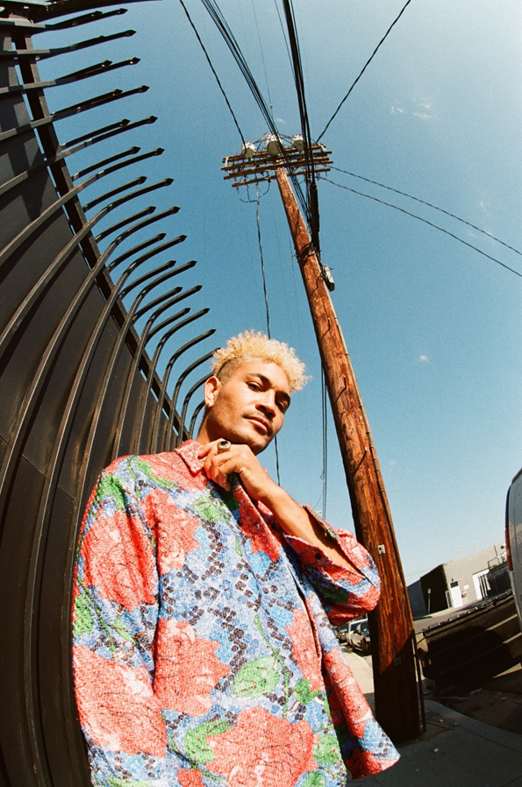

**March 10, 2023 (Los Angeles, CA)** – After building up anticipation with a series of fan favorite releases, multi-platinum maverick **Bryce Vine** uncovers his new ***Serotonin* EP** today via **Warner Records**. Alongside the new project, **Bryce** has teamed up with artist **Chris Gardner** to create an innovative AI-generated video for new single **“Nostalgia,”** which utilizes cutting-edge, custom trained AI facial recognition models that have been made specifically for **Bryce**, making it one of the only – if not the first – music videos to use such technology. Check out the **“Nostalgia” video** [**HERE**](https://brycevine.lnk.to/NostalgiaMusicVideo)and listen to the ***Serotonin* EP** [**HERE**](https://brycevine.lnk.to/Serotonin)**.**

To celebrate, **Bryce** is in the midst of a six-week **North American headline tour**, rolling through venues across the U.S. and Canada this spring. See a full list of dates below, and purchase remaining tickets for **Bryce**’s 2023 tour [**HERE**](http://www.brycevine.com).

The five-track body of work was crafted alongside several acclaimed producers, including 7X GRAMMY Award-winning producer **Federico Vindver** [Jack Harlow, Justin Bieber, Kanye West], **Aaron Zuckerman** [LANY, Bebe Rexha, Lil Wayne], **Alex Delicata** [Kygo, One Republic, Meek Mill],  **Ryan Daly** [John Legend, blackbear, Cheat Codes], long-time collaborator **JP Clark** [Yung Gravy, Mod Sun, Blink 182], **Ryan Wheeler, William Van Zandt**, and UK based producer duo **Dumb Buoys Fishing Club**.

***Serotonin*** illuminates the nuances of his signature genre alchemy as he delivers dreamy melodic anthems lyrically laced with intimately insightful thoughts and truths. In addition to the fan favorite collaboration **“Help”** [feat. **PHEELZ**] – which [*VMAN*](https://nam04.safelinks.protection.outlook.com/?url=https%3A%2F%2Fvman.com%2Farticle%2Fbryce-vine-and-pheelz-collaborate-on-new-single%2F&data=05%7C01%7CPatrice.Compere%40warnerrecords.com%7Cd2843268bc2c49a6ac2308db210c8584%7C8367939002ec4ba1ad3d69da3fdd637e%7C0%7C0%7C638140109890923233%7CUnknown%7CTWFpbGZsb3d8eyJWIjoiMC4wLjAwMDAiLCJQIjoiV2luMzIiLCJBTiI6Ik1haWwiLCJXVCI6Mn0%3D%7C3000%7C%7C%7C&sdata=Epw4eQokimZIHe4NMCL%2BEaydCTAvcvKiNXaY%2FCe2Kz8%3D&reserved=0)hailed as *“a dance breakup anthem”* – and most recent single **“Gold Rush**,**”** the opening track **“Nostalgia”** skates over airy guitar towards a chantable chorus as he confesses, *“Let me put my fucking phone down, and slow it down, I don’t wanna be alone now, not now*.*”* Elsewhere, **“Grow Up”** [feat. **Josef Salvat**] layers a hypnotic hook above a simmering beat with the proclamation, *“I don’t wanna grow up*.*”* Then, there’s **“Stay Afloat**.**”** Acoustic guitar threads around a glitchy beat as his laidback flow dips in and out of a buoyant groove punctuated by a bubbly sample.

About the new project, **Bryce** shares, *“With* ***Serotonin****, I’m inviting you to walk with me down the path of nostalgia and open the door into my daydreams. I want us to rediscover curiosity, a sense of adventure…and the joy that comes from a never-ending summers, driving with the windows down, and feeling invincible. My goal with this project is purely to reinstall that rare rush of serotonin we all deserve to feel and let it playfully linger in the back of our minds for as long as we can…”*

*Download hi-res images + tour admat* [*here*](https://press.warnerrecords.com/brycevine)

**ABOUT BRYCE VINE**

Since popping off with the double-platinum smash [“Drew Barrymore”](https://nam04.safelinks.protection.outlook.com/?url=https%3A%2F%2Fwww.youtube.com%2Fwatch%3Fv%3Dkudi8OtMu9s&data=04%7C01%7CPatrice.Compere%40warnerrecords.com%7Cbda7cff1eefb490cf23108da008b5b0e%7C8367939002ec4ba1ad3d69da3fdd637e%7C0%7C0%7C637822895772929712%7CUnknown%7CTWFpbGZsb3d8eyJWIjoiMC4wLjAwMDAiLCJQIjoiV2luMzIiLCJBTiI6Ik1haWwiLCJXVCI6Mn0%3D%7C3000&sdata=O6Nn5lNtGYkRrjAGwKyBap0gzrIBlwRoZA1qQzeQJbo%3D&reserved=0) and platinum [“La La Land”](https://nam04.safelinks.protection.outlook.com/?url=https%3A%2F%2Fwww.youtube.com%2Fwatch%3Fv%3DdgpPCnLlH9g&data=04%7C01%7CPatrice.Compere%40warnerrecords.com%7Cbda7cff1eefb490cf23108da008b5b0e%7C8367939002ec4ba1ad3d69da3fdd637e%7C0%7C0%7C637822895772929712%7CUnknown%7CTWFpbGZsb3d8eyJWIjoiMC4wLjAwMDAiLCJQIjoiV2luMzIiLCJBTiI6Ik1haWwiLCJXVCI6Mn0%3D%7C3000&sdata=6vFYwGqUdwvmlZcsZT28qf2XOQvsOqrgJYFiJO99Bgc%3D&reserved=0) [feat. YG], Bryce has tallied up more than 2 billion streams to date, and delivered a series of unforgettable performances on *Late Night with Seth Meyers*, *Jimmy Kimmel LIVE!*, *Wendy Williams*, *The Kelly Clarkson Show*, *The Late Late Show with James Corden*, *Live with Kelly and Ryan*, *Good Morning America*, and more. He’s pushed himself outside the confines of genre, collaborating with everyone from Wale, lovelytheband and FITZ to Cheat Codes, Loud Luxury, Parmalee, and Jeremih. At the same time, brands such as Pepsi, TRULY, Malibu Rum, Capitol One, and Fender have sought him out for collaborations.

**FOLLOW BRYCE VINE:**

[Website](https://www.brycevine.com/) | [Facebook](https://www.facebook.com/brycevine) | [Twitter](https://twitter.com/brycevine) | [Instagram](http://instagram.com/brycevine/) | [Youtube](https://www.youtube.com/channel/UCHQE-c1JX7Io3zcXgXBQKlw) | [TikTok](https://www.tiktok.com/@brycevine?lang=en)

**For more information on Bryce Vine, please contact:**

[Ceri.Roberts@warnerrecords.com](mailto:Ceri.Roberts@warnerrecords.com)

Patrice.Compere@warnerrecords.com

