RISING COUNTRY STAR WARREN ZEIDERS RELEASES NEW SINGLE
“PRETTY LITTLE POISON” WITH OFFICIAL MUSIC VIDEO
LISTEN HERE | WATCH HERE

ANNOUNCES NEW EP PRETTY LITTLE POISON (SAMPLER)
OUT APRIL 14

ON THE ROAD FOR PRETTY LITTLE POISON TOUR NOW

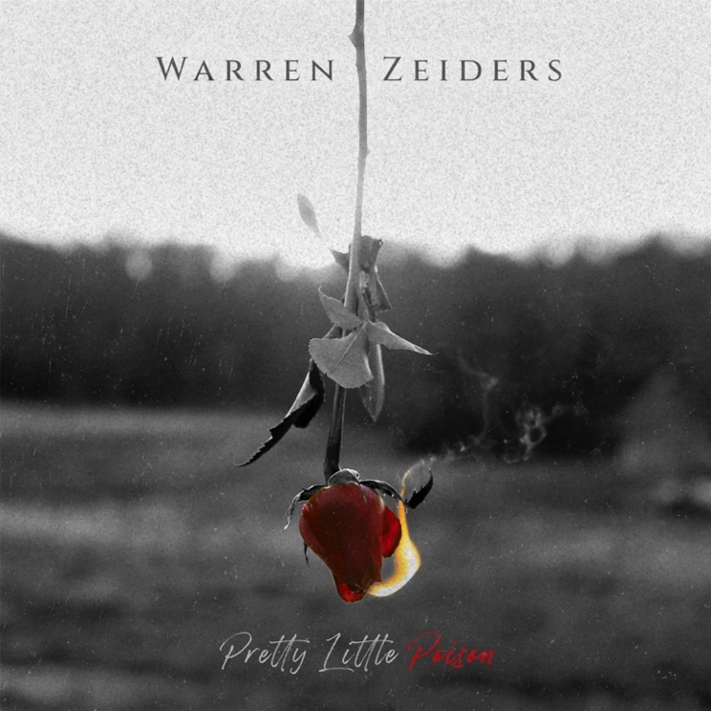
(Hi-res artwork HERE)

March 17, 2023 (Los Angeles, CA) – Today, rising country star Warren Zeiders shares new single “Pretty Little Poison” via Warner Records. Listen HERE and watch the official music video HERE. Alongside the track, he announces the new upcoming EP, Pretty Little Poison (Sampler), to be released on April 14. Including “Pretty Little Poison,” previous single “West Texas Weather,” and two new tracks, the EP is a sampler of what’s to come on Warren’s forthcoming summer album.

Led by Zeiders’ powerful vocals, the stripped-down track illustrates a battle between head and heart. “This is my favorite song that I’ve ever written,” says Zeiders. “Like a moth to a flame, this song is about being led into temptation between love and toxicity. Choosing something or someone that we ultimately know will hurt us in the end.”

Written by Jared Keim, Ryan Beaver and Warren Zeiders and produced by the GRAMMY® Award-winning Ross Copperman, “Pretty Little Poison” arrives on the heels of vibrant single “West Texas Weather.” As he continues to work on his anxiously awaited full-length debut for Warner Records, Zeiders has much more to come in 2023.

The Pretty Little Poison Tour, Zeiders’ biggest headline run to date, is currently underway. New dates have also been added across North America, including performances at Stagecoach, CMA Fest, and Faster Horses Festival. Tickets are available HERE. Full list of dates below.

In 2022, 717 Tapes: The Album notably collected all of Zeiders’ critically acclaimed 717 Tapes singles, EP tracks and a few new songs in a single package, including his recently released “Up To No Good” and “One Hell Of An Angel,” propelling him to the next chapter of his career and cementing the 717 Tapes legacy. He also made his Grand Ole Opry debut in the Summer of 2022—a rite of passage for country’s best and brightest. The 23-year-old burst onto the country music scene only a few years ago, emerging as one of the genre’s fastest rising success stories in recent history, garnering over 1.4 billion views on TikTok and leading People Magazine to observe “Warren Zeiders is a ‘Wild Horse’ who sings about "the truth.’"

2023 Pretty Little Poison Tour Dates:

* New date

Mar 30 Peoria, IL Crusens Farmington Road
Mar 31 Rosemont, IL Joe’s Live
Apr 01 Milwaukee, WI The Rave / Eagles Club
Apr 06 Cincinnati, OH Bogart’s
Apr 07 Rootstown, OH The Dusty Armadillo
Apr 08 Grand Rapids, MI The Intersection
Apr 13 Des Moines, IA Wooly’s
Apr 14 Columbia, MO The Blue Note
Apr 15 Lawrence, KS The Granada
Apr 21 Denver, CO Grizzly Rose
Apr 22 Salt Lake City, UT The Complex
Apr 23 Boise, ID Knitting Factory Concert House
Apr 26 Reno, NV Cargo Concert Hall
Apr 27 Santa Cruz, CA Catalyst
Apr 28 Sacramento, CA Ace of Spades
Apr 30 Indio, CA Stagecoach Festival
May 26 Roanoke, VA Dr. Pepper Park at The Bridges
May 27 Columbus, OH Buckeye Country Superfest
Jun 02 Panama City Beach, FL Gulf Coast Jam
Jun 03 Glencoe, AL BASHI in the Bend*
Jun 08 Nashville, TN CMA Festival*
Jun 10 Clinton, IA Tailgate n’ Tallboys
Jun 15 Valparaiso, IN Central Plaza Park*
Jun 16 North Lawrence, OH Country Fest
Jun 17 Bloomington, IL Tailgate n’ Tallboys
Jun 22 Wichita, KS The Cotillion*
Jun 23 Sioux Falls, SD The District*
Jun 24 Clearwater, NE Clearwater Rodeo
Jul 06 Fort Loramie, OH Country Concert
Jul 07 Independence, IA Buchanan County Fairgrounds & Campgrounds
Jul 13 Arnolds Park, IA Captain’s Getaway*
Jul 14 West Salem, WI Country Boom
Jul 15 Brooklyn, MI Faster Horses Festival
Jul 27 Three Forks, MT Headwaters Country Jam
Jul 29 Wahoo, NE Saunders County Fairgrounds*
Aug 04 Sweet Home, OR Oregon Jamboree Music Festival
Aug 05 George, WA Watershed Festival
Aug 10 Great Falls, MT The Newberry*
Aug 11 Jerome, ID Jerome County Fair & Rodeo*
Aug 12 Grand Junction, CO Warehouse 25 Sixty-Five*
Aug 18 Jordan, NY Kegs Canalside*
Aug 19 Montreal, QC Lasso Festival 2023*
Aug 31 Dewey Beach, DE Bottle & Cork*
Sep 02 Meshoppen, PA Kiwanis Wyoming County Fair*

# # #

Contacts:
Jaclyn D. Carter | Shore Fire Media | jcarter@shorefire.com
Rick Gershon | Warner Records | rick.gershon@warnerrecords.com

FOLLOW WARREN ZEIDERS:
Facebook | Instagram | Twitter | TikTok | YouTube | Spotify
