BENSON BOONE DROPS HOTLY ANTICIPATED PULSE EP — LISTEN HERE

INCLUDES EMOTIONAL NEW TRACK “LITTLE RUNAWAY”
WATCH HERE

SUMMER HEADLINING TOUR KICKS OFF JUNE 1

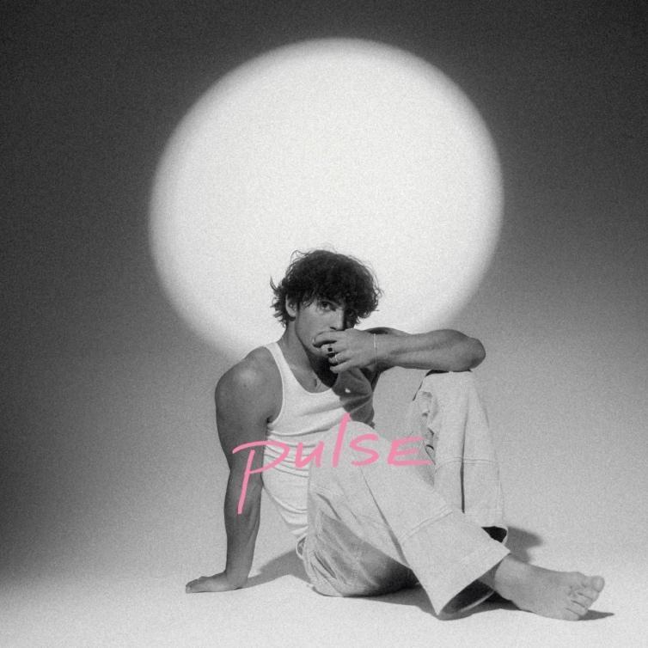
Hi-res download HERE

May 5, 2023 (Los Angeles, CA) – Today, breakout pop artist Benson Boone returns with the eagerly awaited new EP PULSE. Listen HERE via Night Street Records/Warner Records. Included on the 5-song set is the crooner’s new focus track “Little Runaway,” a piano-driven anthem filled with longing and charm. Watch the official music video HERE. In support of the EP, Boone will hit the road this month for a headlining tour with support from Nicky Youre—see dates below.

The EP begins with “Coffee Cake,” a bouncy, boisterous digression on laid-back breakfasts and sparkling conversation. It’s followed by the playful pop gem “Lovely Darling” and his recent single, the introspective “What Was.” Also included is Boone’s smoldering, angsty “Sugar Sweet,” produced by Jason Evigan (Justin Bieber, Dua Lipa, Maroon 5), which truly highlights the singer’s dazzling vocal abilities and has already amassed more than 18 million streams.

Amidst the bluesy arrangements and soaring choruses, “Little Runaway” almost feels like a throwback to the intimacy of Boone’s previous releases. “Won’t you come and we can stare at the stars,” he gently pleads on the single’s chorus, over tinkling keys and a pulsating beat, adding, “And look at the comets from the roof of my car. Little runaway, I know it’s been hard.” It’s impossible not to get swept up in the track’s transporting imagery.

PULSE was preceded by Boone's 2022 piano ballad “Before You” and the Walk Me Home… EP, which includes hits like “In The Stars,” “ROOM FOR 2,” and “GHOST TOWN.” The latter became the 20-year-old's first entry on the Billboard Hot 100 and reached Top 25 at both Top 40 and Hot AC radio. It also became his first RIAA-certified Gold record, followed by “In The Stars,” which was certified in January.

Last night, Boone hosted an intimate album release concert for his fans in Los Angeles, Presented by Breakthrough—the program from Amazon Music supporting up-and-coming artists from around the world—and Warner Records, the event featured Benson performing his full new EP in full for a crowd of fans at The Berrics 2.0 skatepark. Last year, Benson was selected as an Amazon Music Breakthrough Arist; as part of this selection, Benson and Amazon Music worked together on a bespoke campaign to support his music that has included exclusive video and audio content, global marketing campaigns, increased visibility across playlists and programming, events, and more.

Boone was first discovered by Imagine Dragons superstar Dan Reynolds. Since then, he has earned more than 1.2 billion global streams to date, as well as praise from Billboard, who lauded his “restrained vocals” and Consequence, who dubbed the newcomer “an exciting new voice.” With PULSE, Boone showcases impressive artistic growth and hints at bold new horizons.

PULSE Tracklisting:

- Coffee Cake
- Lovely Darling
- What Was
- Sugar Sweet
- Little Runaway

Benson Boone 2023 Tour Dates:

June 1 – New York, NY @ Irving Plaza
June 3 – Philadelphia, PA @ Brooklyn Bowl
June 4 – Washington, DC @ The Howard Theatre
June 6 – Boston, MA @ Brighton Music Hall*
June 8 – Montreal, QC @ Corona Theatre*
June 9 – Toronto, ON @ Opera House**
June 10 – Columbus, OH @ The Basement*
June 12 – Chicago, IL @ Thalia Hall*
June 13 – Minneapolis, MN @ Fine Line
June 14 – Omaha, NE @ The Waiting Room*
June 16 – Denver, CO @ Summit
June 17 – Salt Lake City, UT @ The Union*
June 18 – Boise, ID @ Knitting Factory Concert House
June 20 – Seattle, WA @ The Showbox
June 21 – Portland, OR @ Aladdin Theater*
June 23 – San Francisco, CA @ The Chapel*
June 24 – Los Angeles, CA @ The Fonda Theatre
June 25 – San Diego, CA @ Music Box*

*Sold out
**More tickets added

Credit: Erica Hernandez | Hi-res download HERE

###

FOLLOW BENSON BOONE:
TikTok | Instagram | Twitter | Facebook | YouTube

For more information, please contact:
Darren Baber | Warner Records
Darren.Baber@warnerrecords.com

