BUZZING LOS ANGELES DUO SKYECHRISTY RELEASE NEW SINGLE
“FAKE LOVE” TODAY

LISTEN HERE WATCH HERE

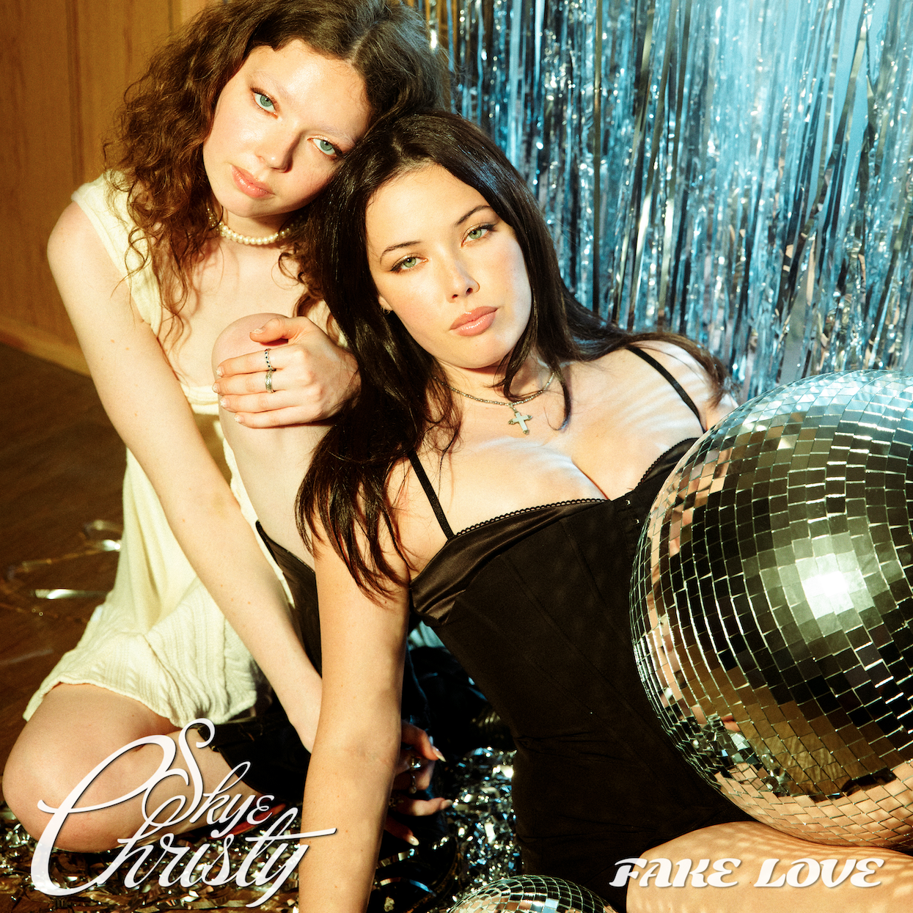

May 26, 2023 (Los Angeles, CA) – Picking up steam as an artist to watch in 2023, buzzing Los Angeles duo SkyeChristy reveal a brand new single entitled “Fake Love” today via Warner Records. Listen to “Fake Love” HERE.

“This song is about changing the narrative. We hear so many songs written from the perspective of men who are toying with women’s emotions,” says SkyeChristy. “We wanted to write a song, where the roles are reversed. A woman who has unwavering confidence, and who is the player rather than the one who’s being played.”

The track threads together delicate acoustic guitar with airy sonics. Their sisterly harmonies instantly captivate once again as the momentum builds towards an ominous warning, “She’ll have found another victim who is willing to give into the fake love she’s been passing around.”

It lands in the wake of “Beach Zombies.” Beyond generating over half-a-million total streams and counting, the single incited critical applause. It picked up plugs from the likes of Billboard and HitsDailyDouble, while the girls sat down for an interview with Spreaker from iHeart. Not to mention, The Honey Pop raved, “Giving us the soundtrack to our dreams, SkyeChristy’s vocals have a way of being soft yet powerful, with the contrast being the duo’s strong suit. Add in the punch of their lyrics, and you’ve got the perfect song.”

The latter arrived on the heels of “I’m Not Like Alice,” “Sending Light (For Lucas)” and “Black Lake.” The sister duo is a sonic union of Georgia Christy Edwards and Sophie Skye Edwards. The Los Angeles natives began writing and recording music together in high school. They honed their voices in choir, even performing at Carnegie Hall as part of their school ensemble choir. Since 2020, they’ve unlocked the power of their familial harmony and have captivated fans around the globe. With their distinct signature sound and forthcoming debut project, the SkyeChristy’s bond will only grow stronger.

Get ready for a whole lot more from SkyeChristy.

Credit: Joelle Grace Taylor – High Res HERE

Stay Up-To-Date With SkyeChristy

TikTok | Instagram | YouTube

# # #

For More Information:

Connor Hunt // connor.hunt@warnerrecords.com

Patrice Compere // patrice.compere@warnerrecords.com

