K-POP GIRL GROUP aespa RELEASE HIGHLY
ANTICIPATED THIRD MINI ALBUM
MY WORLD

LISTEN AND PURCHASE HERE

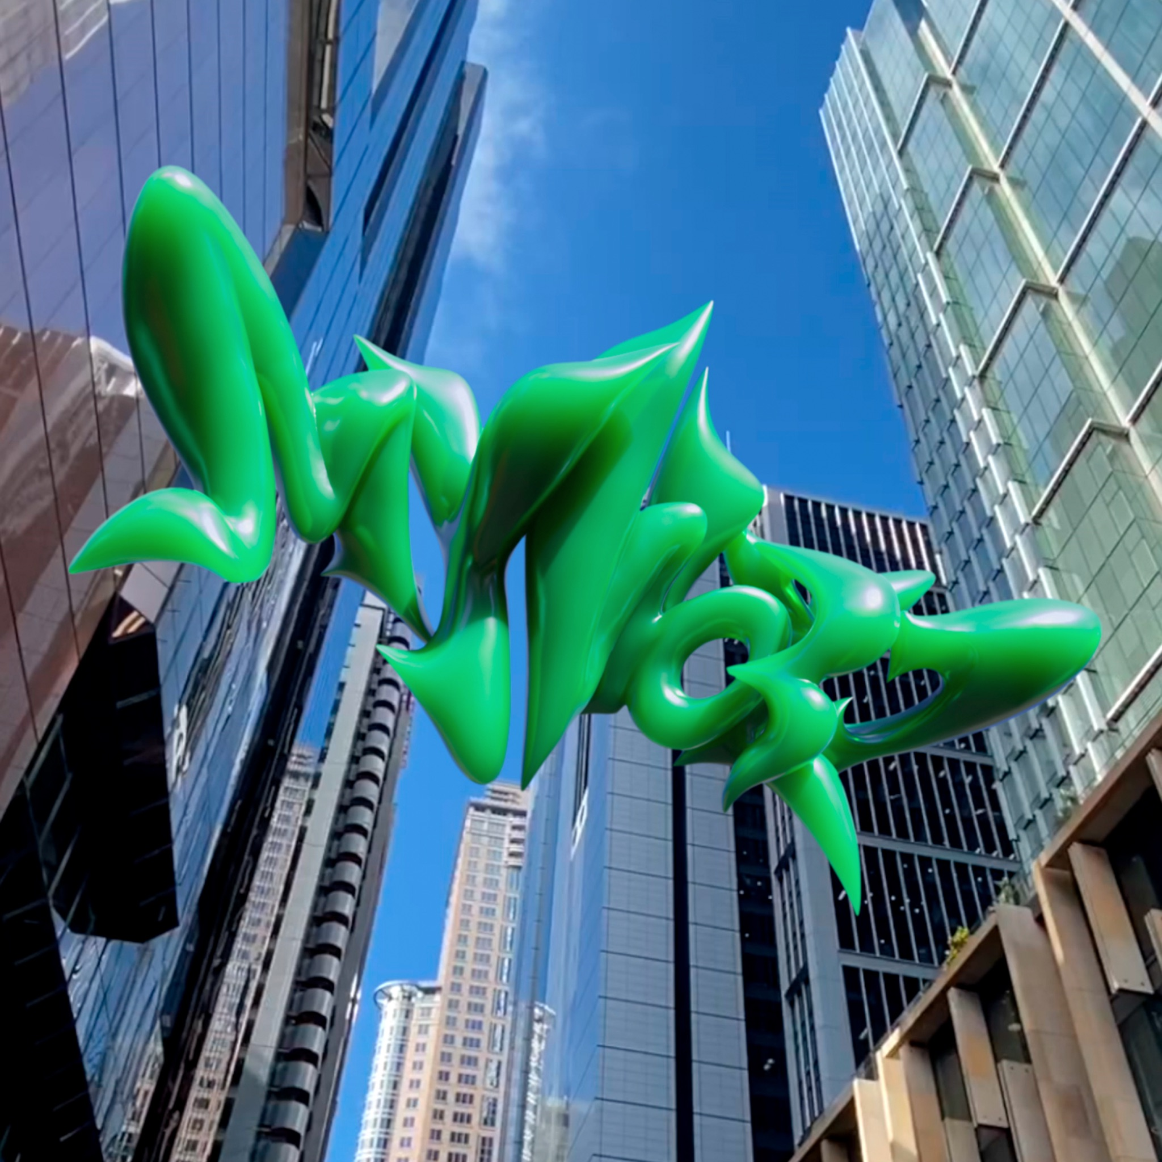
Credit: SM Entertainment - High Res HERE

“one of the most exciting girl groups right now” – NYLON
“aespa deliver addictive pop and winning experiments” - RollingStone
“nothing is more exciting than a new aespa song” – UPROXX
Los Angeles, CA (May 8, 2023) – After stirring up anticipation worldwide, K-pop girl group aespa proudly presents its highly anticipated 3rd Mini Album, MY WORLD, out now via Warner Records. Listen to MY WORLD HERE. Full tracklisting below.

MY WORLD showcases every side of the collective. Whether it be the youthful spirit of “Spicy” or the precious and heartwarming “‘Til’ We Meet Again,” this body of work finds aespa firing on all cylinders, and there’s nothing like it.

The group initially teased the Mini Album with the single “Welcome To MY World” [feat. nævis]. UPROXX proclaimed, “‘Welcome To My World’ featuring naevis is an ethereal blend of human and ai-programmed pop bliss.”

On “Welcome To MY World,” aespa reunited with nævis whom they forged a powerful chemistry with during season one of their cinematic universe. Balancing wistful ethereal guitar with big screen-ready orchestration, this alternative pop anthem issues an invitation to fans everywhere to immerse themselves in the quartet’s music.

MY WORLD ignites the second season of the SMCU (SM Culture Universe). The six-track project magnetically pulls audiences in with its dynamic and diverse collection of dancefloor-ready bangers, soaring R&B ballads, and towering alternative pop. As soon as they broke the news of the project, Twitter caught fire as chronicled by Billboard and more.

As of May 8, aespa is expected to achieve the title of ‘Triple Million Seller’ for the second consecutive time with pre-sale orders of 1.8 million copies for their 3rd Mini Album - MY WORLD. This sets a new record by surpassing their own pre-order sales of 1.6 million copies for their 2nd Mini Album - Girls, which crashed the Top 3 of the Billboard 200.

This summer, aespa are set to make history at Governor’s Ball festival in New York and Outside Lands festival in San Francisco as the first-ever K-Pop group to appear at either festival. Last year, aespa made their U.S. festival debut at Coachella in Indio, CA where they performed on the main stage, they made their official late night U.S. TV debut on Jimmy Kimmel Live and kicked off Good Morning America’s Summer Concert Series in Central Park. Later in July, aespa celebrated the release of Girls - The 2nd Mini Album which debuted at #1 on Billboard’s Top Album Sales chart. The New York Times quoted it as “one of the year’s most impressive K-Pop releases precisely because of its dual mastery of the intricate and the elegant.” Listen to Girls - The 2nd Mini Album HERE. On top of these milestones, aespa also became the first K-pop group to appear on the cover of UPROXX. Read the march cover story HERE.

Once again, aespa has leveled up from every angle. Welcome to their world…

TRACKLISTING
01. Welcome To MY World (Feat. nævis)
02. Spicy
03. Salty & Sweet
04. Thirsty
05. I'm Unhappy
06. 'Til We Meet Again

ABOUT aespa:
aespa [KARINA, WINTER, GISELLE, AND NINGNING] is a fierce female foursome, who in an unprecedented move secured the fastest climb to 100 million views on their debut video for any K-Pop group in YouTube history with their 2020 released, “Black Mamba.” Their 2021 EP, Savage - The 1st Mini Album, was the highest ranking ever for a K-Pop girl group’s entry on the U.S. Billboard 200 album chart. The EP also hit #1 on iTunes Top Albums chart in 20 countries upon release. Beyond praise from Forbes, Teen Vogue, Rolling Stone, Flaunt, and more, TIME touted them among “The Next Generation Leaders, Class of 2022” and Forbes recognized them in their “30 Under 30” Asia list for 2022. Following being named Apple Music’s Global Up Next artist for June 2022, the quartet released their first English-language single “Life’s Too Short” and highly anticipated second EP, Girls - The 2nd Mini Album this past July, which debuted at #1 on Billboard’s Top Album Sales chart.

aespa’s name is derived from a combination of “ae” (avatar and experience) + “aspect.” Each of the four members of aespa has a correlating avatar in the virtual world created from their personal data.

Credit: SM Entertainment - High Res HERE

FOLLOW aespa:
Press Assets | TikTok | Twitter | Instagram | YouTube | Facebook

Warner Records Contacts:
Darren Baber // Darren.Baber@warnerrecords.com
Connor Hunt // Connor.Hunt@warnerrecords.com

Rogers & Cowan PMK:
aespa@rogersandcowanpmk.com

SM Entertainment Contact:
Christina Santamaria // Christina@smtown.com

###

