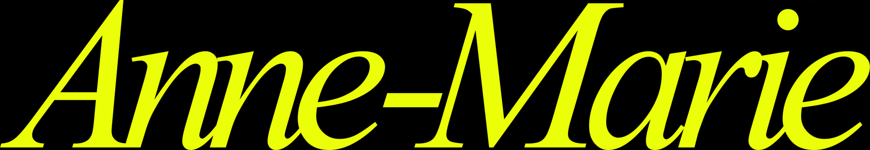
BRITISH POP SUPERSTAR ANNE-MARIE TEAMS UP WITH GLOBAL ICON SHANIA TWAIN FOR “UNHEALTHY” — LISTEN HERE

THIRD STUDIO ALBUM UNHEALTHY OUT JULY 28
PRE-ORDER HERE
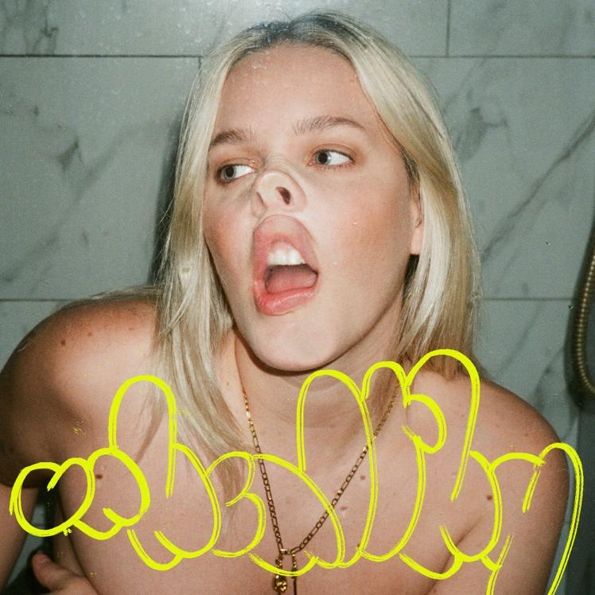
Download hi-res artwork HERE
May 18, 2023 (Los Angeles, CA) — British pop star Anne-Marie has teamed up with Global Superstar Shania Twain for her new single “UNHEALTHY” from her upcoming third studio album, out July 28. Listen to “UNHEALTHY” HERE and pre-order the album HERE.
Anne-Marie featuring Shania Twain’s ‘UNHEALTHY’, produced by Conor and Riley McDonough (Jonas Brothers, Joji, John Legend), is the perfect pop/country tonic. Anne-Marie had always wanted to write a country-influenced song and decided that her upcoming third album would be the perfect home for just that. Being a lifetime fan of Shania—the Queen of country/pop herself—Anne-Marie slid into Twain’s DMs earlier in the year and suggested the collaboration. Fast forward to March, the two chart-topping women met in London and recorded the track.

Pulling from all parts of her life, Anne-Marie’s third album UNHEALTHY offers us a sneak peek into her perfectly imperfect world. Penned over a period when she felt ready to revisit and try to make sense of a host of raw past relationships — whilst also learning to process positive new ones — the new album takes us on a journey from chaos to contentment. UNHEALTHY is Anne-Marie living out her highs and lows on her own terms, embracing an all-new version of herself that’s fiercer, bolder and more blissfully happy than ever before.
Over the album’s thirteen tracks, gutsy empowerment anthems run alongside tender, vulnerable streaks and guitar-fuelled angst. Written and recorded alongside Kamille (Dua Lipa, Sia, Little Mix) McDonough Brothers (Jonas Brothers, Joji, John Legend), Billen Ted, Evan Blair (Nessa Barrett Reneé Rapp), and Nami (Ariana Grande, Sam Smith, Jack Harlow), the album also includes features from Aitch and Khalid.
To date, Anne-Marie has achieved 7 billion global streams. Most recently, she collaborated with David Guetta and Coi Leray on the summer anthem “Baby Don’t Hurt Me.”
On February 3 via Republic Nashville, Shania released her sixth full length album Queen of Me, which received glowing reviews from NPR, Rolling Stone, Consequence, and more out the gate. The album debuted at No. 1 on the UK Albums Chart, No. 5 on Australia’s ARIA Chart, and No. 10 on the US Billboard 200. She is currently lighting up the stages on her sold-out global Queen of Me tour, which runs through November 2023.

UNHEALTHY TRACKLISTING:
- SUCKS TO BE YOU
- SAD B!TCH
- PSYCHO (FT. AITCH)
- HAUNT YOU
- TRAINWRECK
- GRUDGE
- OBSESSED
- KILLS ME TO LOVE YOU
- UNHEALTHY WITH SHANIA TWAIN
- IRISH GOODBYE
- CUCKOO
- YOU & I (FT. KHALID)
- NEVER LOVED ANYONE BEFORE

Credit: George Muncey
Download hi-res photo HERE
Follow Anne-Marie
Official | Instagram | Twitter | Facebook | YouTube | TikTok | Press Materials

For more information on Anne-Marie, please contact:
Darren Baber | Warner Records
Darren.Baber@warnerrecords.com

For more information on Shania Twain, please contact:
Luke Burland | 2B Entertainment
Luke@2bentertainment.net

