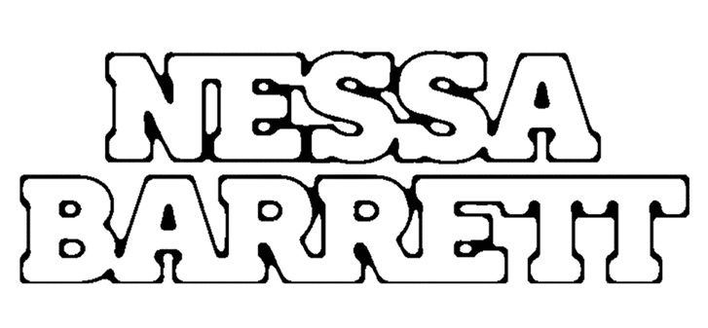

BREAKOUT POP STAR NESSA BARRETT RETURNS WITH NEW SINGLE “AMERICAN JESUS”

LISTEN HERE | WATCH HERE

FACE OF NEW SKIMS CAMPAIGN ALONGSIDE
ICE SPICE, PINKPANTHERESS AND RAYE

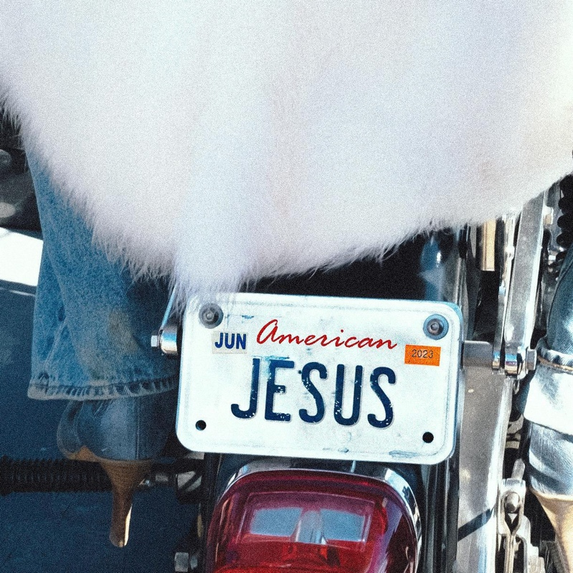
Hi-Res Download HERE

April 14, 2023 (Los Angeles, CA) – Today, pop provocateur Nessa Barrett returns with the incendiary new single “american jesus.” Listen HERE via Warner Records. The sultry, unapologetic anthem from an artist who takes no prisoners, “american jesus” made its debut on the 20-year-old's recent sold-out young forever tour — which wrapped up in Los Angeles in March — and immediately became a fan favorite. Watch the music video HERE.

“You know all my secrets, American Jesus — baby, won’t you take me to heaven tonight,” Barrett coos over a thrumming guitar and pulsing bass. “You know you’re my weakness, American Jesus, save me — you’re the greatest love of my life.” According to the hitmaker, the song is about longing and desire. "It's about the fantasy of someone who is your savior, your cowboy in a crown," she says. "Everyone dreams about a love that’s heavenly, and I know everyone will be able to relate to this."

The new single arrives after the release of “BANG BANG,” a fiery punk-inspired anthem that weaves fantasies of revenge into screeching guitar and driving drums. Prior to that, Barrett released a bevy of big tracks in 2022, including “die first,” “tired of california” and “lovebomb" — all taken from her critically acclaimed debut album young forever.

Also unveiled this week, Nessa is one of the faces of SKIMS’ new campaign featuring the next generation of musical stars, along with Ice Spice, PinkPantheress, and RAYE. The collection launches April 27 on skims.com.

After being named as one of Billboard’s “21 Under 21” — as well as being featured on Ones to Watch’s list of “25 Artists to Watch in 2022,” Uproxx’s “Next Hitmakers List,” and People Magazine’s “Emerging Artist List” — Barrett has gone on to accumulate more than 1.3 billion audio streams to date. She was also nominated for Push Performance of the Year at the 2022 MTV VMAs. She played her first festival last year at When We Were Young in Las Vegas and is set to perform at Reading & Leeds Festival this August.

With bangers like “american jesus,” Barrett is destined to continue making new fans in 2023 with her deliciously devious brand of pop.

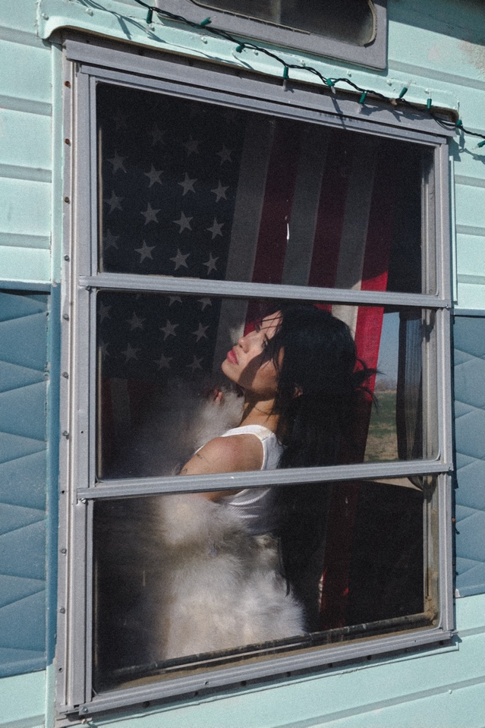
Photo credit: Colin Miller
Hi-res download HERE

Follow Nessa Barrett:
Official | TikTok | Instagram | Twitter | Facebook | YouTube | Press Materials | Store

Nessa Barrett contact:
Darren Baber | Warner Records
Darren.Baber@warnerrecords.com

