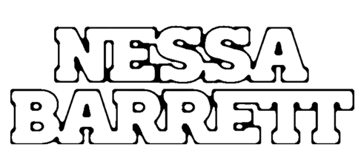

RISING POP STAR NESSA BARRETT DROPS PERSONAL NEW SINGLE “LIE”

LISTEN HERE | WATCH HERE

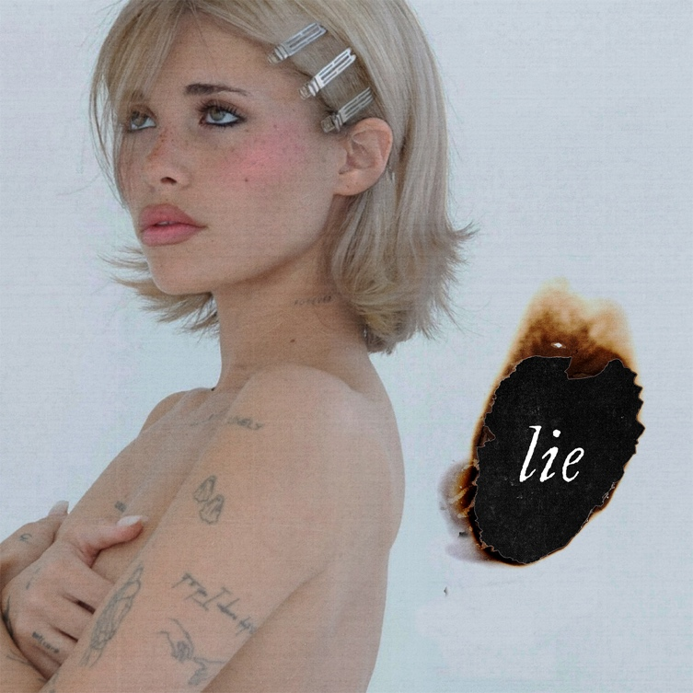
Hi-Res Download HERE

June 23, 2023 (Los Angeles, CA) – Today, pop sensation Nessa Barrett releases her emotional new single “lie.” Listen HERE via Warner Records and watch the video HERE. Introspective and personal, the track showcases a softer, more vulnerable side of the songstress. Since Nessa began teasing the song earlier this week, fans have been eagerly dissecting her hints about the song’s inspiration.

“The hardest pill to swallow is knowing that tomorrow you’re not mine," she sings over ethereal drumming and a sparse piano arrangement. "If I don’t get to have you, thank god our matching tattoos last for life.” In the chorus, Barrett comes to terms with a lover moving on: “You can kiss her softly, never make her cry — you can tell her that you love her as long as it’s a lie.” Bittersweet and lovelorn, "lie" underlines the breakout star's unfiltered approach.

While discussing the inspiration for the track, Barrett revealed that the song is "about accepting that sometimes even though you want something, it's not always meant to be." Ultimately, she hopes it will be a source of comfort. "I hope people who listen to this feel an emotion that is hard for us to accept but need to in order to live a fulfilling life.”

"lie" arrives hot on the heels of recent singles “american jesus” and “BANG BANG!” Prior to that, Barrett released an arsenal of big tracks in 2022, including “die first,” “tired of california,” and “lovebomb" — all taken from her critically acclaimed debut album young forever.

After being named as one of Billboard’s “21 Under 21” twice — as well as being featured on Ones to Watch’s list of “25 Artists to Watch in 2022,” Uproxx’s “Next Hitmakers List,” and People Magazine’s “Emerging Artist List” — Barrett has gone on to accumulate more than 1.4 billion global streams to date. She was also nominated for Push Performance of the Year at the 2022 MTV VMAs, performed at When We Were Young Festival, and took her show on the road for her sold out North American and European young forever tours. This October, she will take the stage at Austin City Limits Festival.

With “lie,” Barrett demonstrates her growth as an artist and provides a glimpse at what's to come from the rising superstar.

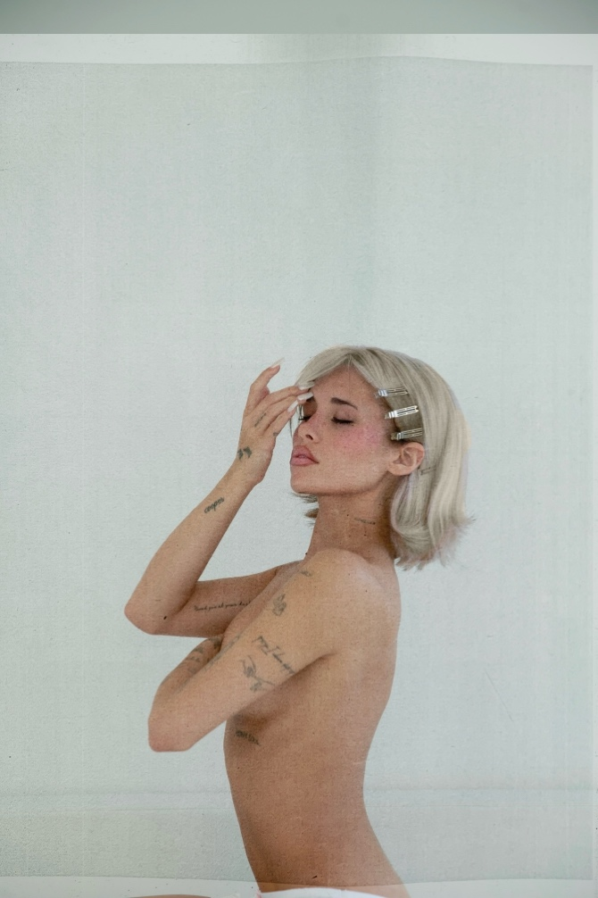
Download hi-res press photo HERE
Photo credit: Colin Miller

Follow Nessa Barrett:
Official | TikTok | Instagram | Twitter | Facebook | YouTube | Press Materials | Store

Nessa Barrett contact:
Darren Baber | Warner Records
Darren.Baber@warnerrecords.com

