BUZZING LOS ANGELES DUO SKYECHRISTY UNVEIL NEW SINGLE + VIDEO “FRIDAY NIGHT THRILLER”

LISTEN HERE WATCH HERE

DEBUT EP THE SUMMER I LOST MY LOVER OUT JULY 21

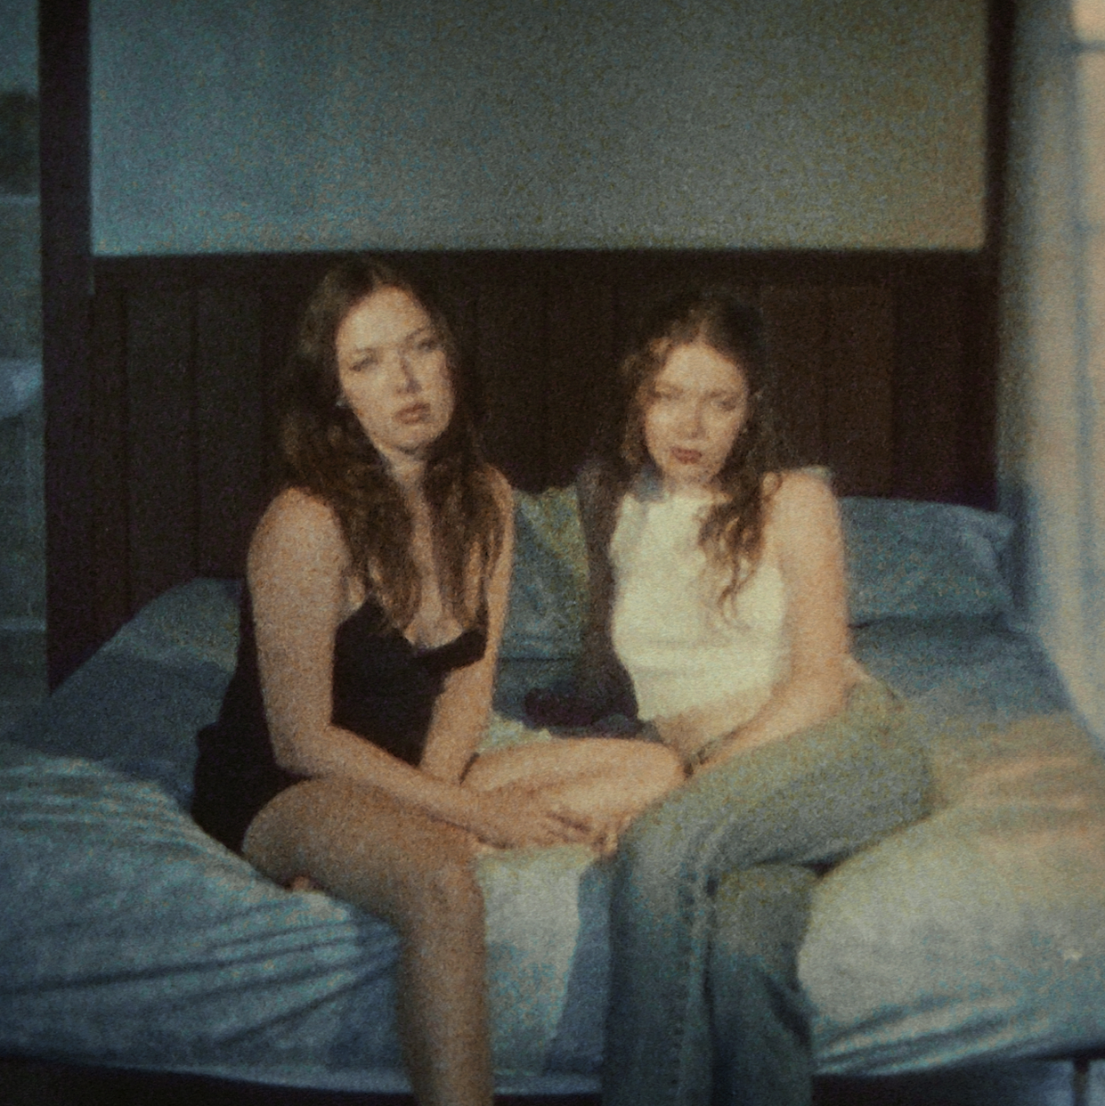
Download high-res photos + artwork here

June 30, 2023 (Los Angeles, CA) – Buzzing Los Angeles sister duo SkyeChristy return with a haunting new single and video “Friday Night Thriller,” heralding the arrival of their debut EP The Summer I Lost My Lover, due out on July 21 on Warner Records. Listen to “Friday Night Thriller” HERE and watch the music video HERE.

On the track, dusty acoustic guitar creaks beneath soulful and striking verses. Jazz-y vocal intonation weighs down on the groaning bass line. Simultaneously, the girls paint a picture of an addictive, yet acidic romance, “He’s a killer, Friday Night Thriller,” punctuated by eerie keys. The accompanying visual intercuts a procession of desert gothic vignettes. SkyeChristy dance in the dark as the perspective sweeps across a sleepy town somewhere in the middle of California. It introduces the title character only to evoke fascination with the voyeuristic gaze of the camera and intimate closeups.

The forthcoming 7-track EP features recent singles “Fake Love,” “Beach Zombies” and “I’m Not Like Alice,” which have caught the attention of Billboard, HITS, Ones To Watch, and The Honey Pop, who raved, “SkyeChristy’s vocals have a way of being soft yet powerful, with the contrast being the duo’s strong suit. Add in the punch of their lyrics, and you’ve got the perfect song.”

The sister duo is a sonic union of Georgia Christy Edwards and Sophie Skye Edwards. The Los Angeles natives began writing and recording music together in high school. They honed their voices in choir, even performing at Carnegie Hall as part of their school ensemble choir. Since 2020, they’ve unlocked the power of their familial harmony and have captivated fans around the globe. With their distinct signature sound and forthcoming debut project, the SkyeChristy’s bond will only grow stronger. Get ready for a whole lot more coming soon.

EP TRACKLISTING:
1. “Family Barbecue”
2. “I’m Not Like Alice”
3. “Beach Zombies”
4. “Fake Love”
5. “Prime Years”
6. “Friday Night Thriller”
7. “Night Before”

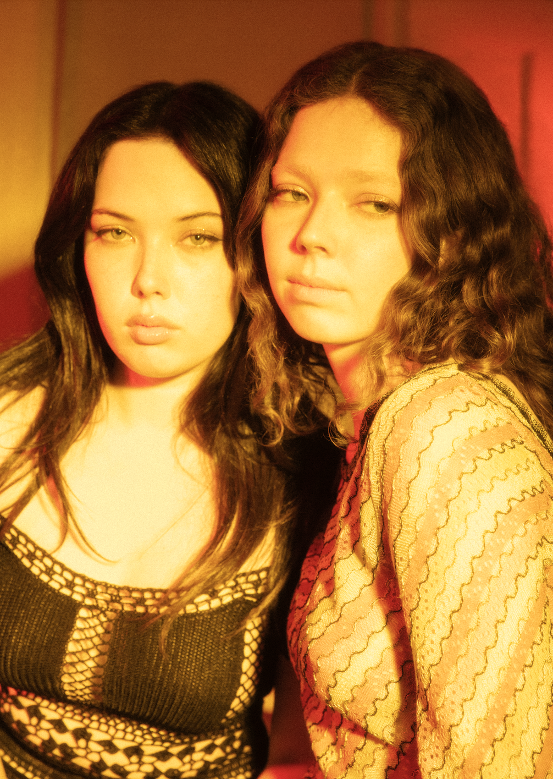
Credit: Joelle Grace Taylor – High Res HERE
# # #

Stay Up-To-Date With SkyeChristy
TikTok | Instagram | YouTube

For More Information:

Connor Hunt // connor.hunt@warnerrecords.com

Patrice Compere // patrice.compere@warnerrecords.com

