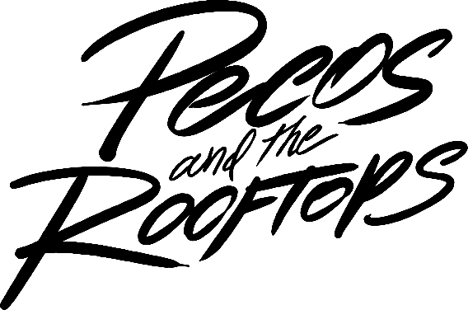

In the family tree of American music, country and rock have long been at odds. Feuding cousins claiming the same legacy, each one spawning a bitter tribe of true believers … but it doesn’t have to be that way. For Warner Records’ Pecos & The Rooftops, it’s time to bury the hatchet once and for all – and bury it deep.

A Texas-based six-piece built around metal-laced sonic aggression and bluesy, confessional song craft, it’s a new generation of country rock – honky-tonk headbangers from the state that gave us both Pantera and George Strait. And this band of brothers could not care less how “different” that makes them.

“It’s true there isn't a lot of rock influence out there right now, but who cares?” says the band’s frontman and primary songwriter, Pecos Hurley. “I think it feels good to have something different going, but it’s not even intentional. We're just making music that we like.”

For them, that means blacked-out country ballads and regret filled, middle-of-the-night rockers, all delivered with the punchy, guitar-driven sound that has slowly faded from mainstream view. Pulling genetic code from modern rock, grunge, nu-metal and beyond, their hook-driven anthems feature booming bass lines and crashing drums – plus a low-down, wrong-side-of-the tracks vocal that seems to rumble from the center of the earth.

It’s a signature sound that has already grown grassroots following, racked up nearly 400 million global streams and earned a Platinum-certification. But with a self-titled major-label debut marking their heaviest hitter to date, a new era begins.

“This is the best music we've ever put out,” Pecos says, flexing matter-of-fact confidence (and a take-it-or-leave-it spirit). “It would be ideal for shit to just absolutely pop off even more.”

Named in part for the rooftop they often hung out on, the band got its start in 2019, when four original members met attending college in Lubbock. It’s a West Texas creative oasis known mostly for its alt-country scene – the original home of artists from Buddy Holly and Waylon Jennings to Wade Bowen and William Clark Green. But Pecos and the boys were a different breed.

All raised on 2000s era hard rock, classic rock and the blues, lead guitarist Zack Foster and bass player Kalen Davis were hometown buddies, living in a ramshackle five-bedroom house and doing what college kids do. A bond formed between them and another pair of friends – Pecos and rhythm guitarist Brandon Jones – and soon, music was at the center of their frequent hangs. Pecos was the only one actively writing songs (since 2016), but one night, that changed.

“We would go to [Zack and Kal’s] place all the time to hang out and drink beers, and wind up jamming on guitars, just messing around with songs,” Pecos recalls. “One night, I started playing a couple of chords and Kal was like, ‘Hey, keep playing that.’”

Adding an on-the-spot hook, those chords would go on to become “This Damn Song” – and eventually the band's breakout single. Pecos took it home and stayed up all night to finish it, ending up with a rock-bottom acoustic ballad – bluesy and bleeding from a freshly broken heart. It took almost a year before he finally recorded it. But when he did, the world turned upside down.

“Shit just hit the fan,” he says with a laugh. “We were like, ‘Well, I guess we're a band now.’”

“This Damn Song” has now earned a RIAA Platinum certification and over 270 million streams – but more important than stats, it also created an identity. Accidental or not, the band had fused thundering sonic power with raw vocal authority, and while that was familiar enough for the rock world, this was different. They matched that energy with personal writing that turned phrases like a dagger, recalling the sharpest Nashville songsmiths.

“My mom loved older country,” Pecos explains, “so I grew up on everything from Waylon and Willie Nelson, Merle Haggard and Johnny Cash … plus a ton of Alan Jackson and George Strait.”

Soon, the band were hitting the road, first teaming up with fellow Texan outlaw Kolby Cooper, and then striking out alone. Honing their sound with the addition of Garrett Peltier (drums) and Hunter Cassell (guitars/keys), a two-year whirlwind of hard touring and hard-nosed performances followed, building their reputation as a band of blue-collar brothers, and leading to 2020’s explosive independent EP, Red Eye. But their full-length Warner debut lights a fresh fuse.

Produced by Andrew Bayliss (Jelly Roll, Austin Snell) and recorded at The Boneyard Studios, it’s a fatter, bolder evolution of their sound – higher voltage and making full use of world-class resources, even if Pecos remains wary of the Nashville “scene.”

“I was skeptical about writing in Nashville for a long time,” he admits. “I even got into a slump where I didn't write for like, several months. But finally, I said, ‘Fuck it’ and came up here and found my guys. I still don't think I've really adopted the Nashville style of writing – but I’ve got my own way.”

With 11 new tracks written over the last two years, Pecos and the band stadium-size their rock prowess, with glacially thick distortion and overdriven solos leading afterburner anthems and grungy ballads alike. All throughout, the shadowy depth of Pecos’ diesel-powered vocal roars on, battling inner demons and drowning toxic sorrows in equal measure. It’s their version of country’s tear-in-your-beer tradition, although taken with a bit of artistic license.

“I mean, I’m married now and happy – I'm in love and shit,” Pecos says with a laugh. “But I still love sad music and feel like it helps people.”

With tracks like the album opening “Bricks,” dropped-D dissonance and a slacker-rock vibe introduce an album full of self-destructive tendencies, while others like the pre-released “5 AM” describe a crippling cycle of addiction, with anthemic vocals and drums pounding as hard as a hungover headache.

Other standouts include the window-shaking “She Says,” matching white-hot guitar riffs to a theme of accepting hard truths. “The Worst Way” coats romantic longing in windblown Western dust, while “Memories” cranks up the ‘80s saturation for an anthem of could-have-beens.

But with “Last Thing I Remember,” Pecos & the Rooftops take their reckless romantic ways to a natural conclusion. Another early release with a heart-broken hard-rock foundation, it’s a mix of poor choices and missed opportunities, as a guy comes to grips with losing what was really important. But that’s a mistake this band are not going to make.

“It's just real, we just tried to make good music,” Pecos says. “This is what we all wanted to do growing up, and it's happening for us now. We're just keeping a grip on it, going out and having fun, and just working our asses off. This is the best stuff we've done.”

# # #

FOLLOW PECOS & THE ROOFTOPS:
Twitter | Instagram | TikTok | YouTube | Website

