NEIL YOUNG AND CRAZY HORSE TO RELEASE VINYL EDITION
OF ODEON BUDOKAN ON SEPTEMBER 1st VIA REPRISE RECORDS

FIRST EVER VINYL RELEASE OF LONG SOUGHT-AFTER TEN-TRACK LIVE ALBUM PRODUCED BY DAVID BRIGGS
RECORDED IN 1976 IN LONDON AND TOKYO

PRE-ORDER HERE

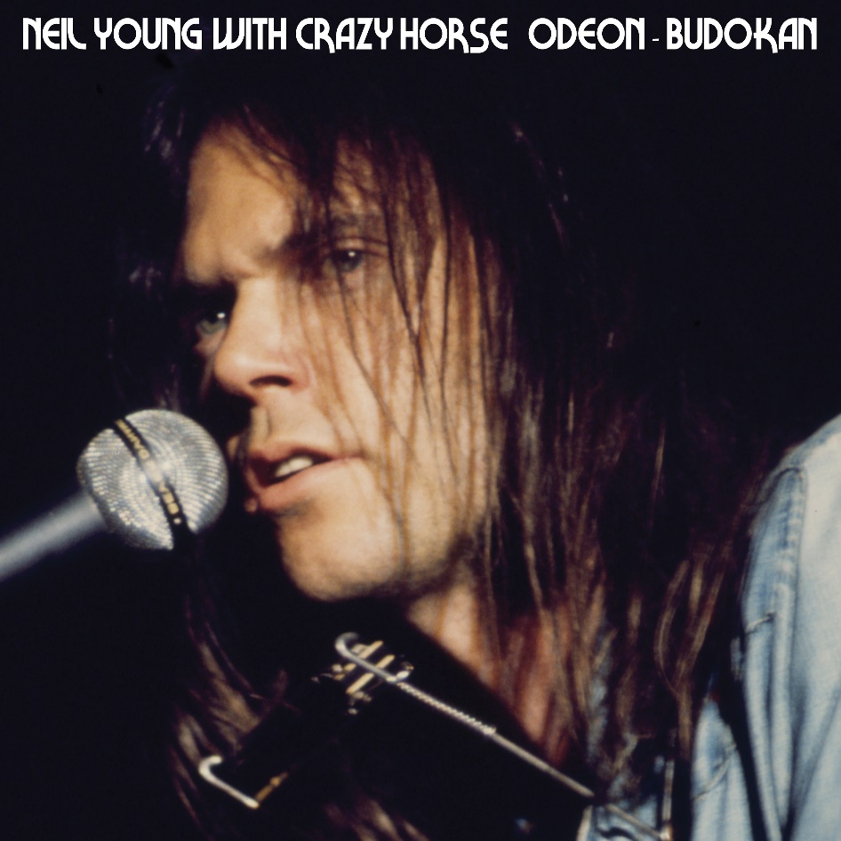
(Download hi-res artwork HERE)

July 21, 2023 (Los Angeles, CA) — There are certain albums in the extensive Neil Young Archives that take on a unique life of their own. Maybe it's their rarity, or a galvanizing reputation that sets them apart. One of the most anticipated releases in this ongoing musical march is the live collection ODEON BUDOKAN, recorded with Crazy Horse, scheduled for September 1st, release via Reprise Records, Neil Young's home label for over 50 years.

Originally recorded in 1976 almost a world apart at two overseas venues: Hammersmith Odeon in London and Nippon Budokan Hall In Tokyo. The ten-track album includes an electrifying range of songs, from well-known classics to true surprises. Tracks on Side 1 were recorded in London March 31, 1976, and feature Neil Young's solo set on guitar and piano from the first half of the concert. Side 2 tracks were recorded two weeks earlier on March 11, 1976, with Young and Crazy Horse at an early electric apex.

This is the first official vinyl release of the previously unissued ODEON BUDOKAN. It has only been available on Compact Disc as part of Neil Young's ARCHIVES VOLUME II box set, released in 2020 in the highest-grade audio high fidelity. Young's songs like "Cowgirl In the Sand," "Cortez the Killer," "Lotta Love," "Stringman" and others are heard at their absolute highest peak.

This album was produced by David Briggs shortly after the 1976 tour. It was put on hold because of other albums that were being made and released at the time.

Odeon Budokan will be available at the Greedy Hand Store at Neil Young Archives (NYA) and music retailers everywhere. Hi-res digital audio will be available at Neil Young Archives and most DSPs. All Greedy Hand Store purchases come with free hi-res digital audio downloads from the Xstream Store © at NYA. Once again, Neil Young's lifetime of music is on the move.

Odeon Budokan Tracklist:
Side 1:
- The Old Laughing Lady
- After The Gold Rush
- Too Far Gone
- Old Man
- Stringman

Side 2:
- Don’t Cry No Tears
- Cowgirl In The Sand
- Lotta Love
- Drive Back
- Cortez The Killer

# # #
Visit: Neil Young Archives (NYA)

For further information, contact Rick Gershon at Warner /Reprise Records:
Rick.Gershon@warnerrecords.com

Follow Neil Young:
Official | TikTok | YouTube | Press Materials

